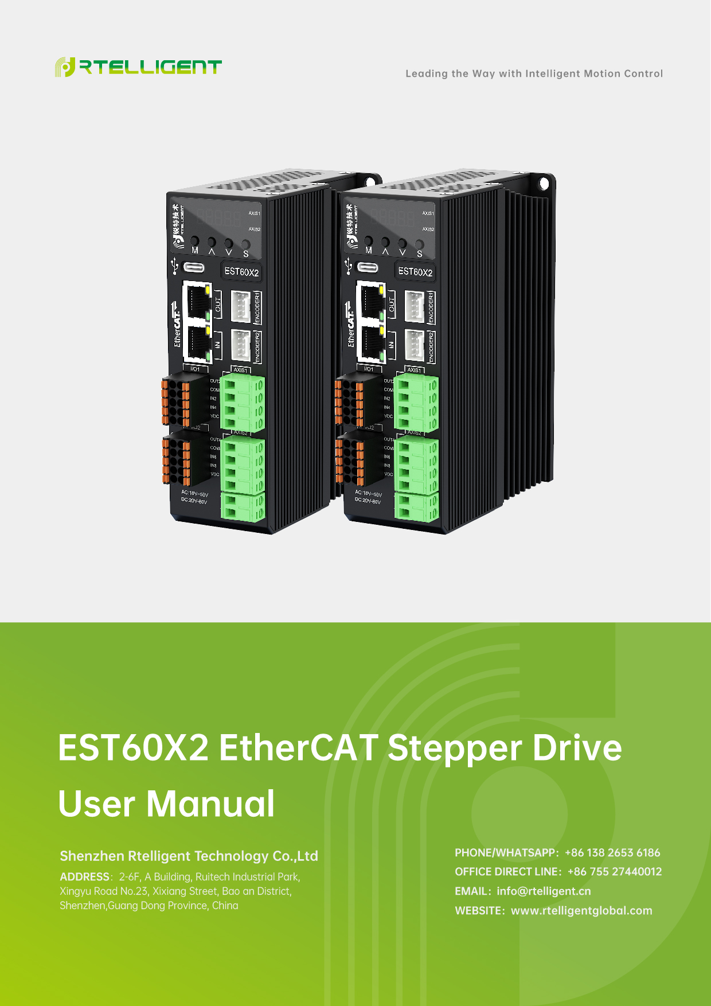

Revision History
Date | Version | Description
2025.06 | V1.0 | Product initial release
2025.08 | V1.1 | Corrected model number error in section 4.4.1
2025.08 | V1.2 | Corrected error description for homing method 14
2025.09 | V1.3 | Modified sections 1.4.1, 1.4.2, and 4.2.7: IN3 as negative limit, IN4 as positive limit.  (Drive software version 5.0.7 and above)
2025.10 | V1.4 | Optimized drive wiring diagram
2025.12 | V1.5 | Added encoder terminal definitions in section 1.2;modified inputport functions in sections 1.4.2 and 4.2.7:  input function value 1 for negative limit, 2 for positive limit.

Content
Revision History - 2 -
1 Drive Description - 8 -
1.1 Product Introduction - 8 -
1.1.1 Key Features - 8 -
1.1.2 Electrical Specifications - 9 -
1.2 Power Supply、Motor Connections & Encoder - 9 -
1.3 Drive Interface Wiring Diagram - 11 -
1.4 Digital Input/Output Ports - 12 -
1.4.1 I/O Port Definitions - 12 -
1.4.2 Digital Input Ports - 13 -
1.4.3 Digital Output Ports - 16 -
1.4.4 Brake Wiring Diagram - 18 -
1.5 Mechanical Dimensions - 19 -
2 Control Panel - 20 -
2.1 Panel Overview - 20 -
2.1.1 Panel Components - 20 -
2.1.2 Panel Display Contents - 20 -
2.1.3 Panel Operation - 21 -
2.1.4 Data Display - 22 -
2.1.5 Fault Display - 23 -
2.1.6 Monitoring Display - 24 -
2.1.7 Communication Operation Status - 25 -
2.2 Parameter Settings - 26 -
2.3 Auxiliary Functions - 27 -
2.3.1 Parameter Management - 27 -
2.3.2 Soft Reset - 27 -
2.3.3 Jog Test Operation - 27 -
2.4 Numeric Addresses - 28 -
2.4.1 Fault Display Codes - 28 -
2.4.2 Monitoring Display Parameters - 29 -
2.4.3 Parameter Settings - 31 -
3 EtherCAT Communication - 36 -
3.1 Communication Overview - 36 -
3.2 Communication Setup - 36 -
3.2.1 EtherCAT Status LEDs - 36 -
3.2.2 EtherCAT Site Address - 37 -
4 Object Dictionary - 38 -
4.1 General Parameters - 38 -
4.1.1 0x1000 Device Type - 38 -
4.1.2 0x1008 Device Name - 38 -
4.1.3 0x1009 Hardware Version - 38 -
4.1.4 0x100A Software Version - 38 -
4.1.5 0x1010 Save Parameters ---- MODBUS Address: 90 - 38 -
4.1.6 0x1011 Restore Factory Defaults ---- MODBUS Address: 91 - 39 -
4.2 Manufacturer Specific Objects - 39 -
4.2.1 0x2000Peak Current - MODBUS Address:：0 - 39 -
4.2.2 0x2001 Micro-stepping (Subdivision) - MODBUS Address: 1 - 40 -
4.2.3 0x2002 Standby Time - MODBUS Address: 2 - 40 -
4.2.4 0x2003 Standby Current Percentage - MODBUS Address: 3 - 40 -
4.2.5 0x2005 / 0x2805 Output Port Function - MODBUS Addresses: 4-5 - 40 -
4.2.6 0x2006 & 0x2806 Output Port Polarity - MODBUS Address: 6 - 41 -
4.2.7 0x2007 0x2807 Input Port Function -- MODBUS Address: 7-10 - 42 -
4.2.8 0x2008 0x2808 Input Port Polarity -- MODBUS Address: 11 - 43 -
4.2.9 0x2009 Filter Time -- MODBUS Address: 12 - 43 -
4.2.10 0x200A Axis Lock Time -- MODBUS Address: 13 - 43 -
4.2.11 0x200B Current Loop Parameters -- MODBUS Address: 14-17 - 44 -
4.2.12 0x200C Motor Parameter -- MODBUS Address：18-23 - 44 -
4.2.13 0x200D Operation Direction Reverse -- MODBUS Address: 24 - 45 -
4.2.14 0x200E Internal Fault Code -- MODBUS Address: 25 - 45 -
4.2.15 0x200F Internal Status Code -- MODBUS Address: 26 - 46 -
4.2.16 0x2010 Position Zero Command -- MODBUS Address: 27 - 46 -
4.2.17 0x2011 Control Mode -- MODBUS Address: 28 - 47 -
4.2.18 0x2020 Encoder Resolution -- MODBUS Address: 29 - 47 -
4.2.19 0x2021 Encoder Position Value -- MODBUS Address: 30 - 47 -
4.2.20 0x2022 Position Error Threshold -- MODBUS Address: 31 - 47 -
4.2.21 0x2023 Servo Mode 1 Control Parameters -- MODBUS Addresses: 33-37 - 48 -
4.2.22 0x2024 Positioning Completed Signal -- MODBUS Address: 38-40 - 48 -
4.2.23 0x2025 Servo Speed Filter -- MODBUS Addresses: 41-43 - 49 -
4.2.24 0x2026 Servo Mode 2 Control Parameters -- MODBUS Addresses: 44-48 - 49 -
4.2.25 0x2043 Speed Command -- MODBUS Address: 49 - 50 -
4.2.26 0x2044 Speed Feedback -- MODBUS Address: 50 - 50 -
4.2.27 0x2048 DC Bus Voltage -- MODBUS Address: 51 - 50 -
4.2.28 0x2049 Input Level Status -- MODBUS Address: 52 - 50 -
4.2.29 0x204A Output Level Status -- MODBUS Address: 53 - 51 -
4.2.30 0x2057 Pulses Per Revolution Selection (Closed-Loop Mode) -- MODBUS Address: 55 - 51 -
4.2.31 0x2060 First Resonance Harmonic Amplitude - 51 -
4.2.32 0x2061 First Resonance Phase Compensation (Phase A) - 52 -
4.2.33 0x2062 First Resonance Phase Compensation (Phase B) - 52 -
4.3 CIA402 Object Dictionary - 52 -
4.3.1 0x603F Fault Code - 52 -
4.3.2 0x6040 Control Word - 53 -
4.3.3 0x6041 Status Word - 54 -
4.3.4 0x6060 Operation Mode - 55 -
4.3.5 0x6061 Operation Mode Display - 56 -
4.3.6 0x6064 Actual Position - 56 -
4.3.7 0x606C Actual Speed - 56 -
4.3.8 0x607A Target Position - 56 -
4.3.9 0x607C Home Offset - 57 -
4.3.10 0x6081 Profile Velocity - 57 -
4.3.11 0x6083 Profile Acceleration - 57 -
4.3.12 0x6084 Profile Deceleration - 57 -
4.3.13 0x6085 Quick Stop Deceleration - 58 -
4.3.14 0x6098 Homing Method - 58 -
4.3.15 0x6099 Homing Speed - 58 -
4.3.16 0x609A Homing Acceleration - 58 -
4.3.17 0x60B8 Probe Function Configuration - 59 -
4.3.18 0x60B9 Probe Status - 60 -
4.3.19 0x60BA Probe 1 Positive Latch Value - 60 -
4.3.20 0x60BB Probe 1 Negative Latch Value - 60 -
4.3.21 0x60BC Probe 2 Positive Latch Value - 61 -
4.3.22 0x60BD Probe 2 Negative Latch Value - 61 -
4.3.23 0x60FD Digital Inputs - 61 -
4.3.24 0x60FE Digital Outputs - 62 -
4.4 CIA402 Motion Control - 62 -
4.4.1 Operation Modes - 62 -
4.4.2 PP Profile Position Mode - 62 -
4.4.3 Profile Velocity(PV) Mode - 64 -
4.4.4 CSP (Cyclic Synchronous Position) Mode - 67 -
4.4.5 CSV (Cyclic Synchronous Velocity) Mode - 67 -
4.4.6 HM (Homing Mode) - 68 -
4.5 Homing Method - 70 -
4.5.1 Method 1 (6098=1) - 70 -
4.5.2 Method 2 (6098=2) - 71 -
4.5.3 Method 3 (6098=3) - 72 -
4.5.4 Method 4 (6098=4) - 73 -
4.5.5 Method 5 (6098=5) - 75 -
4.5.6 Method 6 (6098=6) - 76 -
4.5.7 Method 7 (6098=7) - 77 -
4.5.8 Method 8 (6098=8) - 79 -
4.5.9 Method 9（6098=9） - 81 -
4.5.10 Method 10 (6098=10) - 83 -
4.5.11 Method 11 (6098=11) - 85 -
4.5.12 Method 12 (6098=12) - 87 -
4.5.13 Method 13 (6098=13) - 89 -
4.5.14 Method 14 (6098=14) - 91 -
4.5.15 Method 17 (6098=17) - 93 -
4.5.16 Method 18 (6098=18) - 94 -
4.5.17 Method 19 (6098=19) - 95 -
4.5.18 Method 20 (6098=20) - 96 -
4.5.19 Method 21 (6098=21) - 97 -
4.5.20 Method 22 (6098=22) - 98 -
4.5.21 Method 23 (6098=23) - 99 -
4.5.22 Method 24 (6098=24) - 101 -
4.5.23 Method 25 (6098=25) - 102 -
4.5.24 Method 26 (6098=26) - 104 -
4.5.25 Method 27 (6098=27) - 106 -
4.5.26 Method 28 (6098=28) - 108 -
4.5.27 Method 29 (6098=29) - 110 -
4.5.28 Method 30 (6098=30) - 111 -
4.5.29 Method 33/34 (6098=33/34) - 113 -
4.5.30 Method 35 (6098=35) - 114 -

Drive Description

Product Introduction
Thank you for choosing Rtelligent’s EST60X2 Stepper Motor Drive. The EST60X2 is a dual-axis EtherCAT bus-controlled stepper motor drive with integrated intelligent motion controller functionality, supporting CoE (CANopen over EtherCAT) protocol.

Key Features
- Supports CoE (CANopen over EtherCAT), compliant with CiA 402 standard.
- Operation modes: CSP (Cyclic Synchronous Position), CSV (Cyclic Synchronous Velocity), PP (Profile Position), PV (Profile Velocity), Homing.
- Minimum sync cycle: 100μs.
- Control methods: Open-loop, Closed-loop.
- Motor compatibility: 2-phase stepper motor, 3-phase stepper motor.
- Brake control: Direct brake connection.
- Debug interface: Type-C.
- 5-digit LED display for real-time parameter monitoring and adjustment.
- Digital inputs (per axis):
- Axis 1: 4 opto-isolated inputs (IN1–IN4), IN1 to IN4 are single-ended 24V inputs, the default functions are: positive limit, negative limit, origin input, and enable/disable respectively.
- Axis 2: 4 opto-isolated inputs (IN5–IN8), IN5 to IN8 are single-ended 24V inputs, the default functions are: positive limit, negative limit, origin input, and enable/disable respectively.
- Each axis also includes 2 optically isolated digital output channels capable of withstanding up to 30V with 100mA sink / source current in common-cathode configuration.

Electrical Specifications
EST60X2 bus drive product specifications:
Model | EST60X2
Output Current (A) | 0.5~6A
Power Supply Voltage | 20~80VDC，18~50VAC
Compatible Motors | Closed-loop, 60mm frame size or smaller
Encoder Interface | Incremental quadrature encoder
Encoder Resolution | 0~65535
Opto-isolated Inputs | 8 channels, common anode, 24V input
Opto-isolated Outputs | 4 channels (Alarm, Positioning completed, General Output)
Communication Interface | Dual RJ45
Brake Interface | Direct brake connection (no external relay required)
Warning: Do not exceed the specified operating limits.

Power Supply、Motor Connections & Encoder
Terminal Label | Description
AC | For EST60X2, the power supply supports both AC and DC input:  - DC Input Range: 20VDC ~ 80VDC  - AC Input Range: 18VAC ~ 50VAC  The above voltage ranges define the safe operating limits of the drive.
AC
A1+ | winding terminals for Stepper Motor 1 (2-phase).  Refer to motor manufacturer's wiring specifications.
A1-
B1+
B1-
A2+ | winding terminals for Stepper Motor 2 (2-phase).  Refer to motor manufacturer's wiring specifications.
A2-
B2+
B2-

Encoder terminals：
Illustration Example | Pin Number | Signal | Description
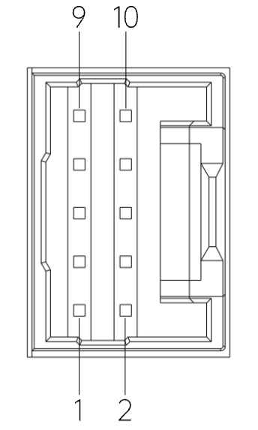 | 1 | NC
 | 2 | PE | Shielding ground
 | 3 | EZ+ | Encoder Z-channel positive input
 | 4 | EZ- | Encoder Z-channel negative input
 | 5 | EB+ | Encoder B-channel positive input
 | 6 | EB- | Encoder B-channel negative input
 | 7 | EA+ | Encoder A-channel positive input
 | 8 | EA- | Encoder A-channel negative input
 | 9 | VCC | Encoder 5V power supply
 | 10 | GND | Encoder 5V power ground

Drive Interface Wiring Diagram
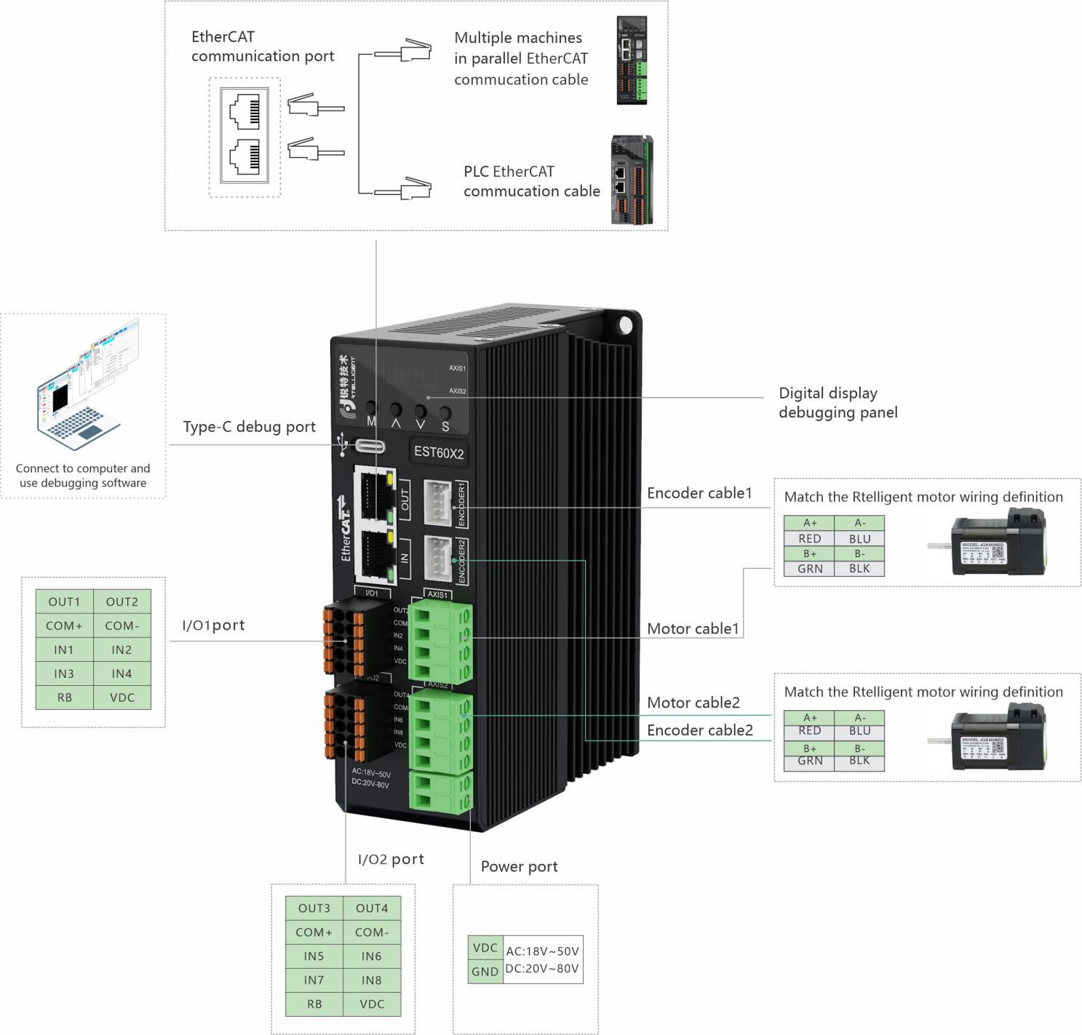

Digital Input/Output Ports
The EST60X2 bus stepper drive features 8 digital input channels and 4 digital output channels.

I/O Port Definitions
Functional Category | Signal Name | Signal Definition | Default Function | Description
Axis 1 Inputs | IN1 | Input 1 | Axis 1 Negative Limit | Voltage: ≤24V;  Only supports common anode positive (NPN);  Not supporting common cathode (PNP).
Axis 1 Inputs | IN2 | Input 2 | Axis 1 Positive Limit
Axis 1 Inputs | IN3 | Input 3 | Axis 1 Home Switch
Axis 1 Inputs | IN4 | Input 4 | Axis 1 Disable
Axis 1 Inputs | COM+ | Input Common Terminal | ---
Axis 2 Inputs | IN5 | Input 5 | Axis 2 Negative Limit | Voltage: ≤24V;  Only supports common anode positive (NPN);  Not supporting common cathode (PNP).
Axis 2 Inputs | IN6 | Input 6 | Axis 2 Positive Limit
Axis 2 Inputs | IN7 | Input 7 | Axis 2 Home Switch
Axis 2 Inputs | IN8 | Input 8 | Axis 2 Disable
Axis 2 Inputs | COM+ | Input Common Terminal | ---
Axis 1 Outputs | OUT1 | Output 1 | Axis 1 Alarm Output | Voltage: ≤24V;  common cathode output;  Current capacity:  OUT1: 30mA max;  OUT2: 100mA max.
Axis 1 Outputs | OUT2 | Output 2 | Axis 1 Positioning completed Output
Axis 1 Outputs | COM- | Output Common Terminal | ---
Axis 2 Outputs | OUT3 | Output 3 | Axis 2 Alarm Output | Voltage: ≤24V;  common cathode output;  Current capacity:  OUT1: 30mA max;  OUT2: 100mA max.
Axis 2 Outputs | OUT4 | Output 4 | Axis 2 Positioning completed Output
Axis 2 Outputs | COM- | Output Common Terminal | ---
Brake Interface | RB | Brake Negative Terminal | --- | Direct 24V brake connection (built-in drive);  No external relay required.
Brake Interface | VDC | Brake Positive Terminal | ---

Digital Input Ports
The EST60X2 bus stepper drive provides 8 digital input channels (IN1~IN8), allocated to two axes: IN1~IN4 for Axis 1. IN5~IN8 for Axis 2
Input Function Configuration: Axis 1: Set via object dictionary 0x2007. Axis 2: Set via object dictionary 0x2807.
Axis 1 input port function settings:
Object Dictionary | Name | Attribute | Type | Range | Default Value | Unit
0x2007:01 | Input 1 Function | R/W/S | UINT | 0~8 | 1 | ---
0x2007:02 | Input 2 Function | R/W/S | UINT | 0~8 | 2 | ---
0x2007:03 | Input 3 Function | R/W/S | UINT | 0~8 | 3 | ---
0x2007:04 | Input 4 Function | R/W/S | UINT | 0~8 | 6 | ---
Axis 2 Input Port Function Settings:
Object Dictionary | Name | Attribute | Type | Range | Default Value | Unit
0x2807:01 | Input 1 Function | R/W/S | UINT | 0~8 | 1 | ---
0x2807:02 | Input 2 Function | R/W/S | UINT | 0~8 | 2 | ---
0x2807:03 | Input 3 Function | R/W/S | UINT | 0~8 | 3 | ---
0x2807:04 | Input 4 Function | R/W/S | UINT | 0~8 | 6 | ---

The digital input port functions are configured through the following value assignments:
Value | Function
0 | General-purpose input
1 | Negative limit input
2 | Positive limit input
3 | Homing (origin) signal input
4 | Fault reset (clear errors)
5 | Emergency stop signal
6 | Motor disable (OFF)
7 | Probe 1 input
8 | Probe 2 input
The input port status of Axis 1 can be read through object 0x60FD, while Axis 2 input port status is read through object 0x68FD.
The polarity configuration for Axis 1 input ports is set via object 0x2008, and for Axis 2 input ports via object 0x2808.
Object Dictionary | Name | Attribute | Type | Range | Default Value | Unit
0x2008 | Inputs Polarity | R/W/S | UINT | 0~0xF | 0xF | ---
0x2808 | Inputs Polarity | R/W/S | UINT | 0~0xF | 0xF | ---
The polarity of each input port is defined by corresponding bits, where Bit 0 defines the polarity of input 1:
Bit15~Bit4 | Bit3 | Bit2 | Bit1 | Bit0
--- | IN4、IN8 | IN3、IN7 | IN2、IN6 | IN1、IN5
0 - Normally Closed (NC)
1 - Normally Open (NO)
The default polarity for all input ports is Normally Open (NO). The default value of object 0x2008 is hexadecimal F (decimal 15). To change the polarity of IN3 (positive limit) and IN4 (negative limit) to Normally Closed (NC), set the corresponding Bit 0 and Bit 1 to 0.

IN1~IN8 single-ended input terminals:
Taking IN1 as an example, the interface circuits from IN1 to IN8 are the same.
When the host device has relay output:
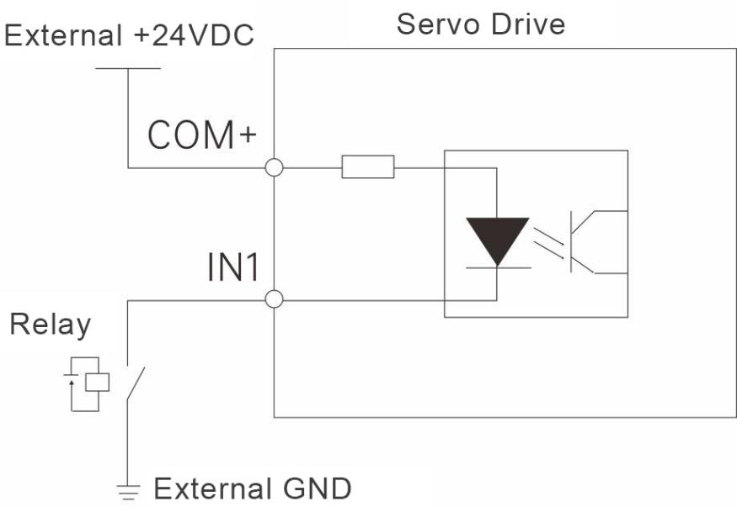
When the host device has open-collector output:
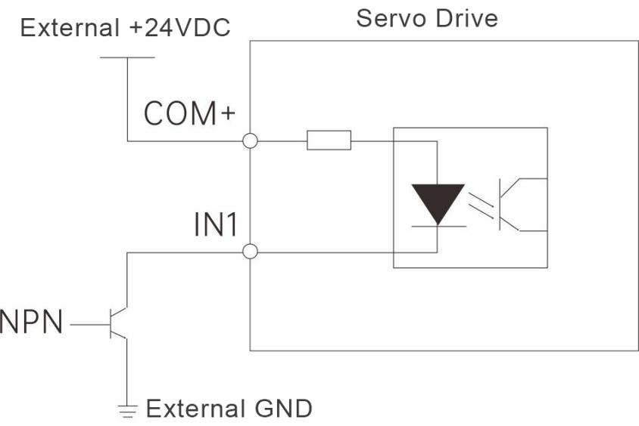
Note: PNP input is not supported.

Digital Output Ports
The EST60X2 features four optically isolated digital output signals.
OUT1 and OUT3 support a maximum output current of 30mA
OUT2 and OUT4 support a maximum output current of 100mA
By default, all digital outputs are configured as normally open (NO) contacts. Their functions can be assigned via:
Object dictionary 0x2005 / 0x2805;
Output polarity is configured through object dictionary 0x2006 / 0x2806.
Axis 1 output ports:
Object Dictionary | Name | Attribute | Type | Range | Default Value | Unit | Remark
0x2005:01 | Output 1 function | R/W/S | UINT | 0~3 | 1 | --- | Output port function selection:  0 - Custom output  1 -Alarm output  3 -Positioning completed output
0x2005:02 | Output 2 function | R/W/S | UINT | 0~3 | 3 | ---
0x2006 | Output polarity setting | R/W/S | UINT | 0~3 | 3 | --- | Set output port characteristics (NO/NC Selection):  0: Normally Closed (NC)  1: Normally Open (NO)

Axis 2 output ports:
Object Dictionary | Name | Attribute | Type | Range | Default Value | Unit | Remark
0x2805: 01 | Output 1 Function | R/W/S | UINT | 0~3 | 1 | --- | Output port function selection:  0: Custom output  1: Alarm output  3: Positioning completed output
0x2805: 02 | Output 2 Function | R/W/S | UINT | 0~3 | 3 | ---
0x2806 | Output Polarity Setting | R/W/S | UINT | 0~3 | 3 | --- | Set output port characteristics (NO/NC Selection):  0: Normally Closed (NC)  1: Normally Open (NO)
Taking OUT1 as an example, the interface circuits from OUT1 to OUT4 are the same:
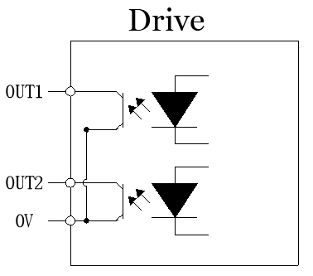
When connected to relay input devices:
Correct wiring diagram:
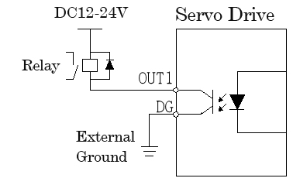

Wrong Wiring Diagram:
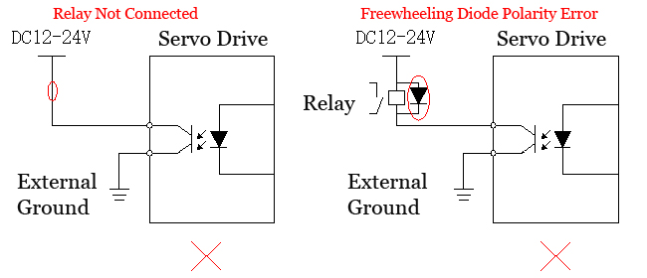
When the host device is optocoupler input:
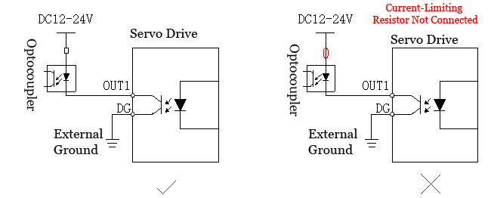

Brake Wiring Diagram
The brake is connected directly to the drive's I/O terminals as follows:
VDC → Brake positive terminal (typically red wire)
RB → Brake negative terminal (typically black wire)
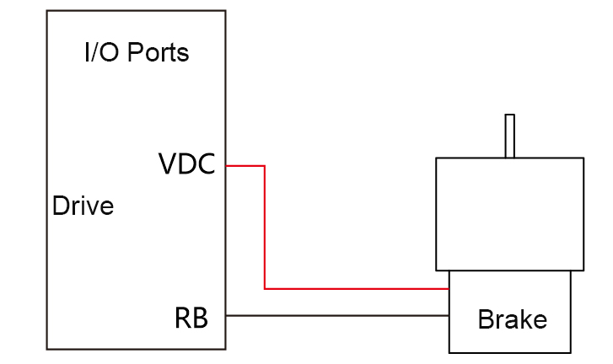

Mechanical Dimensions
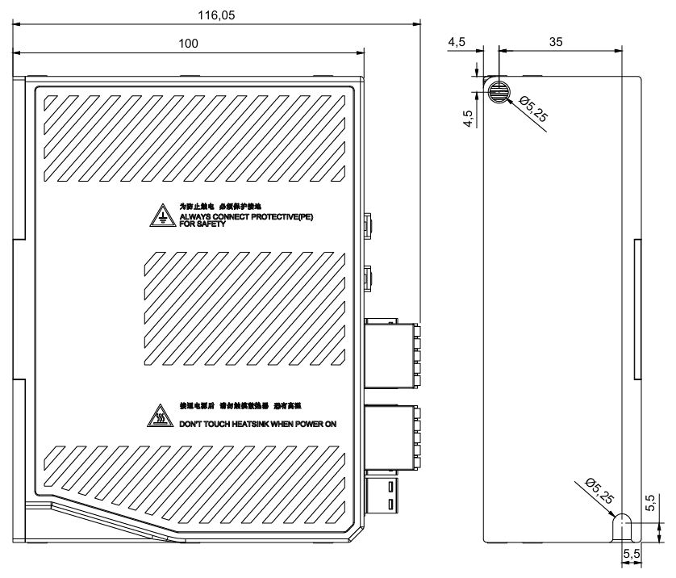
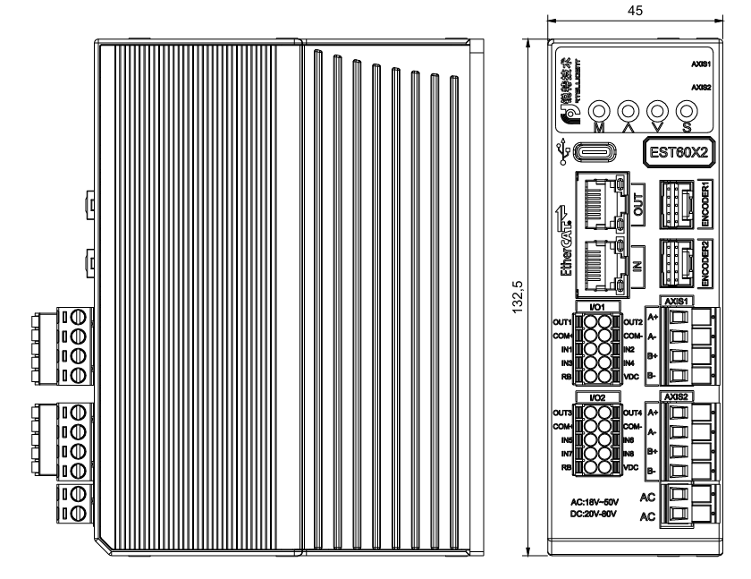

Control Panel

Panel Overview

Panel Components
The drive's display panel consists of four buttons and a 5-digit LED display for status monitoring, test running, parameter management and other functions. The four buttons are labeled as follows:
Functional Category | Symbol | Description | Illustration
Mode/Return/Shift | M | Long press to switch/return, short press to shift | 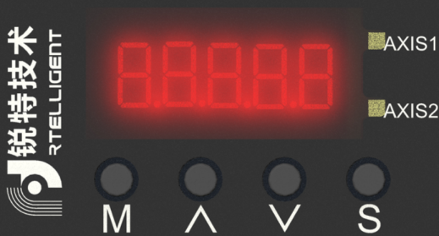
Increase | ▲ | Upward selection/increase value
Decrease | ▼ | Downward selection/decrease value
Confirm | S | Confirm operation
Axis 1 indicator | AXIS1 | Green steady light when enabled
Axis 2 indicator | AXIS2 | Green steady light when enabled

Panel Display Contents
During operation, the LED display provides real-time monitoring and configuration functions including: operational status monitoring, parameter value display, functional testing operations, parameter management, encoder adjustment, and open-loop operation.
- Status monitoring: Displays the drive's current operating status
- Parameter display: Shows configured control parameter values
- Functional display: Enables internal test-run operations
- Parameter management: Manages drive control parameters
- Encoder adjustment & open-loop operation: Manufacturer-reserved functions

Panel Operation
The control panel operation flow for the drive is as follows:
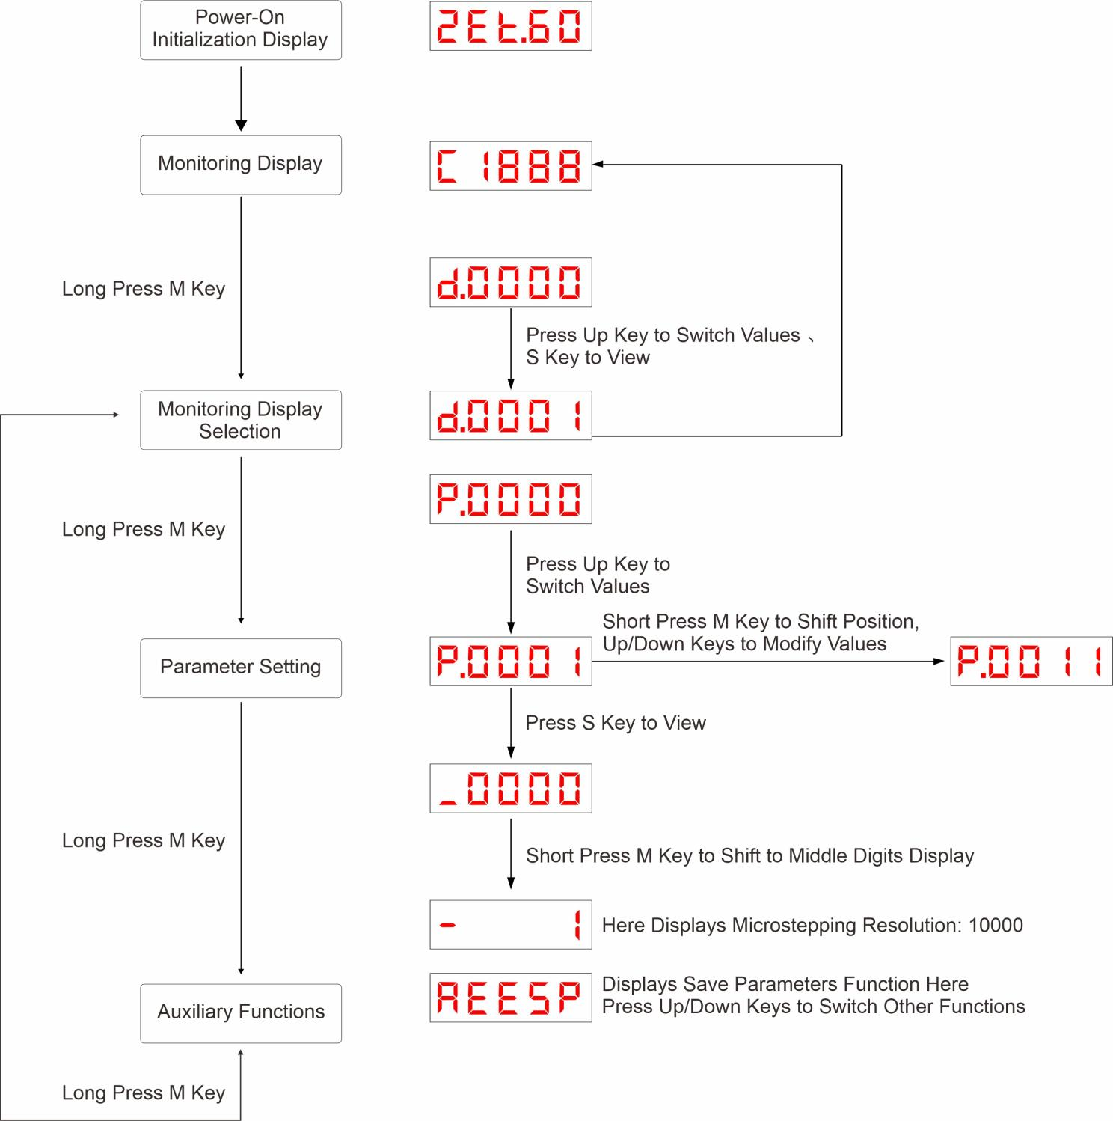
- Power-On initialization: After power is connected and initialization completes, the panel display automatically enters monitoring mode.
- Mode navigation: Long-press "MODE" to switch between display modes or return to the previous menu level.
- Fault display priority: If a fault occurs, the drive automatically switches to show the fault code.

Data Display
Display rules for different data lengths and negative numbers:
- For signed numbers ≤4 digits or unsigned numbers ≤5 digits:
Displayed directly on the 5-digit LED display.For signed numbers, the highest digit shows "–" to indicate a negative value.
- Example displays: -6666 is displayed as:
- 65535 is displayed as:
- For signed numbers >4 digits or unsigned numbers >5 digits:
Displayed in paged format, showing 4 digits per page from LSB (Least Significant Bits) to MSB (Most Significant Bits). Display method: Current page number + Current page value, use the shift key (short press) to toggle between pages.
Example displays:
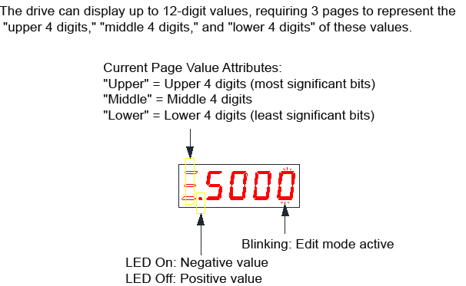

- Example displays: 1073741824 is displayed as:
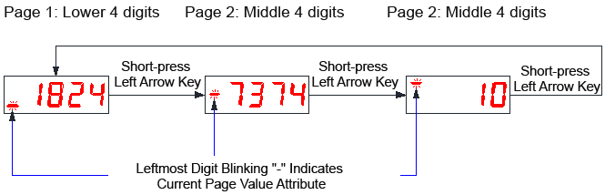
- Example displays:-1073741824 is displayed as:
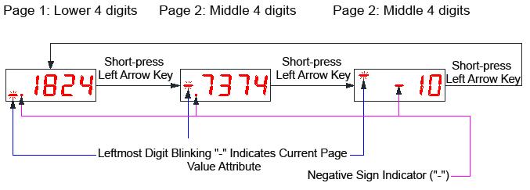

Fault Display
When the drive is in an error state, the LED panel displays relevant fault information. If multiple fault alarms occur simultaneously, the drive panel will cycle through each alarm indication sequentially.
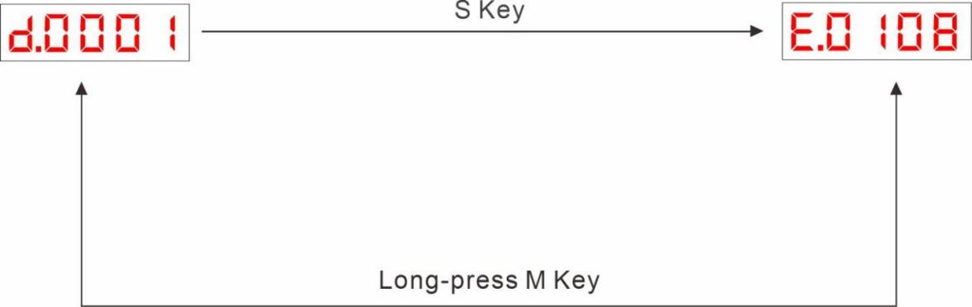
- For specific fault information, please refer to the related content in Section 2.4.1.

Monitoring Display
The monitoring display is used to monitor the operational status of the drive. After the drive completes power-on initialization, the display will show the monitored values of these objects. Specific details of the monitoring display are as follows:
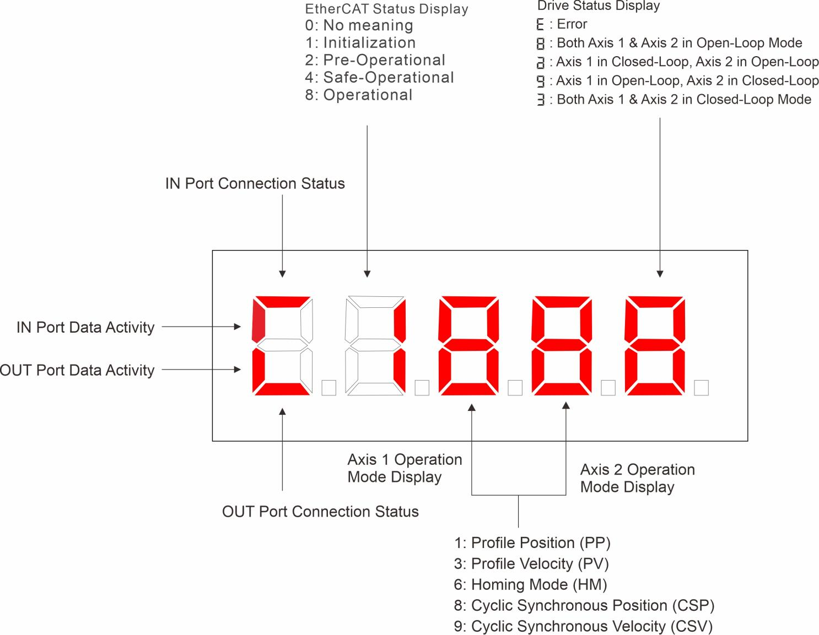
- For related monitored values, please refer to the relevant content in Section 2.4.2.

Communication Operation Status
The communication status, drive status, and connection status are displayed on the same interface. The second digit from the left on the 5-digit LED panel displays the slave's EtherCAT state machine status in character format.
Alternatively, under the speed monitoring interface: The decimal point of the first digit from the left on the 5-digit LED indicates the EtherCAT operation status, defined as follows:
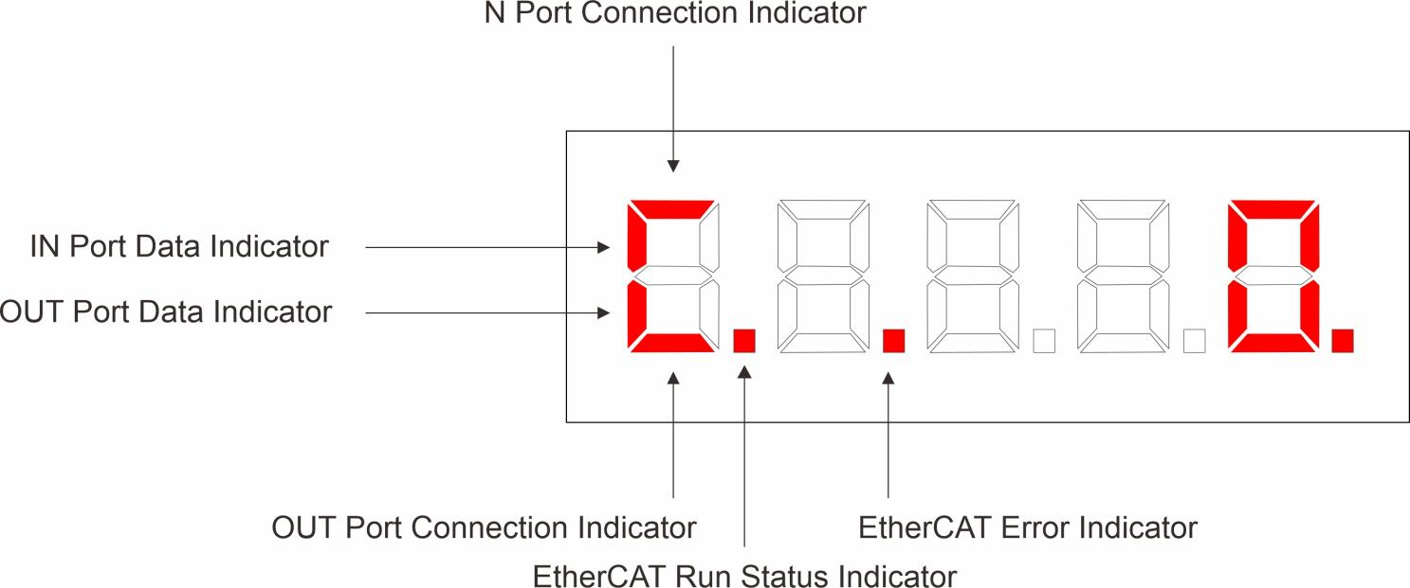
LED | State | Description
EtherCAT Run Indicator | Off | （Initialization State)
EtherCAT Run Indicator | Slow blink | （Pre-Operational State）
EtherCAT Run Indicator | Single blink | （Safe-Operational State）
EtherCAT Run Indicator | Steady on | （Operational State）
EtherCAT Error Indicator | Off | No error
EtherCAT Error Indicator | Slow blink | General error
EtherCAT Error Indicator | Single blink | Synchronization error
EtherCAT Error Indicator | Double blink | Watchdog error
- Fast Blink: 50ms ON / 50ms OFF 10Hz
- Slow Blink: 200ms ON / 200ms OFF 2.5Hz
- Single Blink: 200ms ON / 1000ms OFF
- Double Blink: 200ms ON / 200ms OFF / 200ms ON / 1000ms OFF

Parameter Settings
Parameters can be configured using the drive's control panel. For detailed parameter descriptions, please refer to Section 2.4.3.
Example: Modifying parameter P.0001 (Command pulses per motor revolution)
Default value: 10,000 → Modified value: 5,000
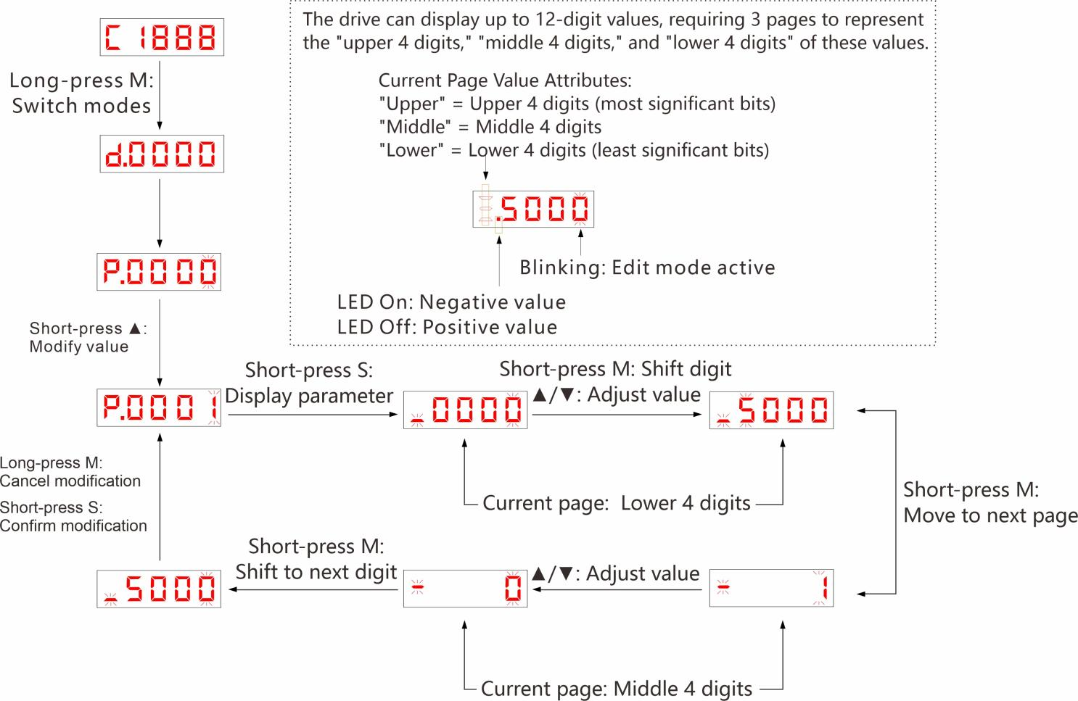

Auxiliary Functions

Parameter Management
Save parameters: Enter the A.EESP interface and briefly press the S key.
Restore factory settings: Enter the A.rESP interface and briefly press the S key.

Soft Reset
Soft reset: Enter the A.rStC interface and briefly press the S key.

Jog Test Operation
This function allows test operation of the drive. The procedure is as follows:
Long press the M key to switch to the A interface.
Use the Up/Down keys to navigate to the A.JoG1 page.
If the drive has no alarms and is not enabled, briefly press the S key. The LED panel will display the default JOG speed of 100 rpm.
Adjust the value using the Up/Down keys, then press S to confirm.
The LED panel will display "READY", and motor operation can then be controlled via the Up/Down keys.
- Note: Disable the bus enable command before performing this operation. A.JoG1 is for Axis 1 test operation, A.JoG2 for Axis 2, and A.JoGA for synchronous dual-axis test operation

Numeric Addresses

Fault Display Codes
- E.0101: Indicates Axis 1 internal voltage error; E.1001: Indicates Axis 2 internal voltage error.
- E.1101: Indicates both Axis 1 and Axis 2 internal voltage errors.
Parameter Index | Description
E.0101 | Axis 1 Internal Voltage Error
E.0102 | Axis 1 Overcurrent Error
E.0103 | Axis 1 Overvoltage Error
E.0104 | Axis 1 Undervoltage Error
E.0106 | Axis 1 Parameter Storage Error
E.0107 | Axis 1 Motor Phase Error
E.0108 | Axis 1 Tracking Error Exceeds the Limit
E.0109 | Axis 1 Encoder Phase Anomaly
E.0110 | Axis 1 EtherCAT Initialization Failure
E.0111 | Axis 1 EtherCAT PHY Communication Error (Initialization OK)
E.1001 | Axis 2 Internal Voltage Error
E.1002 | Axis 2 Overcurrent Error
E.1003 | Axis 2 Overvoltage Error
E.1004 | Axis 2 Undervoltage Error
E.1006 | Axis 2 Parameter Storage Error
E.1007 | Axis 2 Motor Phase Error
E.1008 | Axis 2 Tracking Error Exceeds the Limit
E.1009 | Axis 2 Encoder Phase Anomaly
E.1010 | Axis 2 EtherCAT Initialization Failure
E.1011 | Axis 2 EtherCAT PHY Communication Error (Initialization OK)

Monitoring Display Parameters
Monitor Address | Description | Unit
d.0000 | Drive operation status | -
d.0001 | Bitwise fault code decoding | -
d.0002 | Axis 1 motor speed | rpm
d.0003 | Axis 1 pulse command speed | rpm
d.0004 | Axis 1 DC bus voltage | 0.01V
d.0005 | Axis 1 drive fault code | -
d.0006 | Axis 1 status code | -
d.0007 | Axis 1 CiA402 fault code | -
d.0008 | Axis 1 current input pin signal | -
d.0009 | Axis 1 current output pin signal | -
d.0010 | Axis 1 position error | Encoder Unit
d.0011 | Current synchronization cycle | us
d.0012 | Current ESC register synchronization cycle | us
d.0013 | DC synchronization flag: 1 = DC sync valid; 0 = DC sync invalid | -
d.0014 | Axis 1 sensor status:  Bit 0: Negative limit (0: invalid; 1: valid);  Bit 1: Positive limit (0: invalid; 1: valid);  Bit 2: Origin (0: invalid; 1: valid). | -
d.0015 | Axis 2 motor speed | rpm
d.0016 | Axis 2 pulse command speed | rpm
d.0017 | Axis 2 drive fault code | -
d.0018 | Axis 2 status code | -
d.0019 | Axis 2 CiA402 fault code | -
d.0020 | Axis 2 current input pin signals | -
d.0021 | Axis 2 current output pin signals | -
d.0022 | Axis 2 position error | Encoder Unit
d.0027 | Axis 2 sensor status:  Bit 0: Negative limit (0: invalid; 1: valid);  Bit 1: Positive limit (0: invalid; 1: valid);  Bit 2: Origin (0: invalid; 1: valid). | -
d.0050 | PWM interrupt entry GPT0 timer count value | -
d.0051 | PWM interrupt entry GPT1 timer count value | -
d.0052 | PWM interrupt entry GPT11 timer count value | -
d.0053 | PWM interrupt entry GPT12 timer count value | -
d.0054 | SYNC0 cycle time | 0.1us
d.0055 | GPT0 timer count at SYNC0 start | -
d.0056 | GPT0 timer count at SYNC0 end | -
d.0057 | GPT0 timer count at PDI start | -
d.0058 | GPT0 timer count at PDI end | -
d.0059 | SYNC0 interrupt execution time | 0.1us
d.0060 | SYNC0 interrupt execution cycle | 0.1us
d.0061 | PDI0 interrupt execution time | 0.1us
d.0062 | PDI0 interrupt execution cycle | 0.1us
d.0063 | PWM interrupt execution time | 0.1us
d.0064 | PWM interrupt execution cycle | 0.1us
d.0065 | GPT11 captured value at SYNC0 generation | -
d.0066 | GPT12 timer count value when capturing SYNC0 signal | -
d.0067 | SYNC0 real-time sync cycle deviation | 0.1us
d.0068 | SYNC0 maximum sync deviation | 0.1us
d.0069 | GPT0 cycle | 0.1us
d.0070 | GPT1 cycle | 0.1us
d.0071 | GPT11 cycle | 0.1us
d.0072 | GPT12 cycle | 0.1us
d.0073 | Sync compensation overflow counter | -
d.0074 | ESC configuration register | -

Parameter Settings
Parameter range allocation:
P0000–P0059: Axis 1 parameters. P0200–P0259: Axis 2 parameters. Descriptions is as belows.
Parameter Index | Description | Range | Default Value | Unit
P.0000 | Axis 1 peak current | 0~7500 | 3000 | mA
P.0001 | Axis 1 micro-stepping resolution | 0~65535 | 10000 | Pulse/rev
P.0002 | Axis 1 standby time | 0~65535 | 1000 | ms
P.0003 | Axis 1 standby current percentage | 0~100 | 50 | %
P.0004 | Axis 1 OUT1 function | 0~31 | 1 | ---
P.0005 | Axis 1 OUT2 function | 0~31 | 3 | ---
P.0006 | Axis 1 output polarity | 0~15 | 3 | ---
P.0007 | IN3 function | 0~31 | 1 | ---
P.0008 | IN4 function | 0~31 | 2 | ---
P.0009 | IN5 function | 0~31 | 3 | ---
P.0010 | IN6 function | 0~31 | 6 | ---
P.0011 | Axis 1 input polarity | 0~15 | 15 | ---
P.0012 | Axis 1 smoothing filter time | 0~25600 | 25600 | us
P.0013 | Axis 1 motor lock ramp time | 0~65535 | 1000 | 50us
P.0014 | Axis 1 auto PI enable | 0~1 | 1 | ---
P.0015 | Axis 1 current loop Kp | 0~65535 | 1000 | ---
P.0016 | Axis 1 current loop Ki | 0~65535 | 200 | ---
P.0017 | Axis 1 current loop Kc | 0~65535 | 256 | ---
P.0018 | Axis 1 motor type:  0: Two phase;  1: Three phase. | 0~1 | 0 | ---
P.0019 | Axis 1 auto-tuned resistance | 0~65535 | 1000 | mOhm
P.0020 | Axis 1 auto-tuned inductance | 0~65535 | 1 | mH
P.0021 | Axis 1 set motor resistance | 0~65535 | 1000 | mOhm
P.0022 | Axis 1 set motor inductance | 0~65535 | 1 | mH
P.0023 | Axis 1 motor back-EMF constant | 0~65535 | 256 | ---
P.0024 | Axis 1 motor direction invert | 0~1 | 0 | ---
P.0025 | Axis 1 fault code | 0~65535 | 0 | ---
P.0026 | Axis 1 status code | 0~65535 | 0 | ---
P.0027 | Axis 1 home position address | 0~65535 | 0 | ---
P.0028 | Axis 1 control/drive mode | 0~9 | 1 | ---
P.0029 | Axis 1 encoder resolution | 0~65535 | 4000 | Pulse/rev
P.0030 | Axis 1 encoder count | 0~65535 | 0 | Pulse/rev
P.0031 | Axis 1 tracking error threshold L | -65535~65535 | 4000 | Pulse/rev
P.0032 | Axis 1tracking error threshold H | - | -
P.0033 | Axis 1 servo mode 1 - Kp | 0~65535 | 2000 | ---
P.0034 | Axis 1 servo mode 1 - Ki | 0~65535 | 0 | ---
P.0035 | Axis 1 servo mode 1 - Kv | 0~65535 | 100 | ---
P.0036 | Axis 1 servo mode 1 - Kvff | 0~65535 | 30 | ---
P.0037 | Axis 1 servo mode 1 - Kdi | 0~65535 | 0 | ---
P.0038 | Axis 1 positioning output mode | 0~65535 | 0 | ---
P.0039 | Axis 1 positioning error | 0~65535 | 10 | ---
P.0040 | Axis 1 pulse stop detection time | 0~65535 | 1000 | ---
P.0041 | Axis 1 velocity LPF frequency 1 | 0~65535 | 200 | ---
P.0042 | Axis 1 velocity LPF frequency 2 | 0~65535 | 600 | ---
P.0043 | Axis 1 position loop output LPF frequency | 0~65535 | 2000 | ---
P.0049 | Axis 1 command speed monitoring | 0~65535 | 0 | RPM
P.0050 | Axis 1 feedback speed | 0~65535 | 0 | RPM
P.0051 | Axis 1 DC bus voltage | 0~9999 | 0 | 10mv
P.0052 | Axis 1 DI input status monitor | 0~65535 | 0 | ---
P.0053 | Axis 1 DO output status monitor | 0~65535 | 0 | ---
P.0054 | Axis 1 fault detection enable | 0~65535 | 128 (0x0080) | ---
P.0055 | Axis 1 Micro-stepping Mode | 0~65535 | 0 | ---
P.0059 | Axis 1 DI port digital filter time | 0~65535 | 5 | ms
P.0060 | EtherCAT slave alias address | 0~65535 | 1001 | ---
P.0061 | EtherCAT alias source setting | 0~1 | 0 | ---
P.0062 | Servo drive ID | 0~65535 | 2Et60 (0x12) | ---
P.0063 | MCU firmware version | 0~65535 | 502 | ---
P.0064 | Hardware version | 0~65535 | 500 | ---
P.0065 | Homing mode selection | 0~65535 | 0 | ---
P.0066 | ECAT TXCLK transmission delay | 0~3 | 0 | ---
P.0067 | ECAT sync error alarm threshold | 0~65535 | 0 | ---
P.0068 | Current EtherCAT slave alias | 0~65535 | 0 | ---
P.0069 | Master-Assigned station address | 0~65535 | 0 | ---
P.0070 | LED default monitoring index | 0~65535 | 0 | ---
P.0090 | Save parameters | 0~65535 | 0 | ---
P.0091 | Restore factory defaults | 0~65535 | 0 | ---
P.0100 | ECAT port 0 invalid frame count | 0~65535 | 0 | ---
P.0101 | ECAT port 0 RX error count | 0~65535 | 0 | ---
P.0102 | ECAT port 1 invalid frame count | 0~65535 | 0 | ---
P.0103 | ECAT port 1 RX error count | 0~65535 | 0 | ---
P.0104 | ECAT port 0 forwarding error count | 0~65535 | 0 | ---
P.0105 | ECAT port 1 forwarding error count | 0~65535 | 0 | ---
P.0106 | ECAT processing error count | 0~65535 | 0 | ---
P.0107 | ECAT MCU-to-ESC PDI communication error count | 0~65535 | 0 | ---
P.0108 | ECAT port 0 link loss count | 0~65535 | 0 | ---
P.0109 | ECAT port 1 link loss count | 0~65535 | 0 | ---
P.0200 | Axis 2 peak current | 0~7500 | 3000 | mA
P.0201 | Axis 2 micro-stepping resolution | 0~65535 | 10000 | Pulse/rev
P.0202 | Axis 2 standby time | 0~65535 | 1000 | ms
P.0203 | Axis 2 standby current (%) | 0~100 | 50 | %
P.0204 | OUT3 function | 0~31 | 1 | ---
P.0205 | OUT4 function | 0~31 | 3 | ---
P.0206 | Axis 2 output polarity | 0~15 | 3 | ---
P.0207 | IN5 function | 0~31 | 1 | ---
P.0208 | IN6 function | 0~31 | 2 | ---
P.0209 | IN7 function | 0~31 | 3 | ---
P.0210 | IN8 function | 0~31 | 6 | ---
P.0211 | Axis 2 input polarity | 0~15 | 15 | ---
P.0212 | Axis 2 smoothing filter time | 0~25600 | 25600 | us
P.0213 | Axis 2 motor lock ramp time | 0~65535 | 1000 | 50us
P.0214 | Axis 2 auto PI enable | 0~1 | 1 | ---
P.0215 | Axis 2 current loop Kp | 0~65535 | 1000 | ---
P.0216 | Axis 2 current loop Ki | 0~65535 | 200 | ---
P.0217 | Axis 2 current loop Kc | 0~65535 | 256 | ---
P.0218 | Axis 2 motor type：  0: 2-phase; 1: 3-phase | 0~1 | 0 | ---
P.0219 | Axis 2 auto-tuned resistance | 0~65535 | 1000 | mOhm
P.0220 | Axis 2 auto-tuned inductance | 0~65535 | 1 | mH
P.0221 | Axis 2 set motor resistance | 0~65535 | 1000 | mOhm
P.0222 | Axis 2 set motor inductance | 0~65535 | 1 | mH
P.0223 | Axis 2 motor Back-EMF constant | 0~65535 | 256 | ---
P.0224 | Axis 2 motor direction invert | 0~1 | 0 | ---
P.0225 | Axis 2 fault code | 0~65535 | 0 | ---
P.0226 | Axis 2 status code | 0~65535 | 0 | ---
P.0227 | Axis 2 home position address | 0~65535 | 0 | ---
P.0228 | Axis 2 control/drive mode | 0~9 | 1 | ---
P.0229 | Axis 2 encoder resolution | 0~65535 | 4000 | Pulse/rev
P.0230 | Axis 2 encoder count | 0~65535 | 0 | Pulse/rev
P.0231 | Axis 2 tracking error threshold L | -65535~65535 | 4000 | Pulse/rev
P.0232 | Axis 2 tracking error threshold H | - | -
P.0233 | Axis 2 servo mode 1 - Kp | 0~65535 | 2000 | ---
P.0234 | Axis 2 servo mode 1 - Ki | 0~65535 | 0 | ---
P.0235 | Axis 2 servo mode 1 - Kv | 0~65535 | 100 | ---
P.0236 | Axis 2 servo mode 1 - Kvff | 0~65535 | 30 | ---
P.0237 | Axis 2 Servo Mode 1 - Kdi | 0~65535 | 0 | ---
P.0238 | Axis 2 positioning completed output mode | 0~65535 | 0 | ---
P.0239 | Axis 2 positioning error | 0~65535 | 10 | ---
P.0240 | Axis 2 pulse stop detection time | 0~65535 | 1000 | ---
P.0241 | Axis 2 velocity LPF frequency 1 | 0~65535 | 200 | ---
P.0242 | Axis 2 velocity LPF frequency 2 | 0~65535 | 600 | ---
P.0243 | Axis 2 position loop output LPF frequency | 0~65535 | 2000 | ---
P.0249 | Axis 2 command speed monitoring | 0~65535 | 0 | RPM
P.0250 | Axis 2 feedback speed | 0~65535 | 0 | RPM
P.0251 | Axis 2 DC bus voltage | 0~9999 | 0 | 10mv
P.0252 | Axis 2 DI input status monitor | 0~65535 | 0 | ---
P.0253 | Axis 2 DO output status monitor | 0~65535 | 0 | ---
P.0254 | Axis 2 fault detection enable | 0~65535 | 128 (0x0080) | ---
P.0255 | Axis 2 micro-stepping mode | 0~65535 | 0 | ---
P.0259 | Axis 2 DI port digital filter time | 0~65535 | 5 | ms

EtherCAT Communication

Communication Overview
EtherCAT communication is a highly efficient, low-latency real-time industrial Ethernet protocol specifically designed for automation applications. It supports various network topologies including linear, star, tree, and ring configurations to accommodate different scale network requirements. Through integrated timestamping and clock synchronization functions, EtherCAT provides precise synchronization between nodes, making it ideal for applications demanding high timing accuracy such as multi-axis control and distributed data acquisition. Additionally, EtherCAT supports redundancy mechanisms like dual network cards and ring redundancy to enhance system stability and reliability. For stepper drives, EtherCAT communication offers stronger anti-interference capability, reduced sensitivity to EMC issues, and enables more precise control and synchronization, thereby improving overall system performance and stability.

Communication Setup
Please use CAT5E (or higher grade) Ethernet cables.
Connect the Ethernet IN port to the controller or the OUT port of the previous drive on the bus. Connect the Ethernet OUT port to the IN port of the next drive on the bus. If the drive is the last node on the bus, only the Ethernet IN port needs to be connected.

EtherCAT Status LEDs
The green LED on the RJ45 indicates Link status, showing whether an Ethernet cable is connected.
The yellow LED indicates activity status, showing whether data communication is occurring.
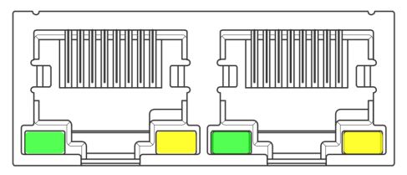

EtherCAT Site Address
The EST60X2 drive supports two methods for setting the slave address: setting the site alias using the object dictionary 0x2150 and setting the site alias using ESC, and selecting through the object dictionary 0x2151.
By default, 0x2151 is set to 0, indicating the node address is assigned by the master station and stored in EEPROM.
When users need to manually configure a fixed address, they must first set 0x2151 to 1, then write the desired address value to 0x2150.
0x2151 | 0x2150 | Site Address
0 | 1001 | Configure the site alias of the master station to the EEPROM 0x0004 address of ESC.
1 | Set value | The setting value for object dictionary 2150 is the node address value.

Object Dictionary

General Parameters

0x1000 Device Type
Object Type | Data Type | Access Type | PDO Mapping | Default Value
VAR | UNSIGNED32 | RO | NO | 0x00040192
Bit 0~15：Device profile number 0x0192: CiA402
Bit 16~31：Additional information 0x0004: Stepper Drive

0x1008 Device Name
Displays the current drive model name.
Object Type | Data Type | Access Type | PDO Mapping | Default Value
VAR | Visible string | RO | NO | EST60X2

0x1009 Hardware Version
Object Type | Data Type | Access Type | PDO Mapping | Default Value
VAR | Visible string | RO | NO | 40

0x100A Software Version
Object Type | Data Type | Access Type | PDO Mapping | Default Value
VAR | Visible string | RO | NO | 4000

0x1010 Save Parameters ---- MODBUS Address: 90
Object Dictionary 0x1010 Sub-Index: Write “1” in “01” to save current parameters.
Note: Stop motor operation before saving parameters.

Data Structure:
Index | Sub-Index | Name | PDO Mapping | Default Value
1010 | 01 | Save Parameters | No | 0

0x1011 Restore Factory Defaults ---- MODBUS Address: 91
Object Dictionary 0x1011 Sub-Index: Write “1” in “01” to restore drive to factory default settings.
Note: STOP motor operation before initiating factory reset
Index | Sub-Index | Name | PDO Mapping | Default Value
1011 | 01 | Restore Default Parameters | No | 0

Manufacturer Specific Objects
Axis 2 Manufacturer Object Address = Axis 1 Manufacturer Object Address + 0x800
Example:
- 0x2000: Configures motor operating current for Axis 1
- 0x2800: Configures motor operating current for Axis 2

0x2000Peak Current - MODBUS Address:：0
Object Dictionary | Name | Attribute | Type | Range | Default Value | Unit
0x2000 | Peak Current | R/W/S | UINT | 0~7000 | 3000 | mA
This object is used to set the sinusoidal peak current for stepper motor operation in open-loop mode. When matching with smaller motors, please adjust the current before connecting the motor to prevent motor damage due to excessive current.

0x2001 Micro-stepping (Subdivision) - MODBUS Address: 1
Object Dictionary | Name | Attribute | Type | Range | Default Value | Unit
0x2001 | Motor Resolution | R/W/S | UINT | 0~65535 | 10000 | Pulse/rev
This object sets the number of pulses required for one full motor revolution in open-loop mode. In closed-loop mode, the micro-stepping resolution is determined by 0x2020 (encoder resolution). To modify micro-stepping in closed-loop mode, first set 0x2057 to 1, then adjust 0x2001. Direct modification of 0x2020 is prohibited as it may cause closed-loop operation failure.

0x2002 Standby Time - MODBUS Address: 2
Object Dictionary | Name | Attribute | Type | Range | Default Value | Unit
0x2002 | Idle Time | R/W/S | UINT | 0~65535 | 1000 | ms
This object is used to set the time for the stepper motor to enter standby mode after it stops running during open-loop operation.

0x2003 Standby Current Percentage - MODBUS Address: 3
Object Dictionary | Name | Attribute | Type | Range | Default Value | Unit
0x2003 | Idle Current Percent | R/W/S | UINT | 0~100 | 50 | %
This object sets the holding current percentage (relative to the operating current configured in 0x2000) when the stepper motor enters standby mode after stopping in open-loop operation.

0x2005 / 0x2805 Output Port Function - MODBUS Addresses: 4-5
Axis 1 output port function
Object Dictionary | Name | Attribute | Type | Range | Default Value | Unit
0x2005:01 | Output 1 Function | R/W/S | UINT | 0~31 | 1 | ---
0x2005:02 | Output 2 Function | R/W/S | UINT | 0~31 | 3 | ---

Axis 2 output port function
Object Dictionary | Name | Attribute | Type | Range | Default Value | Unit
0x2805:01 | Output 1 Function | R/W/S | UINT | 0~31 | 1 | ---
0x2805:02 | Output 2 Function | R/W/S | UINT | 0~31 | 3 | ---
EST60X2 contains four output ports, and this object is used to configure the corresponding functions of these output ports.
Port function definitions:
Value | Function
0 | Customized output
1 | Alarm output
3 | Positioning completed output
When configured as a custom output, the port state can be controlled through polarity settings in registers 0x2006 and 0x2806.

0x2006 & 0x2806 Output Port Polarity - MODBUS Address: 6
Axis 1 output port polarity:
Object Dictionary | Name | Attribute | Type | Range | Default Value | Unit
0x2006 | Outputs Polarity | R/W/S | UINT | 0~31 | 3 | ---
Axis 2 output port polarity:
Object Dictionary | Name | Attribute | Type | Range | Default Value | Unit
0x2806 | Outputs Polarity | R/W/S | UINT | 0~31 | 3 | ---
Configure normally open/closed characteristics of output ports: Bit0 sets polarity for output 1, Bit1 for output 2 (0=NC, 1=NO).
Bit15~bit2 | Bit1 | Bit0
--- | OUT2、OUT4 | OUT1、OUT3

0x2007 0x2807 Input Port Function -- MODBUS Address: 7-10
Axis 1 input port function:
Object Dictionary | Name | Attribute | Type | Range | Default Value | Unit
0x2007:01 | Input 1 Function | R/W/S | UINT | 0~8 | 1 | ---
0x2007:02 | Input 2 Function | R/W/S | UINT | 0~8 | 2 | ---
0x2007:03 | Input 3 Function | R/W/S | UINT | 0~8 | 3 | ---
0x2007:04 | Input 4 Function | R/W/S | UINT | 0~8 | 6 | ---
Axis 2 input port function:
Object Dictionary | Name | Attribute | Type | Range | Default Value | Unit
0x2807:01 | Input 5 Function | R/W/S | UINT | 0~8 | 1 | ---
0x2807:02 | Input 6 Function | R/W/S | UINT | 0~8 | 2 | ---
0x2807:03 | Input 7 Function | R/W/S | UINT | 0~8 | 3 | ---
0x2807:04 | Input 8 Function | R/W/S | UINT | 0~8 | 6 | ---
EST60X2 includes 8 input ports. This object is used to configure the corresponding functions of the input ports.
Value | Function
0 | General-purpose input
1 | Negative limit input
2 | Positive limit input
3 | Home signal input
4 | Fault reset
5 | Emergency stop (E-stop) signal
6 | Motor disable
7 | Probe 1
8 | Probe 2
The input port status of Axis 1 is read through object 0x60FD, and Axis 2's is read through 0x68FD.
The input port polarity of Axis 1 is set via object 0x2008, and Axis 2's via 0x2808

0x2008 0x2808 Input Port Polarity -- MODBUS Address: 11
Object Dictionary | Name | Attribute | Type | Range | Default Value | Unit
0x2008 | Inputs Polarity | R/W/S | UINT | 0~F | 0xF | ---
0x2808 | Inputs Polarity | R/W/S | UINT | 0~F | 0xF | ---
Each bit defines the polarity of the corresponding input port. Bit 0 configures the polarity of Input Port 1:
Bit15~bit4 | Bit3 | Bit2 | Bit1 | Bit0
--- | IN4、IN8 | IN3、IN7 | IN2、IN6 | IN1、IN5
0 = Normally Closed (NC), 1 = Normally Open (NO)

0x2009 Filter Time -- MODBUS Address: 12
Object Dictionary | Name | Attribute | Type | Range | Default Value | Unit
0x2009 | Filter Time | R/W/S | UINT | 0~25600 | 25600 | us
EST60X2 integrates a moving average filter, and this object configures the filter time. A longer filter time results in smoother motor start/stop operations but increases response lag.
Technical key points analysis: Lag time = Filter time

0x200A Axis Lock Time -- MODBUS Address: 13
Object Dictionary | Name | Attribute | Type | Range | Default Value | Unit
0x200A | Soft lock Time | R/W/S | UINT | 0~65535 | 1000 | us
When enabled, the EST60X2 needs to lock the stepper motor for initial positioning. To reduce startup vibration, the drive incorporates a ramp-based axis lock feature. This object configures the ramp time for motor locking when the motor is enabled.
Lock Time = Set Value × 50μs × 2 = Set Value × 100μs

0x200B Current Loop Parameters -- MODBUS Address: 14-17
Object Dictionary | Name | Attribute | Type | Range | Default Value | Remark
0x200B:01 | AutoPI enable | R/W/S | UINT | 0~1 | 1 | The drive identifies motor parameters and auto-calculates PI gains during initial positioning. 0=Disabled, 1=Enabled.
0x200B:02 | Iloop_Kp | R/W/S | UINT | 100~65535 | 1000 | When 0x200B:01 is 1, this register cannot be set; When it is 0, the user can set it.
0x200B:03 | Iloop_Ki | R/W/S | UINT | 0~10000 | 200
0x200B:04 | Iloop_Kc | R/W/S | UINT | 0~1024 | 256 | Anti-Windup Gain
EST60X2 implements micro-stepping control of stepper motors through current regulation. By default, the EST60X2 employs an auto-tuning algorithm to identify the motor's electrical parameters and automatically compute optimized current loop PI gains.

0x200C Motor Parameter -- MODBUS Address：18-23
Object Dictionary | Name | Attribute | Type | Range | Default Value | Remark
0x200C:01 | Motor type | R/W/S | UINT | 0~1 | 0 | 0: Two-phase stepper motor  1: Three-phase stepper motor (Reserved, currently unavailable)
0x200C:02 | Resistance Auto | R | UINT | 100~65535 | 1000 | Automatically detected when Auto-PI is enabled  Unit: mOhm
0x200C:03 | Inductance Auto | R | UINT | 0~10 | 1 | Automatically detected when Auto-PI is enabled  Unit: mH
0x200C:04 | Resistance Set | R/W/S | UINT | 0~  10000 | 1000 | Motor winding resistance  Unit: mOhm
0x200C:05 | Inductance Set | R/W/S | UINT | 1~10 | 1 | Motor winding inductance  Unit:mH
0x200C:06 | BEMF coefficient | R/W/S | UINT | 0~1000 | 256 | EST60X2

Servo Mode 1
When the EST60X2 operates in servo mode 1, the motor's electrical parameters (resistance/inductance) do not participate in control algorithms. Users are not required to configure these values. Users can verify motor connection integrity by checking the auto-identified resistance and inductance values in this object.
Servo Mode 2
When operating in servo mode 2, the EST60X2 drives the closed-loop stepper motor in Field-Oriented Control (FOC) mode. Due to the stepper motor's unique architecture, field-weakening control is required to achieve optimal FOC performance. The field-weakening parameters are dynamically estimated based on: motor winding resistance, motor winding inductance and back-EMF coefficient.
The auto-identified resistance and inductance values typically meet operational requirements. However, users may manually configure these parameters based on the motor manufacturer's specifications if needed. The back-EMF constant (Ke) can be calculated and set using the following formula:
0x200C:06 = (Rated Torque [N·m] / Rated Current [A]) × 500

0x200D Operation Direction Reverse -- MODBUS Address: 24
Object Dictionary | Name | Attribute | Type | Range | Default Value | Unit
0x200D | Invert motor direction | R/W/S | UINT | 0~1 | 0 | ---
When the motor's actual rotation direction contradicts system requirements, this object allows software-based direction reversal without physical rewiring.

0x200E Internal Fault Code -- MODBUS Address: 25
Object Dictionary | Name | Attribute | Type | Default Value
0x200E | Alarm Code | R | UINT | 0
This object displays the drive’s real-time fault codes, where each bit corresponds to a specific fault status.

Fault Codes | Fault Status
0x0001 | Internal voltage error
0x0002 | Overcurrent
0x0004 | Overvoltage
0x0008 | Reserved
0x0080 | Position error exceeds the tolerance
Else | Reserved
When any of the above faults occur, after resolving the fault condition, write 0x80 to object 0x6040 to clear the fault codes in both 0x603F and 0x200E.

0x200F Internal Status Code -- MODBUS Address: 26
Object Dictionary | Name | Attribute | Type | Default Value
0x200F | Status Code | R | UINT | 0
This object displays the current status code of the drive, with each bit of the object corresponding to a status.
Status Code | Status
0x0001 | Drive enabled
0x0002 | Drive faulted
0x0004 | Positioning completed signal
0x0008 | Motor running / stopped
0x0010 | Homing complete
0x0020 | Drive ready
Else | Reserved

0x2010 Position Zero Command -- MODBUS Address: 27
Object Dictionary | Name | Attribute | Type | Range | Default Value | Unit
0x2010 | Zero Position | R/W | UINT | 0~1 | 0 | ---
Writing 01h to this object resets the position actual value (object dictionary 0x6064) to zero.
This function is typically used for unidirectional continuous operation - the user must properly stop the motor, clear the position value via this object, then re-enable the drive to prevent position counter overflow.

0x2011 Control Mode -- MODBUS Address: 28
Object Dictionary | Name | Attribute | Type | Range | Default Value | Unit
0x2011 | Control mode | R/W/S | UINT | 0~2 | 1 | ---
Configuration of stepper motor operation mode (Synchronized with drive firmware - typically not modified after initial setup)
0——Open-Loop, 1——Closed-Loop, 2——Closed-Loop + FOC

0x2020 Encoder Resolution -- MODBUS Address: 29
Object Dictionary | Name | Attribute | Type | Range | Default Value | Unit
0x2020 | Encoder Resolution | R/W/S | UINT | 0~65535 | 4000 | Pulse/rev
When using closed-loop mode for the stepper motor, the encoder resolution must be configured. After setting this parameter, a save operation and power cycle are required for the changes to take effect.

0x2021 Encoder Position Value -- MODBUS Address: 30
Object Dictionary | Name | Attribute | Type | Range | Default Value | Unit
0x2021 | Encoder Counter in one rev | R | UINT | 0~65535 | 0 | Pulse/rev
This object indicates the motor's real-time angular position within a single mechanical revolution.

0x2022 Position Error Threshold -- MODBUS Address: 31
Object Dictionary | Name | Attribute | Type | Range | Default Value | Unit
0x2022 | Position Trae Error Limit | R/W/S | UINT | 1000~65535 | 4000 | Pulse/rev
In closed-loop stepper mode, the motor triggers an alarm and disables itself when position error exceeds this threshold. This parameter takes effect immediately after configuration.

0x2023 Servo Mode 1 Control Parameters -- MODBUS Addresses: 33-37
Object Dictionary | Name | Attribute | Type | Range | Default Value | Remark
0x2023:01 | PosLoop_Kp | R/W/S | UINT | 0~10000 | 2000 | Proportional Gain, Kp - adjusts motor position response stiffness
0x2023:02 | PosLoop_Ki | R/W/S | UINT | 0~1000 | 0 | Integral Gain, Ki - eliminates steady-state position error
0x2023:03 | PosLoop_Kd | R/W/S | UINT | 0~10000 | 100
0x2023:04 | PosLoop_Kvff | R/W/S | UINT | 0~100 | 30 | Velocity Feedforward
0x2023:05 | PosLoop_Kdi | R/W/S | UINT | 0~500 | 0 | Low-speed resonance suppression gain (Max: 200)
This parameter is only active when the EST60X2 operates in Servo Mode 1 (closed-loop control). The default gain value is recommended for most applications.

0x2024 Positioning Completed Signal -- MODBUS Address: 38-40
Object Dictionary | Name | Attribute | Type | Range | Default Value | Remark
0x2024:01 | InPosMode | R/W/S | UINT | 0~10000 | 0 | Positioning completed detection mode  0——Continuous detection  1——Detection after pulse commands stop
0x2024:02 | InPosCnt | R/W/S | UINT | 0~1000 | 10 | The system confirms "In-Position" status when the position error remains below the configured pulse threshold for the specified dwell time.
0x2024:03 | InPosTime | R/W/S | UINT | 0~10000 | 1000
This object actively verifies whether the motor position is within the configured precision range when operating in closed-loop modes.

0x2025 Servo Speed Filter -- MODBUS Addresses: 41-43
Object Dictionary | Name | Attribute | Type | Range | Default Value | Remark
0x2025:01 | FV1_HZ | R/W/S | UINT | 0~1000 | 200 | Servo Mode 2 Filter Configuration
0x2025:02 | FV2_HZ | R/W/S | UINT | 0~2000 | 600 | Servo Mode 2 Filter Configuration
0x2025:03 | FPOUT_HZ | R/W/S | UINT | 0~5000 | 5000 | Servo Mode 2 Filter Configuration
This object takes effect in servo mode 2 for configuring speed loop feedback bandwidth.
FV1_HZ sets the primary low-pass filter cutoff frequency for speed feedback signals.
FV2_HZ configures the secondary LPF bandwidth, typically set as 3×FV1_HZ for optimal noise attenuation.
FPOUT_HZ defines the output variable bandwidth for FOC speed loop, with default values recommended for most applications.

0x2026 Servo Mode 2 Control Parameters -- MODBUS Addresses: 44-48
Object Dictionary | Name | Attribute | Type | Range | Default Value | Remark
0x2026:01 | PVIA_Kp | R/W/S | UINT | 0~10000 | 2000 | Position Proportional Gain (Kp) - Adjusts position response stiffness
0x2026:02 | PVIA_Ki | R/W/S | UINT | 0~1000 | 100 | Integral Gain (Ki) - Eliminates steady-state position error
0x2026:03 | PVIA_Kv1 | R/W/S | UINT | 0~10000 | 200 | Speed Feedback Gain 1
0x2026:04 | PVIA_Kv2 | R/W/S | UINT | 0~100 | 30 | Speed Feedback Gain 2
0x2026:05 | PVIA_Kvff | R/W/S | UINT | 0~500 | 0 | Speed Feedforward Gain 1
This object takes effect under servo mode 2 with field-oriented control (FOC) algorithm implementation.
Usually PVIA_Kv1+ PVIA_Kv2 > PVIA_Kvff

0x2043 Speed Command -- MODBUS Address: 49
Object Dictionary | Name | Attribute | Type | Range | Default Value | Unit
0x2043 | Speed Reference | R | UINT | 0~65535 | 0 | RPM
This object reflects the motor's current speed command.

0x2044 Speed Feedback -- MODBUS Address: 50
Object Dictionary | Name | Attribute | Type | Range | Default Value | Unit
0x2044 | Speed Feedback | R | UINT | 0~65535 | 0 | RPM
This object indicates the motor's real-time actual speed.

0x2048 DC Bus Voltage -- MODBUS Address: 51
Object Dictionary | Name | Attribute | Type | Range | Default Value | Unit
0x2048 | Bus Voltage | R | UINT | --- | 0 | 10mV
Bus Voltage（V） = Register Value (0x2048)/100

0x2049 Input Level Status -- MODBUS Address: 52
Object Dictionary | Name | Attribute | Type | Range | Default Value | Unit
0x2049 | Input Level | R | UINT | --- | 0 | ---
This object provides real-time monitoring of the physical electrical states of all digital input terminals.
Bit15~bit6 | Bit5 | Bit4 | Bit3 | Bit2 | Bit1 | Bit0
--- | IN6 | IN5 | IN4 | IN3 | IN2 | IN1
0——No input signal
1——Input signal

0x204A Output Level Status -- MODBUS Address: 53
Object Dictionary | Name | Attribute | Type | Range | Default Value | Unit
0x204A | Output Level | R | UINT | --- | 0 | ---
This object provides real-time monitoring of the physical electrical states of all digital output terminals.
Bit15~bit2 | Bit1 | Bit0
--- | OUT2 | OUT1
0——Output active in current output port
1——Output inactive in current output port

0x2057 Pulses Per Revolution Selection (Closed-Loop Mode) -- MODBUS Address: 55
Object Dictionary | Name | Attribute | Type | Range | Default Value | Unit
0x2057 | Number of pulses per revolution selection | R/W/S | UINT | --- | 0-1 | ---
0——Uses PPR value from 0x2020
1——Uses PPR value from 0x2001

0x2060 First Resonance Harmonic Amplitude
Object Dictionary | Name | Attribute | Type | Range | Default Value | Unit
0x2060 | Amplitude of First Anti-Vibration | R/W/S | UINT | 0-1000 | 0 | ---
This object eliminates vibration at the first resonance point of two-phase stepper motors by injecting compensatory harmonics onto the set current waveform, requiring precise adjustment of both harmonic amplitude and phase for effective cancellation.

0x2061 First Resonance Phase Compensation (Phase A)
Object Dictionary | Name | Attribute | Type | Range | Default Value | Unit
0x2061 | Phase A of First Anti-Vibration | R/W/S | UINT | 0-1024 | 0 | ---
Phase-A Harmonic Phase Tuning

0x2062 First Resonance Phase Compensation (Phase B)
Object Dictionary | Name | Attribute | Type | Range | Default Value | Unit
0x2062 | Phase B of First Anti-Vibration | R/W/S | UINT | 0-1024 | 0 | ---
Phase-B Harmonic Phase Tuning

CIA402 Object Dictionary

0x603F Fault Code
Object Dictionary | Name | Attribute | Type | Range | Default Value
0x603F | Error Code | RW | UINT | --- | 0
Upon fault occurrence, first eliminate the fault condition, then write 0x0080 to control word 0x6040 to clear register 0x603F.
Fault codes are defined as follows:
Error Code | Description
0x7122 | Phase loss or hall sensor failure
0x7500 | Communication Error
0x3150 | Phase A internal voltage fault
0x3151 | Phase B internal voltage fault
0x8611 | Following Error Overflow
0x2211 | Overcurrent
0x3210 | Overvoltage

0x6040 Control Word
This object controls the operational states of the drive and motion, enabling functions such as drive enable/disable, motor start/stop, and fault clearance.
Object Dictionary | Name | Attribute | Type | Range | Default Value
0x6040 | Control Word | RW | UINT | --- | 0
Control word bit definition:
Bit | Description
0 | Switch ON
1 | Enable Voltage
2 | Quick Stop
3 | Enable Operation
4 | Operation Mode Related
5 | Operation Mode Related
6 | Operation Mode Related
7 | Fault Reset
8 | Pause
9 | Operation Mode Related
10-15 | Reserved
Control word (0x6040) Bit 0-3 & Bit7 Combination Description:
Command | Control Word Bit
Command | Bit7 | Bit3 | Bit2 | Bit1 | Bit0
Shutdown | 0 | x | 1 | 1 | 0
Switch on | 0 | 0 | 1 | 1 | 1
Switch on + Enable operation | 0 | 1 | 1 | 1 | 1
Disable voltage | 0 | x | x | 0 | x
Quick stop | 0 | x | 0 | 1 | x
Disable Operation | 0 | 0 | 1 | 1 | 1
Enable Operation | 0 | 1 | 1 | 1 | 1
Fault reset | 0->1 | x | x | x | x

Bit 4/5/6/8/9 Mode-Specific Definitions:
PP Mode
Bit | Name | Value | Description
4 | New Target Position | 0->1 | Rising edge (0→1) loads a new target position
5 | Reserved
6 | Abs/Rel Mode | 0 | Absolute Position Mode
6 | Abs/Rel Mode | 1 | Relative Position Mode
8 | Pause | 0 | Motor Await Positioning Completion
8 | Pause | 1 | Motor stop command
9 | Reserved
PV Mode
Bit | Name | Value | Description
8 | Pause | 0 | Motor accelerates to the set speed
8 | Pause | 1 | Motor decelerates to zero and stops
Homing Mode
Bit | Name | Value | Description
4 | Start homing | 0->1 | Start homing
8 | Pause | 0 | Controlled by bit4
8 | Pause | 1 | Stop homing

0x6041 Status Word
This object configures the probe function.
Object Type | Data Type | Access Type | PDO Mapping | Default Value
VAR | UNSIGNED16 | RW | Yes | 0

The register bit definition is as follows:
Bit | Description
0 | Ready To Switch ON
1 | Switch ON
2 | Operation Enabled
3 | Fault
4 | Voltage Enabled
5 | Quick Stop
6 | Switch On Disabled
7 | Warning
8 | Reserved
9 | Remote
10 | Target reached
11-15 | Reserved
Bit 9: Remote; Bit9 indicates control word has settled.

0x6060 Operation Mode
0x6060 Modes of operation is used to set the operating mode.
Object Dictionary | Name | Attribute | Type | Range | Default Value
0x6060 | Mode of Operation | RW | INTEGER8 | --- | 0
The EST60X2 bus drive supports the following operating modes:
Value | Mode
1 | Profile Position Mode (PP)
3 | Profile Velocity Mode (PV)
6 | Homing Mode (HM)
8 | Cyclic Synchronous Position Mode (CSP)
9 | Cyclic Synchronous Velocity Mode (CSV)

0x6061 Operation Mode Display
Show the current operating mode, with definitions identical to 0x6060.
Object Dictionary | Name | Attribute | Type | Range | Default Value
0x6061 | Mode of Operation Display | R | INTEGER8 | --- | 0

0x6064 Actual Position
Display the current actual position of the motor in pulses.
Object Dictionary | Name | Attribute | Type | Range | Default Value
0x6064 | Position Actual Value | R | INTEGER32 | --- | 0

0x606C Actual Speed
Display the motor's current actual position in P/S (Pulses per Second).
Object Dictionary | Name | Attribute | Type | Range | Default Value
0x606C | Position Actual Velocity | R | INTEGER32 | --- | 0

0x607A Target Position
This object sets the target position in PP (Profile Position) mode and CSP (Cyclic Synchronous Position) mode. The unit is Pulse.
Object Dictionary | Name | Attribute | Type | Range | Default Value
0x607A | Profile Target Position | RW | INTEGER32 | --- | 0
In PP mode, Control word Bit6 (0x6040.6) is used to set the coordinate system as either relative or absolute.
In CSP mode, the target position always uses absolute positioning mode.

0x607C Home Offset
This object sets the offset between the zero-point sensor and position 0. The unit is pulse.
Object Dictionary | Name | Attribute | Type | Range | Default Value
0x607C | Home Offset | RW | INTEGER32 | --- | 0

0x6081 Profile Velocity
This object sets the maximum speed for trapezoidal acceleration/deceleration commands in PP mode. The unit is pulse/s.
Object Dictionary | Name | Attribute | Type | Range | Default Value
0x6081 | Profile Velocity | RW | INTEGER32 | --- | 10000

0x6083 Profile Acceleration
This object sets the acceleration rate for trapezoidal motion commands in PP and PV modes. The unit is pulse/s².
Object Dictionary | Name | Attribute | Type | Range | Default Value
0x6083 | Profile Acceleration | RW | INTEGER32 | --- | 100000

0x6084 Profile Deceleration
This object sets the deceleration rate for trapezoidal motion commands in PP and PV modes. The unit is pulse/s².
Object Dictionary | Name | Attribute | Type | Range | Default Value
0x6084 | Profile Deceleration | RW | INTEGER32 | --- | 100000

0x6085 Quick Stop Deceleration
This object sets the emergency deceleration rate when triggered by limit switches, homing sensors, or faults in PP, PV, or Homing modes. The unit is pulse/s².
Object Dictionary | Name | Attribute | Type | Range | Default Value
0x6085 | Quick stop Deceleration | RW | INTEGER32 | --- | 500000

0x6098 Homing Method
This object configures the motor's homing procedure.
Object Dictionary | Name | Attribute | Type | Range | Default Value
0x6098 | Homing Method | RW | INTEGER8 | 1~35 | 17
For detailed descriptions, refer to the homing mode documentation.

0x6099 Homing Speed
This object sets the motor speed during homing.
Object Dictionary | Name | Attribute | Type | Range | Default Value | Unit
0x6099:01 | Homing Velocity (fast) | R/W/S | UNSIGNED32 | --- | 10000 | Pulse/s
0x6099:02 | Homing Velocity (slow) | R/W/S | UNSIGNED32 | --- | 2000 | Pulse/s

0x609A Homing Acceleration
This object sets the acceleration/deceleration rates for the homing profile. The unit is pulse/s²
Object Dictionary | Name | Attribute | Type | Range | Default Value
0x609A | Homing Acceleration | RW | UNSIGNED32 | --- | 100000

0x60B8 Probe Function Configuration
This object configures the probe function.
Object Type | Data Type | Access Type | PDO Mapping | Default Value
VAR | UNSIGNED16 | RW | Yes | 0
The register bit definition is as follows:
Bit | Value | Definition
0 | 0 | Probe 1 Disabled
0 | 1 | Probe 1 Enabled
1 |  | Reserved
2 |  | Reserved
3 |  | Reserved
4 | 0 | Disable Probe 1 Rising Edge Latch
4 | 1 | Enable Probe 1 Rising Edge Latch
5 | 0 | Disable Probe 1 Falling Edge Latch
5 | 1 | Enable Probe 1 Falling Edge Latch
6 |  | Reserved
7 |  | Reserved
8 | 0 | Probe 2 Disabled
8 | 1 | Probe 2 Enabled
9 |  | Reserved
10 |  | Reserved
11 |  | Reserved
12 | 0 | Disable Probe 2 Rising Edge Latch
12 | 1 | Enable Probe 2 Rising Edge Latch
13 | 0 | Disable Probe 2 Falling Edge Latch
13 | 1 | Enable Probe 2 Falling Edge Latch
14 |  | Reserved
15 |  | Reserved
Positive positions are latched on the rising edge, while negative positions are latched on the falling edge.

0x60B9 Probe Status
This object defines the status of the probe function.
Object Type | Data Type | Access Type | PDO Mapping | Default Value
VAR | UNSIGNED16 | R | Yes | 0
The status bits are defined as follows:
Bit | Value | Definition
0 | 0 | Probe 1 Disabled
0 | 1 | Probe 1 Enabled
1 | 0 | Probe 1 Rising Edge Latch: None
1 | 1 | Probe 1 Rising Edge Latch: Captured
2 | 0 | Probe 1 Falling Edge Latch: None
2 | 1 | Probe 1 Falling Edge Latch: Captured
3-7 | 0 | Reserved
8 | 0 | Probe 2 Disabled
8 | 1 | Probe 2 Enabled
9 | 0 | Probe 2 Rising Edge Latch: None
9 | 1 | Probe 2 Rising Edge Latch: Captured
10 | 0 | Probe 2 Falling Edge Latch: None
10 | 1 | Probe 2 Falling Edge Latch: Captured
11-15 | 0 | Reserved

0x60BA Probe 1 Positive Latch Value
This object stores the position of the rising edge latch of probe 1.
Object Type | Data Type | Access Type | PDO Mapping | Default Value
VAR | UNSIGNED32 | R | Yes | 0

0x60BB Probe 1 Negative Latch Value
This object stores the position of the falling edge latch of probe 1.
Object Type | Data Type | Access Type | PDO Mapping | Default Value
VAR | UNSIGNED32 | R | Yes | 0

0x60BC Probe 2 Positive Latch Value
This object stores the position of the rising edge latch of probe 2.
Object Type | Data Type | Access Type | PDO Mapping | Default Value
VAR | UNSIGNED32 | R | Yes | 0

0x60BD Probe 2 Negative Latch Value
This object stores the position of the falling edge latch of probe 2.
Object Type | Data Type | Access Type | PDO Mapping | Default Value
VAR | UNSIGNED32 | R | Yes | 0

0x60FD Digital Inputs
This object monitors the input ports of the drive.
Object Type | Data Type | Access Type | PDO Mapping | Default Value
VAR | UNSIGNED32 | RO | Yes | 0x00000000

Bit0 | CW limit | 0——Inactive  1——Limit active
Bit1 | CCW limit | 0——Inactive  1——Limit active
Bit2 | HOME | 0——Zero point inactive  1——Zero point active
Bit3~ Bit15 | Reserved
Bit16 | IN1 | Physical state of input port  0 —— Input signal inactive  1 —— Input signal active
Bit17 | IN2
Bit18 | IN3
Bit19 | IN4
Bit20 | IN5
Bit21 | IN6
Bit22~Bit31 | Reserved

0x60FE Digital Outputs
This object sets the speed in PV mode, with units in Pulse/s.
Object Dictionary | Name | Attribute | Type | Range | Default Value | Unit
0x60FE:01 | physical outputs | R/W/S | UNSIGNED32 | --- | 0
0x60FE:02 | bit mask | R/W/S | UNSIGNED32 | --- | 0
Physical outputs:
Bit 0~15: Reserved functions
Bit 16~17: Used to control OUT1~OUT2
Bit 18~31: Reserved

CIA402 Motion Control

Operation Modes
EST Series EtherCAT stepper drive supports the following operation modes (0x6060):
Profile Position (PP)
Profile Velocity (PV)
Cyclic Synchronous Position (CSP)
Homing (HM)

PP Profile Position Mode
- Profile Position Mode Description
The standard position mode is a point-to-point operation mode that uses setpoints consisting of velocity, acceleration, deceleration, and target position. Once all these parameters are configured, the drive will buffer the commands and begin executing the setpoints.

- Enabling Profile Position Mode
To enable Profile Position Mode, the value of object dictionary 6060h (Operation Mode) must be set to 0001h. The actual operation mode can be verified through object dictionary 6061h (Operation Mode Display) to confirm the drive has entered the correct mode.
- Setting Motion Parameters
Configure the following object dictionaries:
607Ah: Target Position
6081h: Profile Velocity
6083h: Profile Acceleration
6084h: Profile Deceleration
- Startup and Stop Procedure
After power-on, the drive remains in a disabled state. Writing 0006h to control word 6040h will transition the drive to "Ready to Switch On" state.
To initiate motion by indicating a new setpoint, send 001Fh to the control word object dictionary at 6040h.
To enable drive operation, the value 001Fh must be written to the control word object dictionary address 6040h. This also signifies that a new setpoint is ready. The drive uses Bit 12 of the status word (6041h) to indicate reception of a valid setpoint. Since the setpoint is edge-triggered, once the drive receives and processes the setpoint, the control word must be cleared by writing 000Fh to the control word register.
- Control Word Bits
- New Setpoint (Bit 4)
Set this bit high to latch a new setpoint. Once the drive receives the setpoint, Bit 12 of the status word (6041h) will be set to high (1). The control word's Bit 4 must then be reset to 0.

- Setpoint Change (Bit 9)
When set to low (0): The drive will enter idle state after completing the current setpoint and await a new setpoint command. When set to high (1): The drive will complete execution of the previous setpoint at the originally configured velocity before transitioning to the new velocity profile for subsequent setpoint execution.
- Immediate Setpoint Activation (Bit 5)
When high (1): The new setpoint takes immediate precedence, causing the motor to execute movement to the new target position using the updated velocity profile.
- Absolute/Relative Mode (Bit 6)
When set high (1), the setpoint operates in relative position mode. For example, if the current motor position is 10,000 steps and the new setpoint is 20,000 steps, the final position will be 30,000 steps (10,000 + 20,000). When set low (0), the setpoint operates in absolute position mode. Using the same example where the current position is 10,000 steps and the new setpoint is 20,000 steps, the motor will move to exactly 20,000 steps (a movement of 10,000 steps from the current position). Do not change this bit while the motor is in motion.

Profile Velocity(PV) Mode
- Profile Velocity Mode (PV Mode) Description
Profile Velocity Mode (PV Mode) is a relatively simple operation mode. Once the target speed, acceleration, and deceleration are configured, the drive will command the motor to accelerate to the operating speed according to the acceleration parameters, or decelerate to stop based on the deceleration parameters.
The diagram below illustrates an example of configuring speed mode:
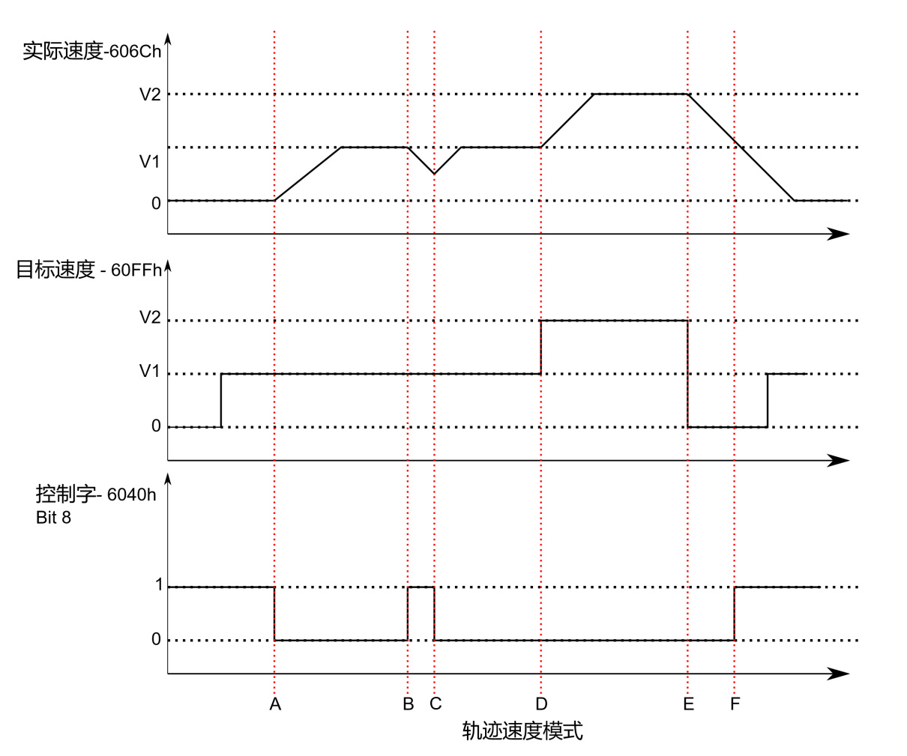
The diagram above illustrates the relationship between the motor's operating status, actual speed, target speed, and control word commands.
 | Target Speed | 6040h Stop Bit-Bit4 | Motor in Motion State
Start | 0 | 1 | Motor stop command issued
A | V1 | 1 -> 0 | Motor accelerates to V1 (Target Velocity 1)
B | V1 | 0 ->1 | Motor decelerates to stop
C | V1 | 1 -> 0 | Motor re-accelerates to V1 before complete stop (Overlap Condition)
D | V1 -> V2 | 0 | Motor accelerates from V1 to V2 (Target Velocity 2)
E | V2 -> 0 | 0 | Motor decelerates from V2 to 0
F | 0 | 0 -> 1 | Motor stopped
G | 0 -> V1 | 1 | Motor stopped
The table above explains how the stop bit and target speed work together to affect motor velocity. Between points B and C, the motor does not come to a complete stop but decelerates according to the profile deceleration value initiated at point B. When the stop bit transitions at point C, the motor immediately accelerates back to the target speed. At point E, reducing the target speed to zero produces the same effect as using the stop bit.
It should be noted that both activating the stop bit and setting the target speed to zero maintain torque on the motor. To allow the axis to move freely, the drive must be placed in a "Drive Disabled" (non-enabled) state.
- Enabling Profile Velocity Mode
To enable Profile Position Mode (PP Mode), the value 0001h must be written to Object Dictionary 6060h (Modes of Operation). The actual operating mode can be verified by reading Object Dictionary 6061h (Modes of Operation Display) to confirm the drive has entered the correct mode.
- Configuring Motion Parameters
Configure the following object dictionaries: 60FFh: the velocity; 6083h: Profile Acceleration; 6084h: Profile Deceleration.
- Enabling the Drive
Upon power-up, the drive remains in a disabled state. Writing 0x0006 to Control Word (0x6040) transitions the drive to "Ready to Switch On" state. Subsequently writing 0x010F to 0x6040 brings the drive to "Operation Enabled" state while maintaining the motor in a stopped condition.
- Starting & Stopping Motion
To initiate or halt motion, toggle the Stop bit (Bit 8) of the Control Word. Setting the Stop bit to 0 (0x000F) starts/continues motion, while setting it to 1 (0x010F) stops motion.
The profile velocity (0x60FF) determines motor direction: a positive value (>0) commands forward rotation, a negative value (<0) reverses rotation, and zero stops the motor. Users can directly switch from forward to reverse rotation - the motor will decelerate to stop and then accelerate in the opposite direction to the newly set speed.

CSP (Cyclic Synchronous Position) Mode
- Synchronous Position Mode Description
In this mode, the master controller generates the position trajectory and transmits the target position (0x607A) to the drive at each PDO (Process Data Object) update cycle. The drive subsequently provides feedback including: actual motor position, optional real-time motor velocity and motor torque/current.
- Enabling CSP Mode
To enable the cyclic synchronous position mode, the value 0008h must be written to the dictionary address 6060h.
- Enabling the Drive
After power-on, the drive is in a disabled state. The control word 6040h defaults to 0006h, placing the drive in the "Ready to switch on" state. To enable the drive (allowing it to respond to CSP commands), write the value 0x000F to 6040h. After setting the target position, write 0x001F to 6040h again to start the motor.

CSV (Cyclic Synchronous Velocity) Mode
- Synchronous Velocity Mode Description
Synchronous velocity mode refers to a motion control application where multiple motors or devices operate in synchronization, maintaining the same speed and direction.
In this mode, the master controller generates the speed profile and sends the target velocity (0x60FF) to the drive in each PDO update cycle. The drive then provides feedback on the actual motor speed and optionally the motor torque.
- Enabling CSV Mode
To enable the cyclic synchronous velocity (CSV) mode, the value 0008h must be written to the object dictionary address 6060h.
- Enabling the Drive
After power-on, the drive is in a disabled state. Writing 0006h to control word 6040h will transition the drive to the "Ready to switch on" state. To enable the drive (allowing it to respond to CSV commands), write 0x000F to 6040h again. The motor will then be operational in cyclic synchronous velocity (CSV) mode.

HM (Homing Mode)
Rtelligent EST series stepper drives not only support the CIA402-defined homing modes (17-35), but also support torque homing modes (Homing Modes 36 and 37).
Homing mode is used to locate the mechanical home position and establish its relationship with the mechanical zero position.
- Mechanical Origin: A fixed physical position, typically aligned with a home switch or the motor's Z-phase signal.
- Mechanical Zero Point: The absolute zero reference of the machine.
After homing is completed, the motor stops at the mechanical origin position. The relationship between the mechanical origin and zero positions can be configured via object 607Ch:
Mechanical Origin = Mechanical Zero + 607Ch (Home Offset)
When 607Ch = 0, the mechanical origin and zero positions coincide.
- Homing Parameter Configuration
Configure the homing speed, acceleration/deceleration, zero offset, and related sensor input signals.
- Related Object Dictionary Entries
Related Object Dictionary | Description
0x607C | Zero Offset
0x6098 | Homing Method Selection
0x6099 | Homing Speed
0x609A | Homing Acceleration/Deceleration
0x2007 | Input Port Function Selection
0x2008 | Input Port Polarity Setting

- Enabling Homing Function
To enable profile position mode, you must set the value of object dictionary 6060h (Operation Mode) to 0006h. You can verify whether the drive has entered the correct operation mode by checking object dictionary 6060h (Modes of Operation Display).
After initial power-up, the drive is in a disabled state. Write 6 to control word 6040h to set the drive to the "Ready to Switch On" state. Then write 000Fh to control word 6040h to switch the drive to "Operation Enabled" mode.
- Starting Homing Function
Homing Method: Set via object dictionary 6098h;
Homing Speed: Configured through 0x6099;
Homing Trigger: Initiate homing by generating a rising edge (0→1) on Bit 4 of control word 6040h. Check homing progress via status word 6041h.
- Aborting Homing Function
Homing Method Setup: Configure via object dictionary 6098h;
Homing Abort: Generate a rising edge (0→1) on Bit 8 of control word 6040h to stop homing;
Status Monitoring: Check homing status via status word 6041h.

Homing Method
The EST60X2 drive supports a homing mode from 1 to 35. The specific definition and homing process are as follows:

Method 1 (6098=1)
Origin: Z signal
Deceleration point: Negative limit signal (NOT)
- The negative limit signal is invalid when starting homing
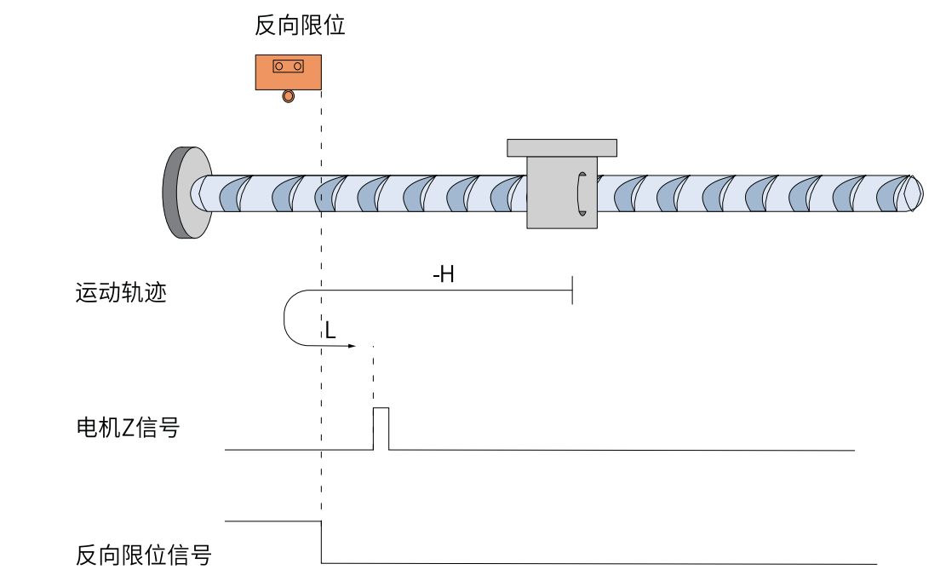
In the figure, "H" represents high-speed 6099.01, and "L" represents low-speed 6099.02.
When NOT=OFF, it starts homing at high speed in reverse. When encountering the rising edge of NOT, it slows down in reverse and runs at low speed in forward direction. Stop the machine when encountering the first Z signal after the NOT falling edge.

- The negative limit signal is valid when starting homing
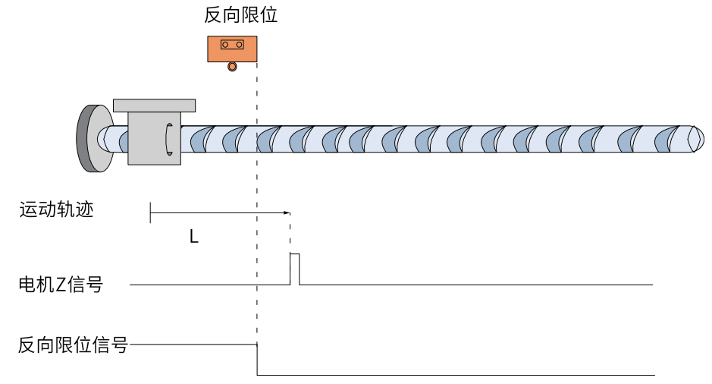
When NOT=ON, it starts homing, directly returning homing at a low speed in the forward direction, and stops at the first Z signal after encountering the NOT falling edge.

Method 2 (6098=2)
Origin: Z signal
Deceleration point: Positive limit signal (POT)
- The positive limit signal is invalid when starting homing
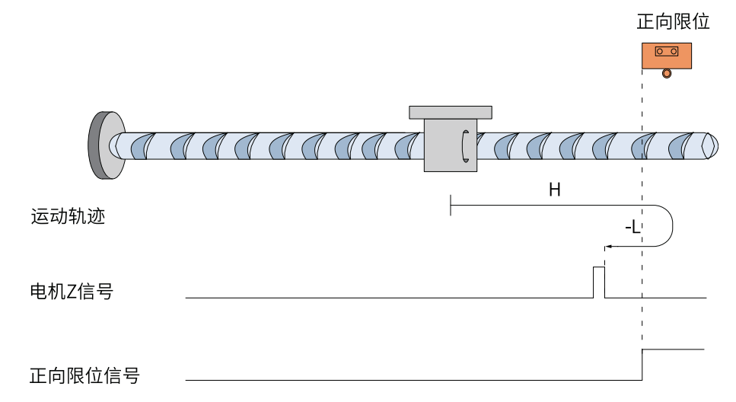
When POT=OFF, start homing at high speed in the forward direction. When encountering the rising edge of POT, slow down, reverse, and run at low speed in the reverse direction, and stops at the first Z signal after encountering the POT falling edge.

- The positive limit signal is valid when starting homing
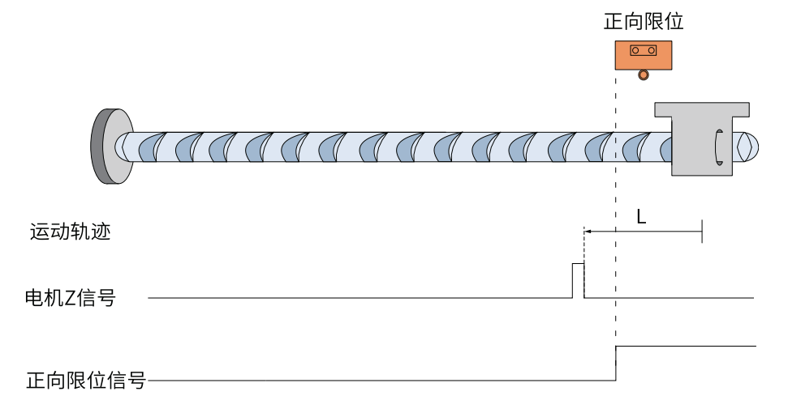
When POT=ON, it starts homing, directly reverse homing at low speed, and stops at the first Z signal after encountering the falling edge of POT.

Method 3 (6098=3)
Origin: Z signal
Deceleration point: Origin signal (HOME)
- The origin switch signal is invalid when starting homing
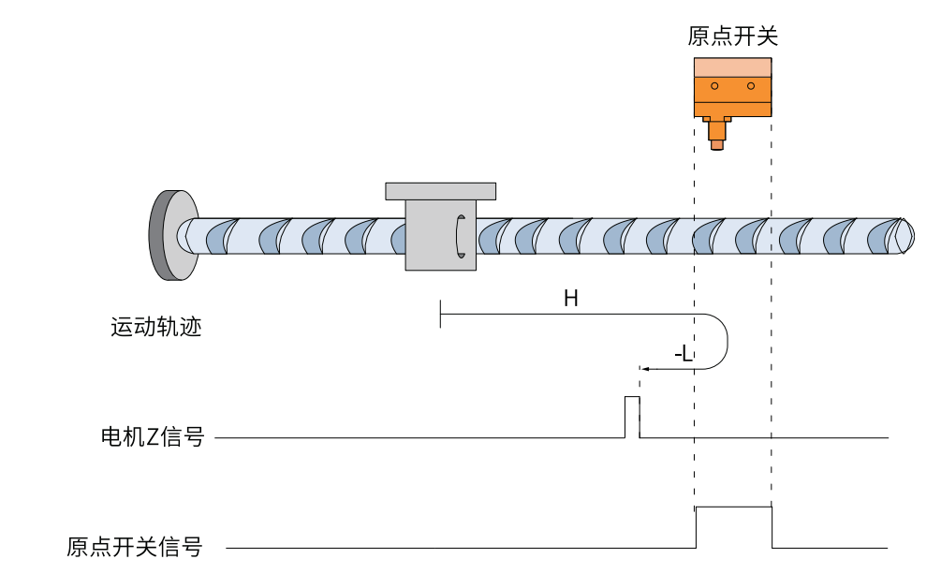
When HOME=OFF, it starts homing at a high speed in the forward direction. When encountering the rising edge of HOME, it slows down in the reverse direction and runs at a low speed in the reverse direction. And stops at the first Z signal after encountering the falling edge of HOME.

- When starting homing, the origin switch signal is valid
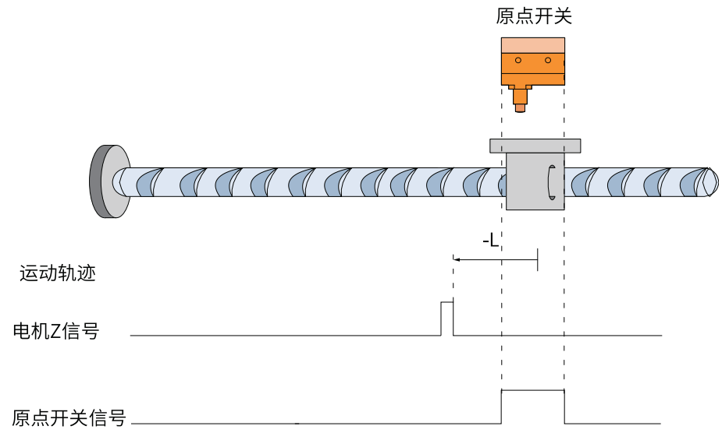
When HOME=ON, it starts homing, starting homing at low reverse speed, and stopping at the first Z signal after encountering the falling edge of HOME.

Method 4 (6098=4)
Origin: Z signal
Deceleration point: Origin signal (HOME)
- The origin switch signal is invalid when starting homing
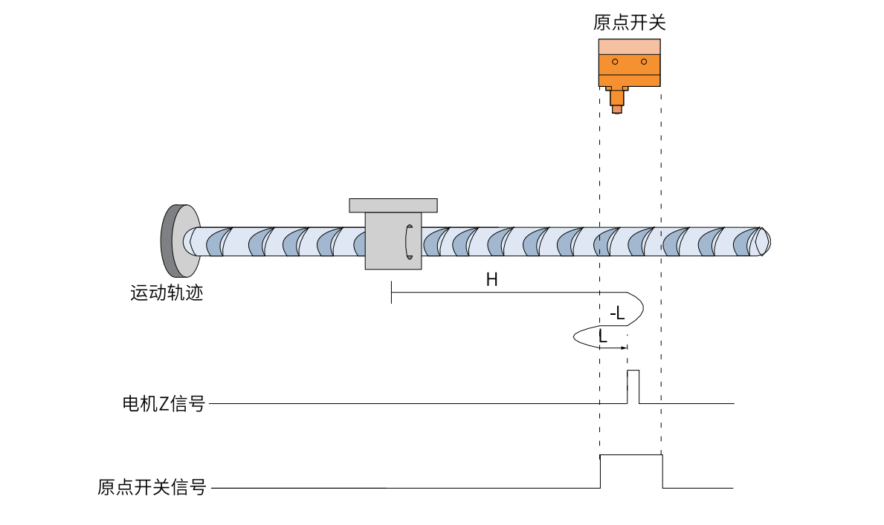

When HOME=OFF, it starts homing at a high speed in the forward direction. When encountering the rising edge of HOME, it slows down in the reverse direction and runs at a low speed in the reverse direction. When encountering the falling edge of HOME, it slows down in the reverse direction and runs at a low speed in the forward direction. It stops at the first Z signal after encountering the rising edge of HOME.
- When starting homing, the origin switch signal is valid
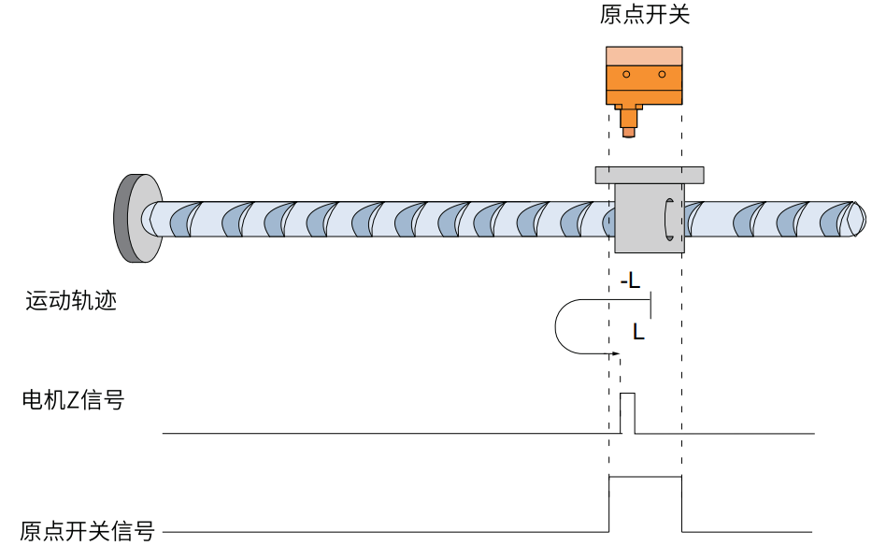
When HOME=ON, it starts homing at low speed in reverse. When encountering the NOT falling edge, it slows down in reverse and runs at low speed in forward direction. It stops at the first Z signal after encountering the rising edge of HOME.

Method 5 (6098=5)
Origin: Z signal
Deceleration point: Origin signal (HOME)
- The origin switch signal is invalid when starting homing
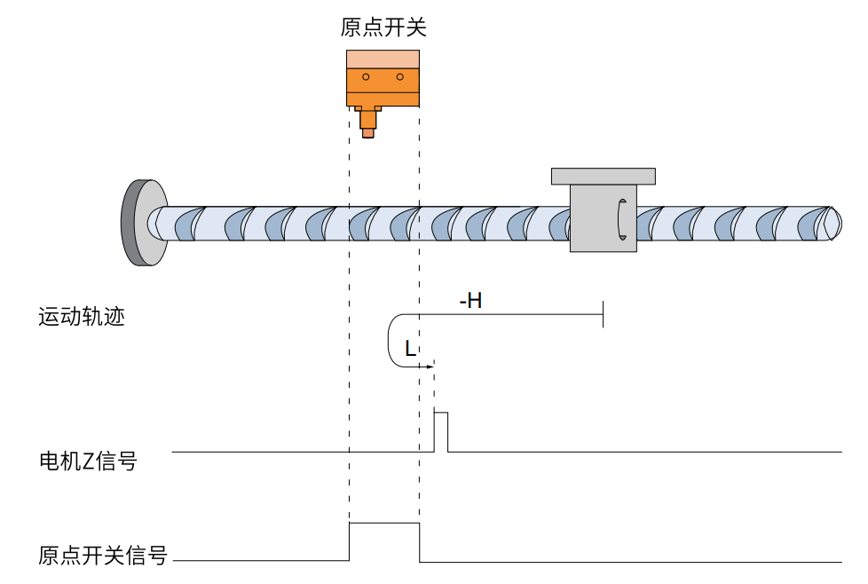
When HOME=OFF, start homing at reverse high speed. When encountering the rising edge of HOME, slow down in reverse and run at low speed in forward direction. Stop at the first Z signal after encountering the falling edge of HOME.
- When starting homing, the origin switch signal is valid
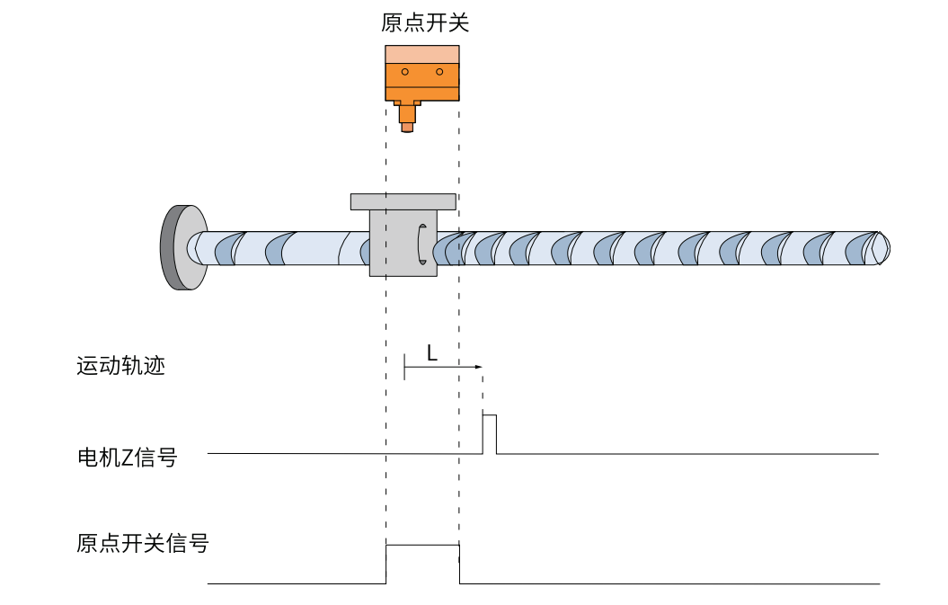
When HOME=ON, it starts homing at a low forward speed, and stops at the first Z signal after encountering the falling edge of HOME.

Method 6 (6098=6)
Origin: Z signal
Deceleration point: Origin signal (HOME)
- The origin switch signal is invalid when starting homing
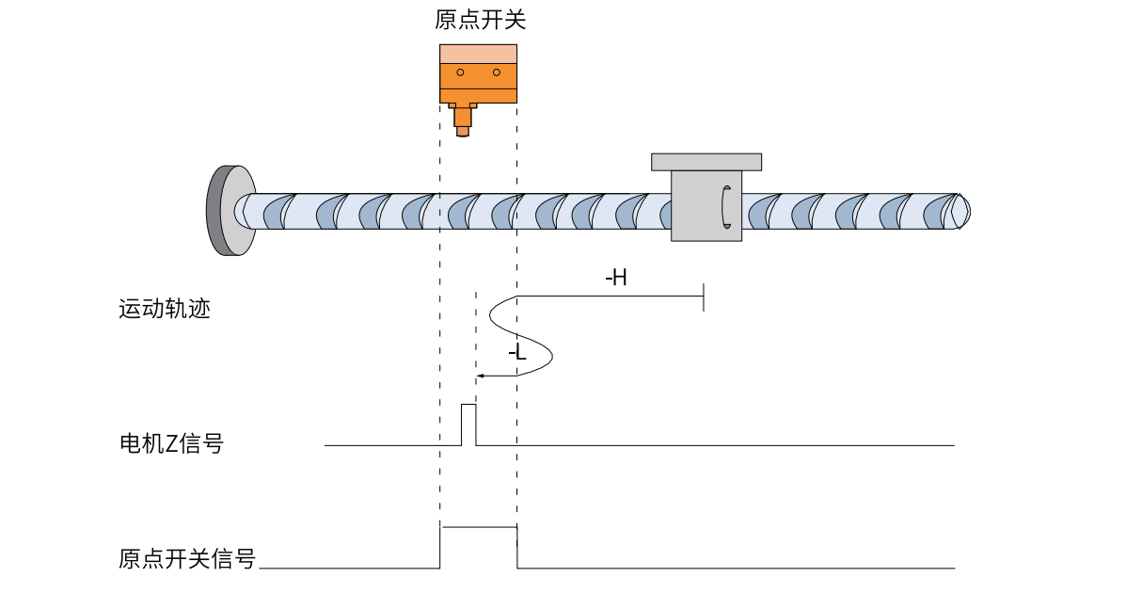
When HOME=OFF, it starts homing at high speed in reverse. When encountering the rising edge of HOME, it slows down in reverse and runs at low speed in forward direction. When encountering the falling edge of HOME, it slows down in reverse and runs at low speed in reverse direction. And stops at the first Z signal after encountering the falling edge of HOME.
- When starting homing, the origin switch signal is valid
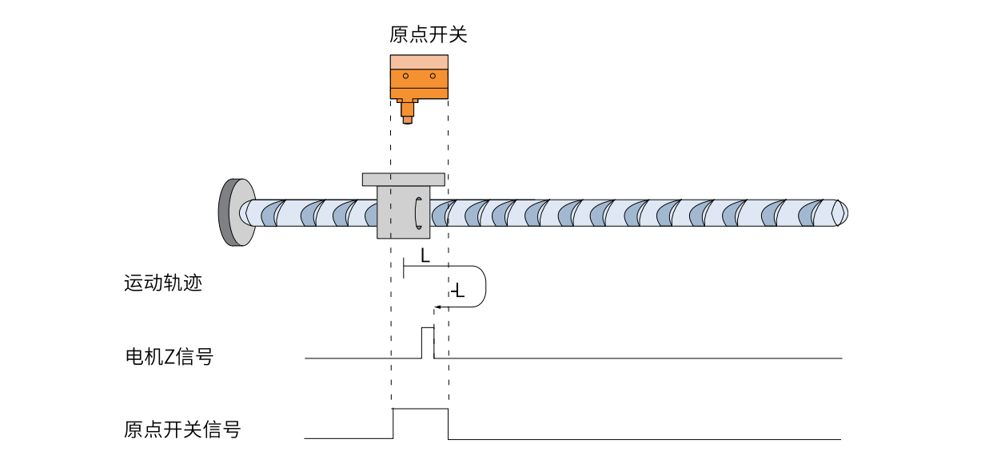
When HOME=ON, it starts homing at a low speed in the forward direction. When encountering the falling edge of HOME, it slows down in the reverse direction and runs at a low speed in the reverse direction. And stops at the first Z signal after encountering the falling edge of HOME.

Method 7 (6098=7)
Origin: Z signal
Deceleration point: Origin signal (HOME)
- When starting homing, the origin switch signal is invalid and no positive limit switch has been encountered
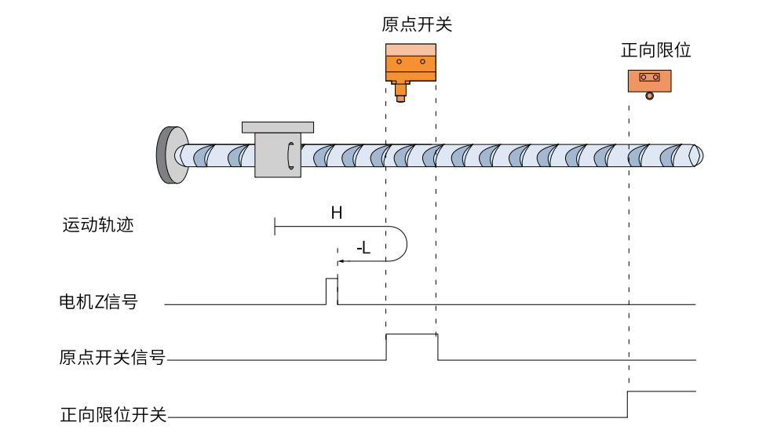
When HOME=OFF and POT=OFF, the homing process starts. It begins moving at high speed in the positive direction. After encountering the rising edge of the HOME signal, it decelerates and reverses direction, then continues moving at low speed in the reverse direction. It stops at the first Z signal encountered after the falling edge of the HOME signal.

- When starting homing, the origin switch signal is invalid and a positive limit switch is encountered
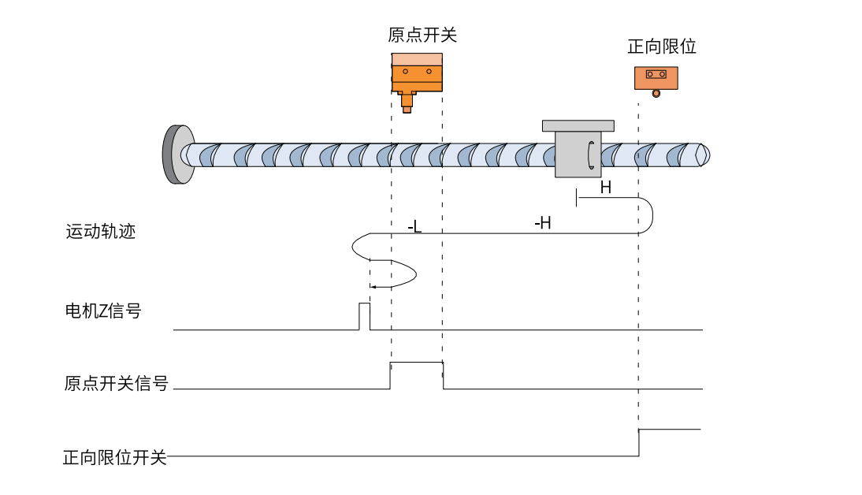
When HOME=OFF and POT=OFF, the homing process begins. It starts moving at high speed in the positive direction. Upon detecting the rising edge of the POT signal, it automatically reverses direction and moves at high speed in the negative direction. After encountering the rising edge of the HOME signal, it switches to low-speed reverse movement. Upon detecting the falling edge of the HOME signal, it decelerates, reverses direction again, and moves at low speed in the positive direction. When it encounters the next rising edge of the HOME signal, it decelerates once more, reverses direction, and continues at low speed in the negative direction, finally stopping at the first Z signal after the falling edge of the HOME signal.

- When homing starts, the origin switch signal is valid
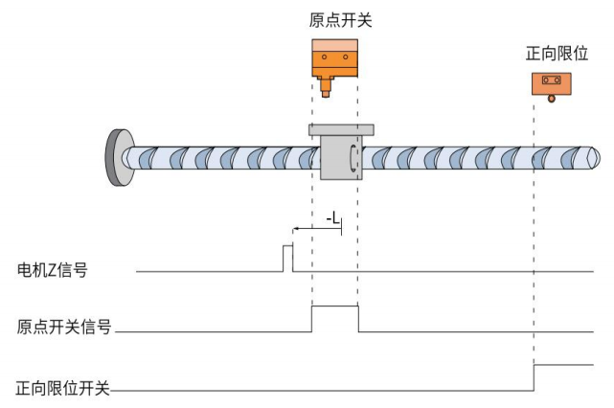
When HOME=ON, POT=OFF, it starts to homing at a low speed in the reverse direction, and stops when it encounters the first Z signal after the falling edge of HOME.

Method 8 (6098=8)
Origin: Z signal
Deceleration point: origin signal（HOME）
- The origin switch signal is invalid when starting homing, and the positive limit switch is not encountered.
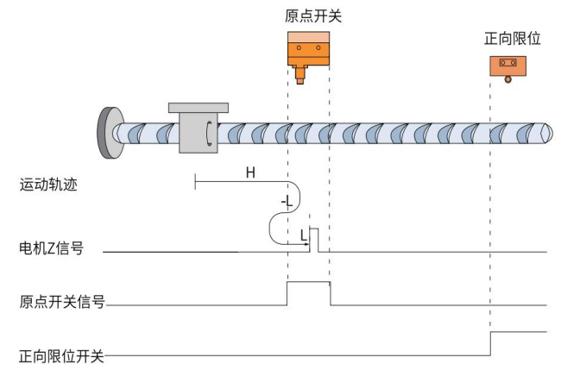

When HOME=OFF, POT=OFF, it starts to homing at high speed in the forward direction. After encountering the rising edge of HOME, it decelerates and reverses, and runs at low speed in the reverse direction. After encountering the falling edge of HOME, it decelerates and reverses, and runs at low speed in the forward direction. It stops at the first Z signal after the rising edge of HOME.
- When homing, the origin switch signal is invalid and encounters the positive limit switch
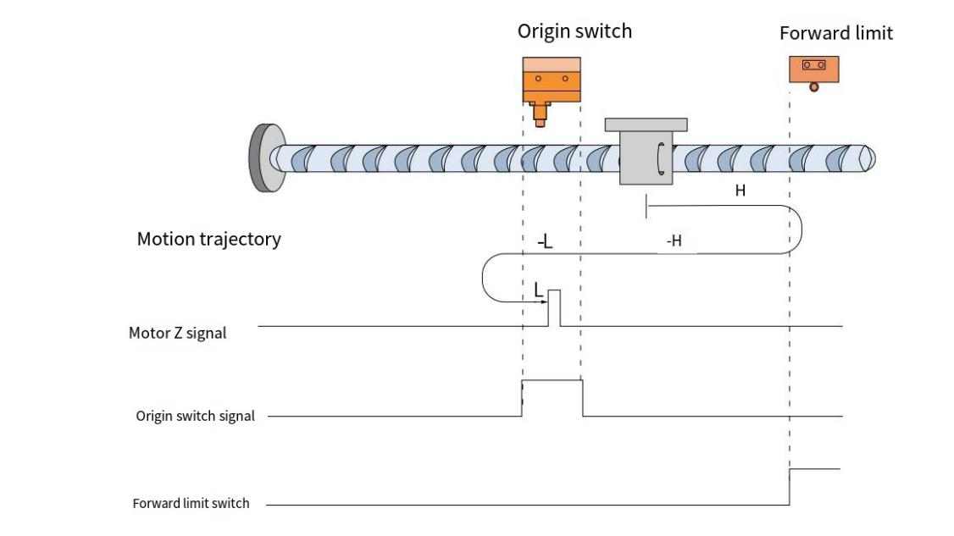
When HOME=OFF, POT=OFF, it starts homing at high speed in the forward direction. After encountering the rising edge of POT, it automatically runs in the reverse direction at high speed. After encountering the rising edge of HOME, it runs in the reverse direction at low speed. After encountering the falling edge of HOME, it decelerates and reverses, runs in the forward direction at low speed, and stops at the first Z signal after the rising edge of HOME.

- The origin switch signal is valid when starting homing
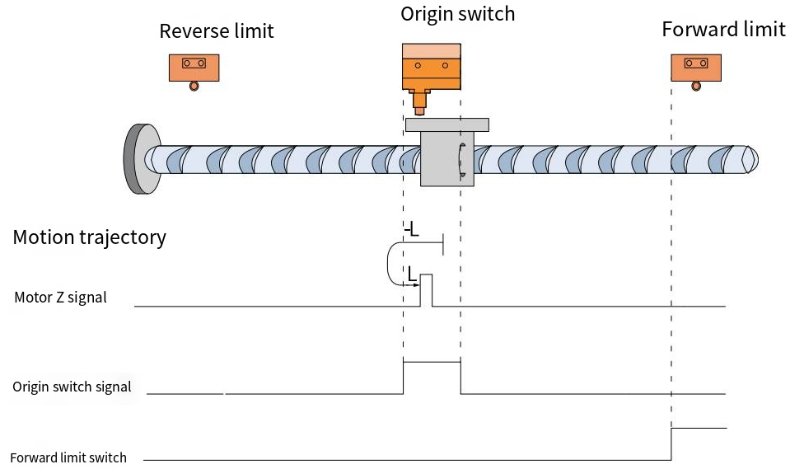
When HOME=ON and POT=OFF, the machine starts homing at a low speed in the reverse direction. After encountering the falling edge of HOME, it decelerates and reverses, and runs at a low speed in the forward direction. It stops at the first Z signal after the rising edge of HOME.

Method 9（6098=9）
Origin: Z signal
Deceleration point: origin signal（HOME）
- The origin switch signal is invalid when starting the return to zero, and the positive limit switch is not encountered
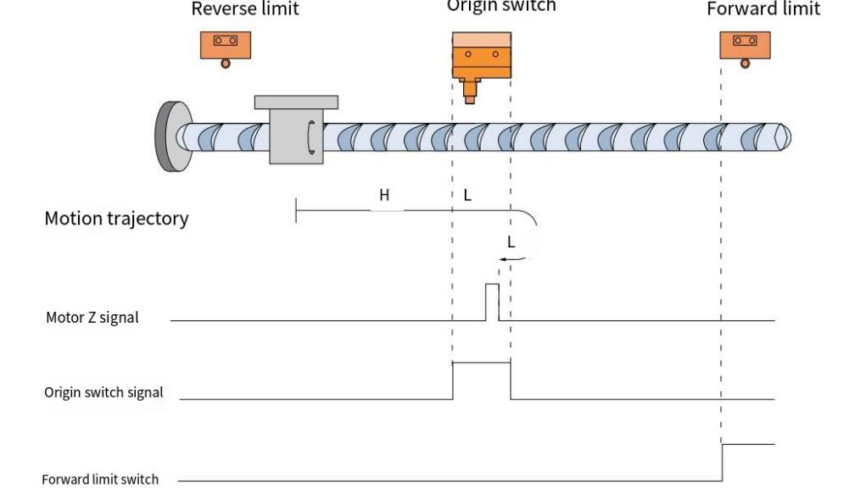
When HOME=OFF, POT=OFF, it starts to return to zero at high speed in the forward direction. After encountering the rising edge of HOME, it runs at low speed in the forward direction. After encountering the falling edge of HOME, it decelerates and reverses, runs at low speed in the reverse direction, and stops at the first Z signal after the rising edge of HOME.
- When homing, the origin switch signal is invalid and encounters the positive limit switch
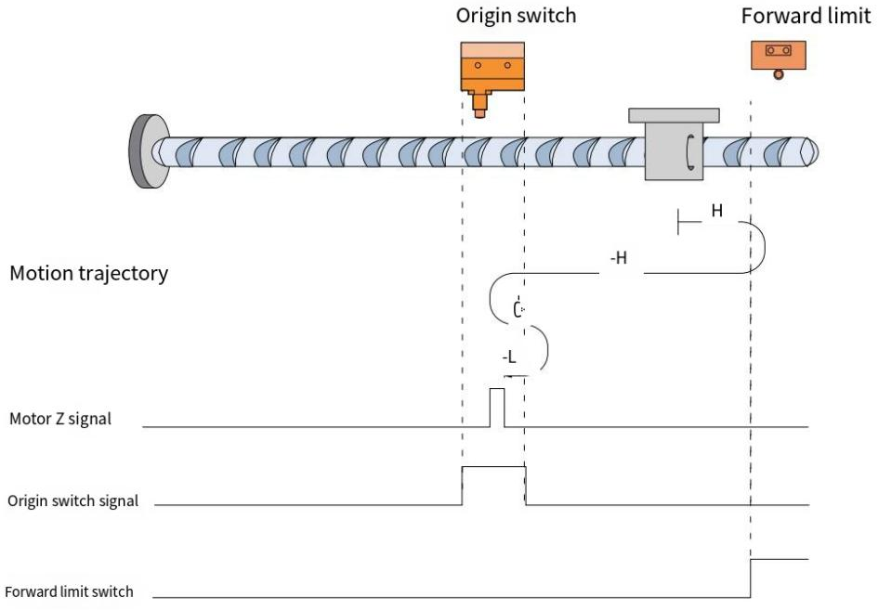
When HOME=OFF, POT=OFF, it starts homing at high speed in the forward direction. After encountering the rising edge of POT, it automatically runs in the reverse direction at high speed. After encountering the rising edge of HOME, it decelerates and reverses, and runs at low speed in the forward direction. After encountering the falling edge of HOME, it decelerates and reverses, and runs at low speed in the reverse direction. It stops at the first Z signal after the rising edge of HOME.

- The origin switch signal is valid when homing
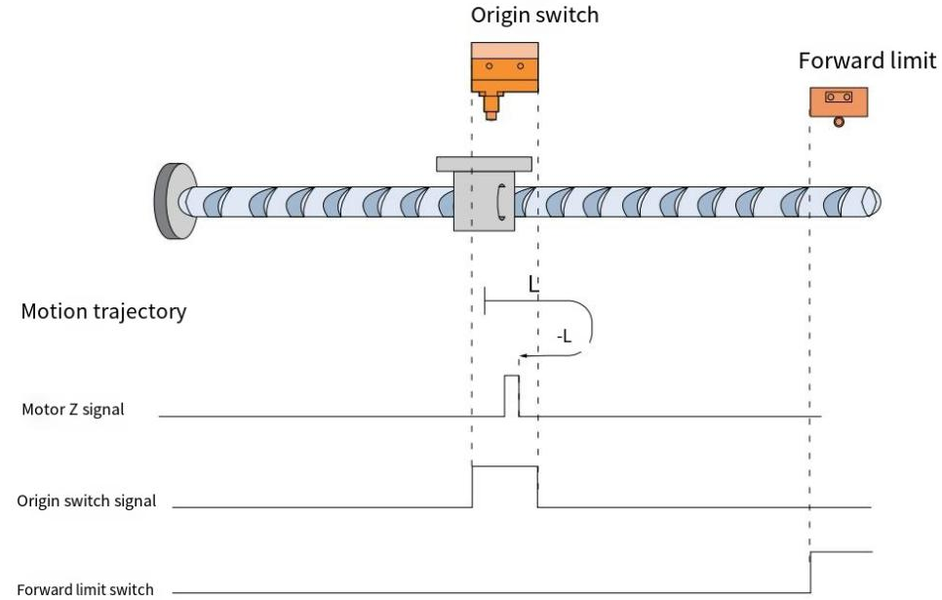
When HOME=ON, POT=OFF, it starts homing at a low speed in the forward direction. After encountering the falling edge of HOME, it decelerates and reverses, runs at a low speed in the reverse direction, and stops at the first Z signal after the rising edge of HOME.

Method 10 (6098=10)
Origin: Z signal
Deceleration point: origin signal（HOME）
- The origin switch signal is invalid when starting homing, and the positive limit switch is not encountered.
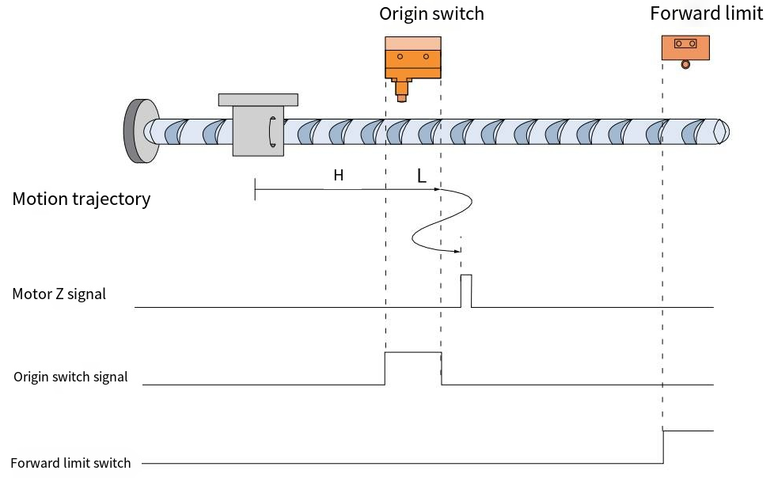

When HOME=OFF, POT=OFF, it starts homing at high speed in the forward direction. After encountering the rising edge of HOME, it runs at low speed in the forward direction. After encountering the falling edge of HOME, it decelerates and reverses, and runs at low speed in the reverse direction. After encountering the rising edge of HOME, it decelerates and reverses, and runs at low speed in the forward direction. It stops at the first Z signal after the falling edge of HOME.
- When homing, the origin switch signal is invalid and encounters the positive limit switch.
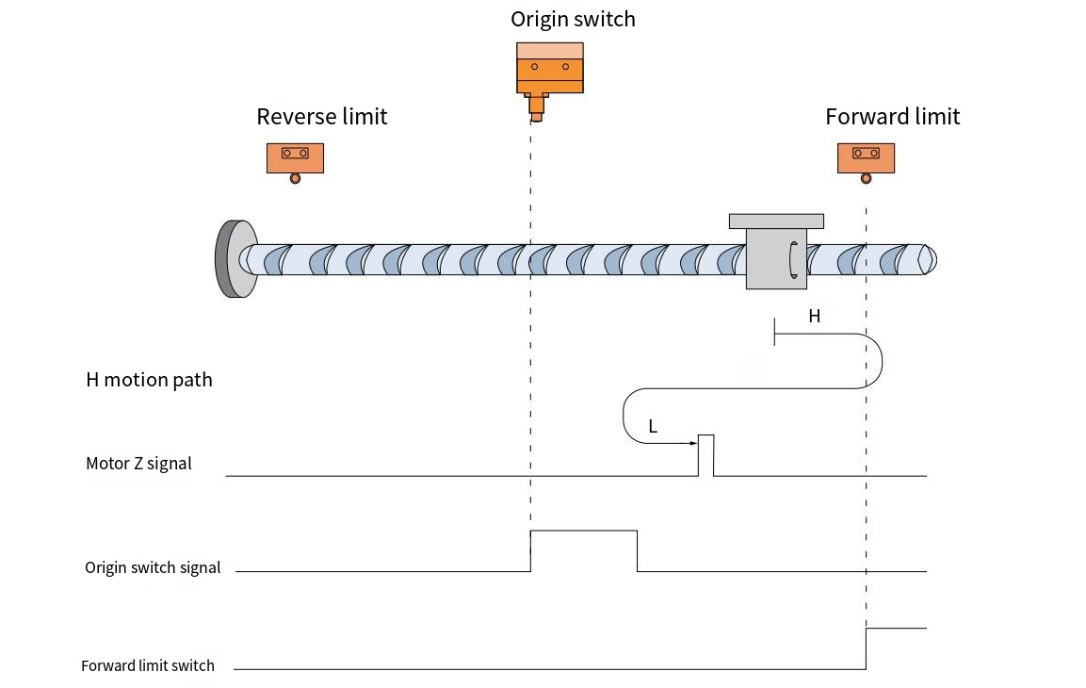
When HOME=OFF, POT=OFF, it starts homing at high speed in the forward direction. After encountering the rising edge of POT, it automatically runs in the reverse direction at high speed. After encountering the rising edge of HOME, it decelerates and reverses, runs in the forward direction at low speed, and stops at the first Z signal after the falling edge of HOME.

- The origin switch signal is valid when starting homing
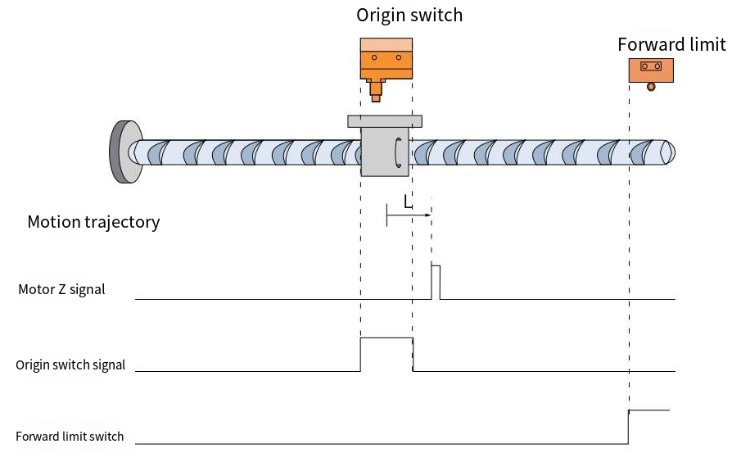
When HOME=ON and POT=OFF, the machine starts homing at a low forward speed and stops at the first Z signal after the falling edge of HOME.

Method 11 (6098=11)
Origin: Z signal
Deceleration point: Origin signal (HOME)
- The origin switch signal is invalid when starting homing, and no negative limit switch is encountered
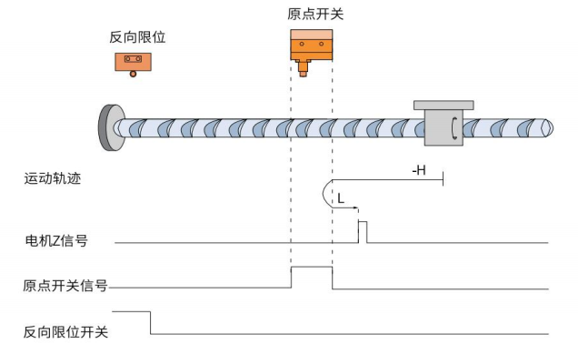

When HOME=OFF, NOT=OFF, it starts homing at high speed in the reverse direction. After encountering the rising edge of HOME, it decelerates and reverses, runs at low speed in the forward direction, and stops at the first Z signal after the falling edge of HOME.
- The origin switch signal is invalid when starting homing, and the negative limit switch is encountered.
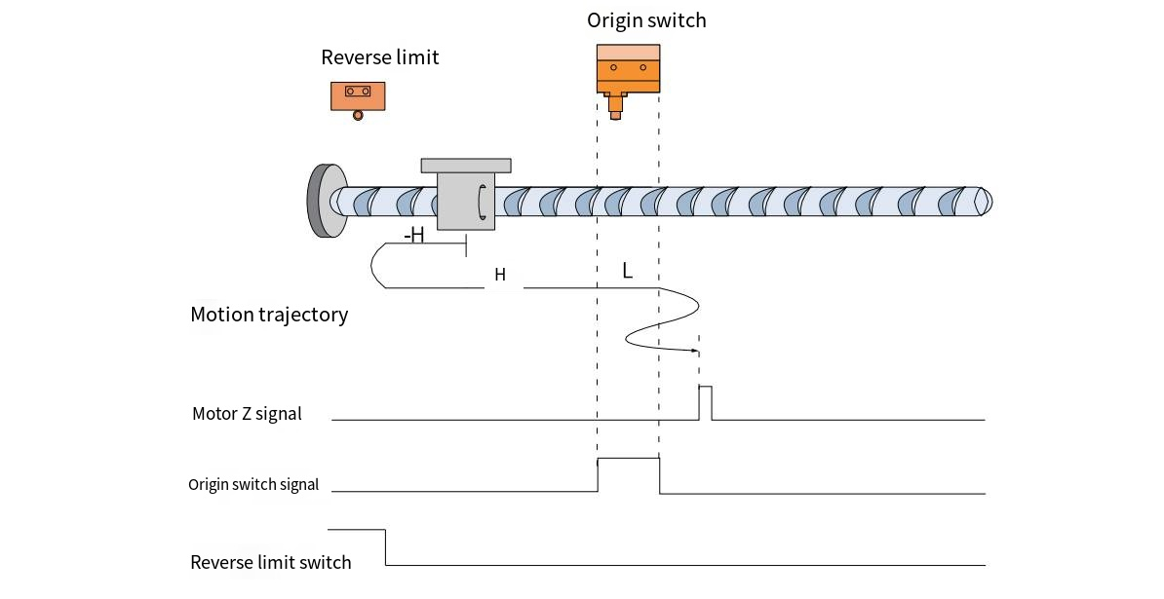
When HOME=OFF, NOT=OFF, it starts homing at high speed in the reverse direction. After encountering the rising edge of NOT, it immediately runs in the forward high speed. After encountering the rising edge of HOME, it runs in the forward low speed. After encountering the falling edge of HOME, it decelerates and reverses, and runs in the reverse low speed. After encountering the rising edge of HOME, it decelerates and reverses, and runs in the forward low speed. It stops at the first Z signal after the falling edge of HOME.

- The origin switch signal is valid when starting homing
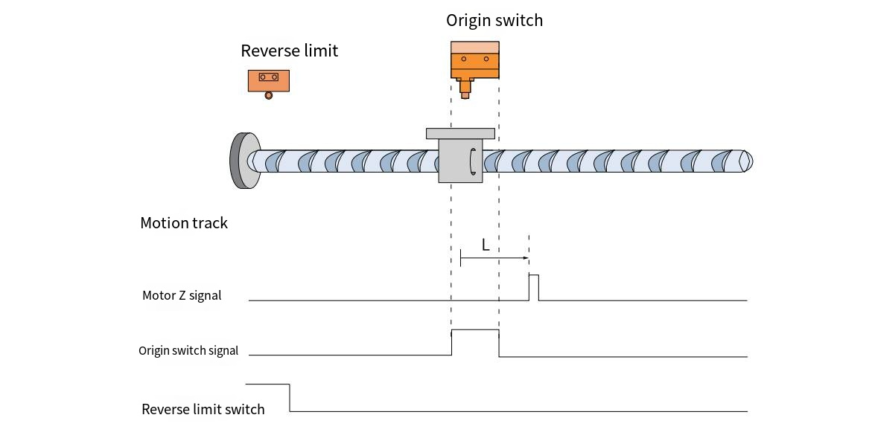
When HOME=ON, NOT=OFF, the machine starts homing at a low forward speed and stops at the first Z signal after the falling edge of HOME.

Method 12 (6098=12)
Origin: Z signal
Deceleration point: Origin signal (HOME)
- The origin switch signal is invalid when starting homing, and no negative limit switch is encountered
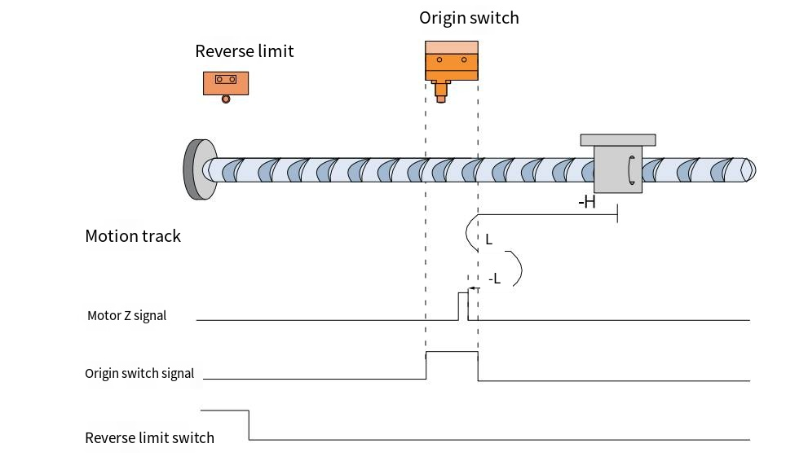

When HOME=OFF, NOT=OFF, it starts homing at high speed in the reverse direction. After encountering the rising edge of HOME, it decelerates and reverses, and runs at low speed in the forward direction. After encountering the falling edge of HOME, it decelerates and reverses, and runs at low speed in the reverse direction. It stops at the first Z signal after the rising edge of HOME.
- When homing, the origin switch signal is invalid and encounters a negative limit switch.
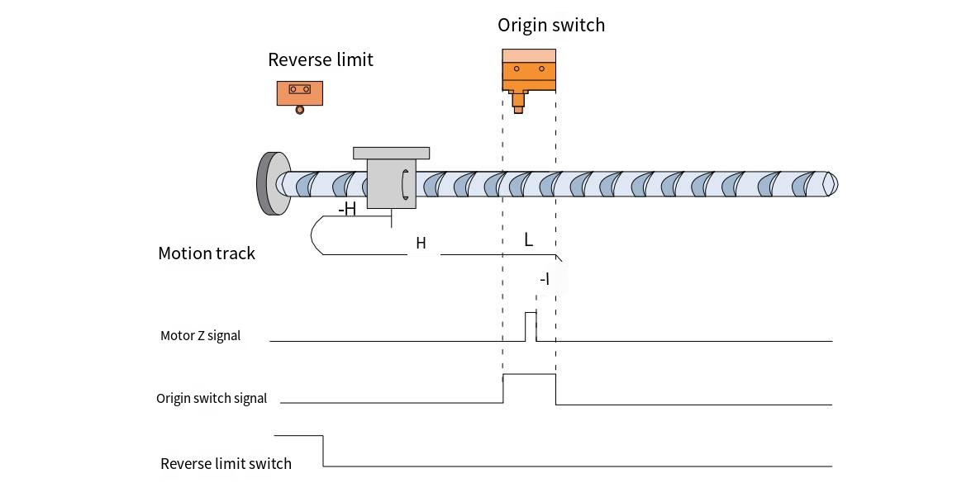
When HOME=OFF, NOT=OFF, it starts to return to zero at high speed in the reverse direction. After encountering the rising edge of NOT, it immediately runs in the forward direction at high speed. After encountering the rising edge of HOME, it runs in the forward direction at low speed. After encountering the falling edge of HOME, it decelerates and reverses, runs in the reverse direction at low speed, and stops at the first Z signal after the rising edge of HOME.

- The origin switch signal is valid when starting homing
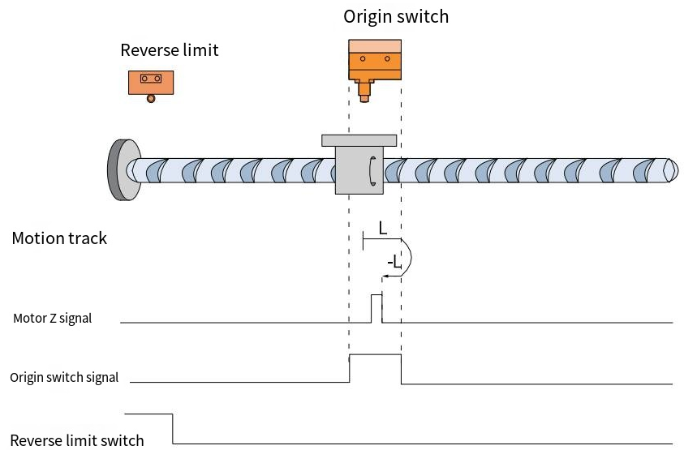
When HOME=ON, NOT=OFF, it starts homing at a low speed in the forward direction. After encountering the falling edge of HOME, it decelerates and reverses, running at a low speed in the reverse direction. It stops at the first Z signal after the rising edge of HOME.

Method 13 (6098=13)
Origin: Z signal
Deceleration point: Origin signal (HOME)
- The origin switch signal is invalid when starting homing, and no negative limit switch is encountered
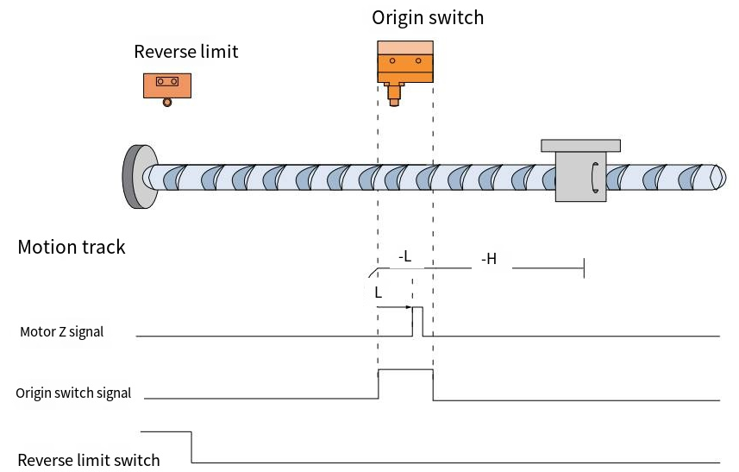
When HOME=OFF, NOT=OFF, it starts homing at high speed in the reverse direction. After encountering the rising edge of HOME, it runs in the reverse direction at low speed. After encountering the falling edge of HOME, it decelerates and reverses, runs in the forward direction at low speed, and stops at the first Z signal after the rising edge of HOME.
- When homing, the origin switch signal is invalid and encounters a negative limit switch.
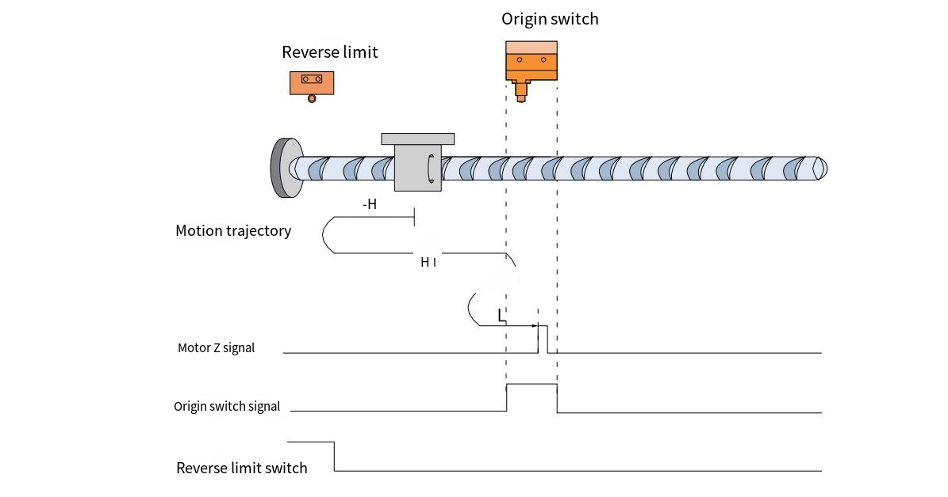
When HOME=OFF, NOT=OFF, it starts homing at high speed in the reverse direction. After encountering the rising edge of NOT, it immediately runs in the forward direction at high speed. After encountering the rising edge of HOME, it decelerates and reverses, and runs in the reverse direction at low speed. After encountering the falling edge of HOME, it decelerates and reverses, and runs in the forward direction at low speed. It stops at the first Z signal after the rising edge of HOME.

- The origin switch signal is valid when starting homing
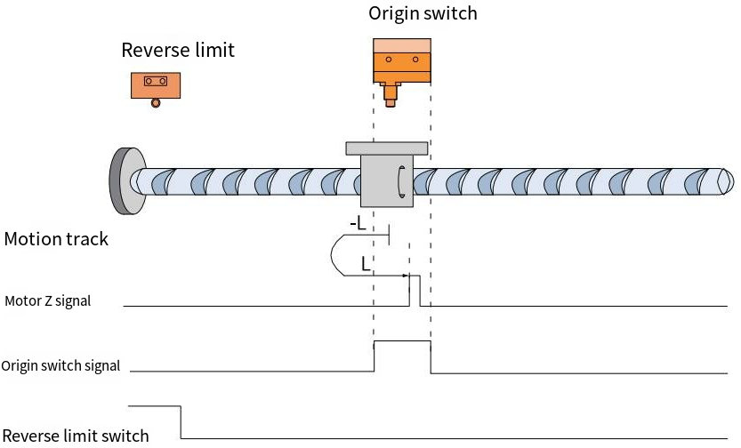
When HOME=ON, NOT=OFF, it starts homing at a low speed in the forward direction. After encountering the falling edge of HOME, it decelerates and reverses, running at a low speed in the forward direction. It stops at the first Z signal after the rising edge of HOME.

Method 14 (6098=14)
Origin: Z signal
Deceleration point: Origin signal (HOME)
- The origin switch signal is invalid when starting homing, and no negative limit switch is encountered.
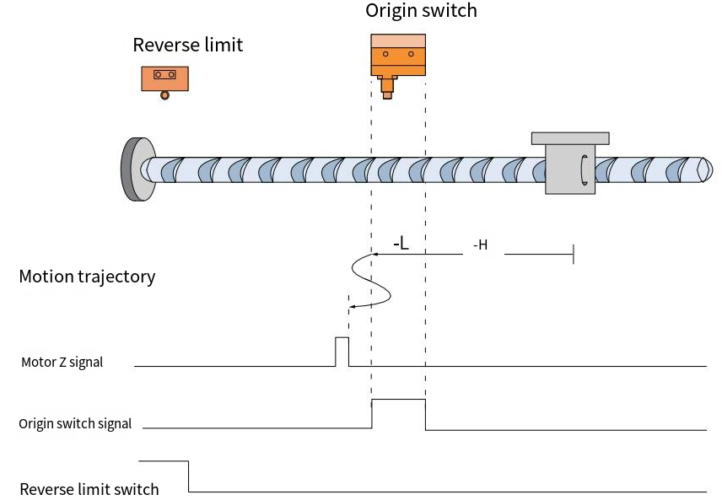

When HOME=OFF, NOT=OFF, it starts homing at high speed in the reverse direction. After encountering the rising edge of HOME, it runs in the reverse direction at low speed. After encountering the falling edge of HOME, it decelerates and reverses, runs in the forward direction at low speed, and stops at the first Z signal after the rising edge of HOME.
- When homing, the origin switch signal is invalid and encounters a negative limit switch.
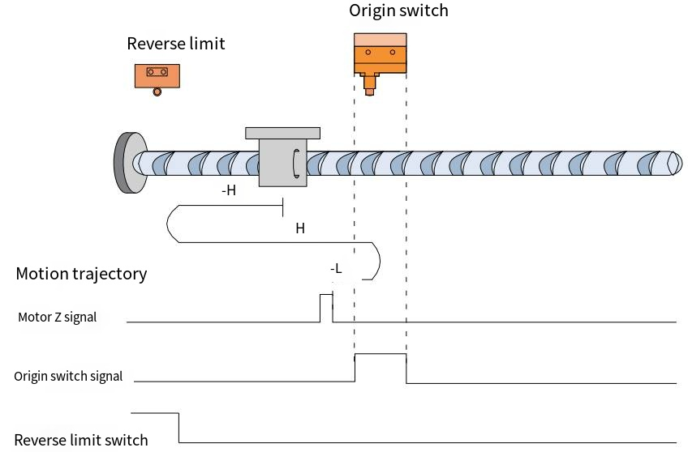
When HOME=OFF, NOT=OFF, it starts homing at high speed in the reverse direction. After encountering the rising edge of NOT, it immediately runs in the forward direction at high speed. After encountering the rising edge of HOME, it decelerates and reverses, and runs in the reverse direction at low speed. After encountering the falling edge of HOME, it stops at the first Z signal.
- The origin switch signal is valid when starting to return to zero.
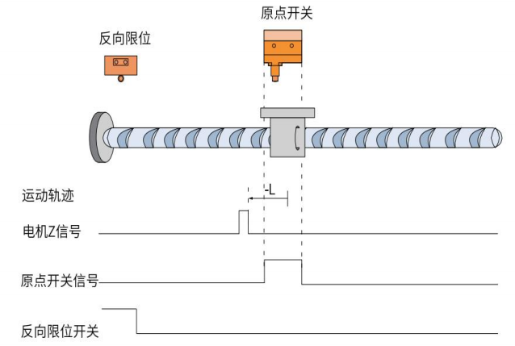

When HOME=ON, NOT=OFF, it starts homing at a low speed in the reverse direction. After encountering the falling edge of HOME, it stops at the first Z signal.

Method 17 (6098=17)
Origin: Negative limit signal (NOT)
Deceleration point: Negative limit signal (NOT)
- The negative limit signal is invalid when starting homing
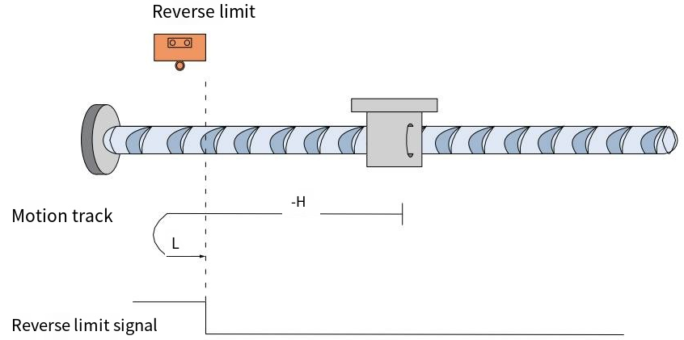
When NOT=OFF, it starts homing at a high speed in the reverse direction. After encountering the rising edge of NOT, it decelerates and reverses, runs at a low speed in the forward direction, and stops after encountering the falling edge of NOT.
- The negative limit signal is valid when starting homing
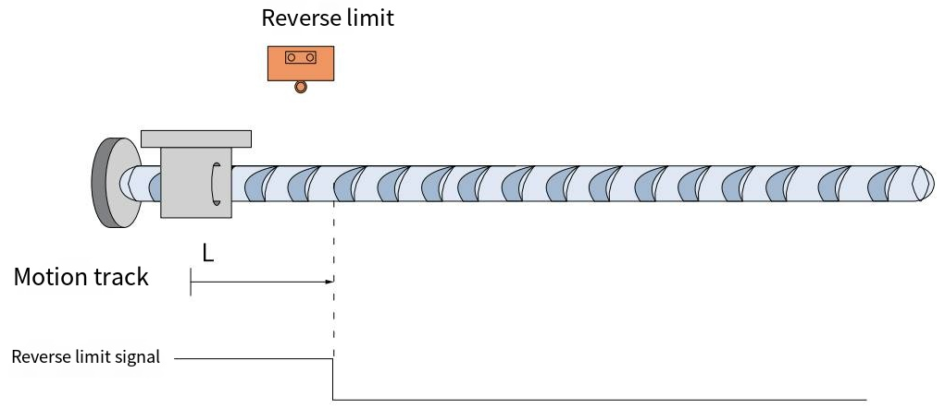
When NOT=ON, is starts homing at a low speed in the forward direction. And stops after encountering the falling edge of NOT.

Method 18 (6098=18)
Origin: Positive limit signal (POT)
Deceleration point: Positive limit signal (POT)
- The positive limit signal is invalid when starting homing
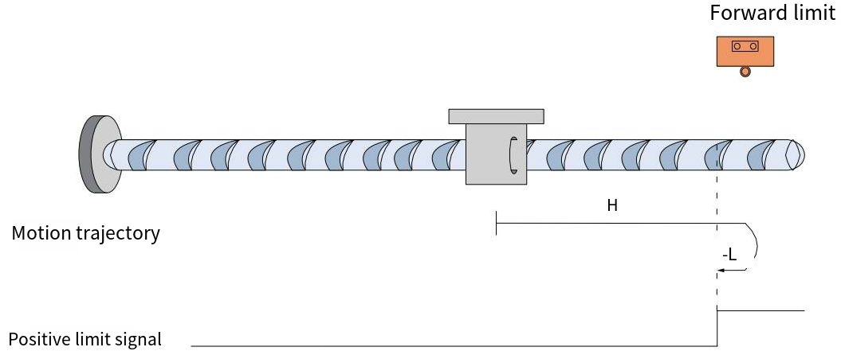
When POT=OFF, it starts homing at a high forward speed. After encountering the rising edge of POT, it decelerates and reverses, runs at a low speed in the reverse direction, and stops after encountering the falling edge of POT.
- The positive limit signal is valid when starting homing
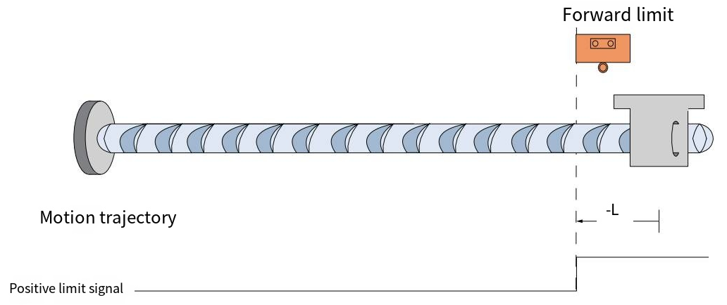
When POT=ON, it starts homing at a low speed in the reverse direction and stops when it encounters the falling edge of POT.

Method 19 (6098=19)
Origin: Origin switch signal (HOME)
Deceleration point: origin switch signal (HOME)
- The origin switch signal is invalid when starting homing
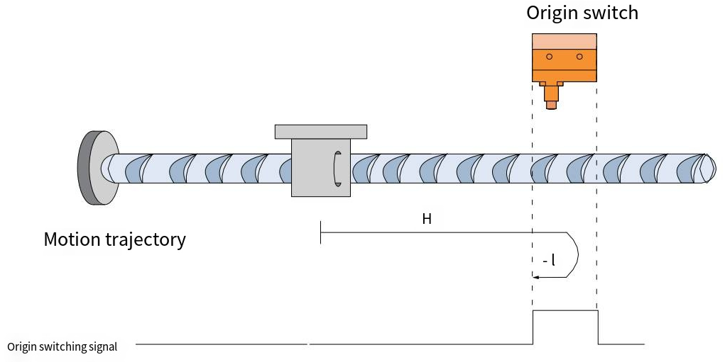
When HOME=OFF, it starts homing at high speed in the forward direction. After encountering the rising edge of HOME, it decelerates and reverses, runs at low speed in the reverse direction, and stops after encountering the falling edge of HOME.
- The origin switch signal is valid when starting homing
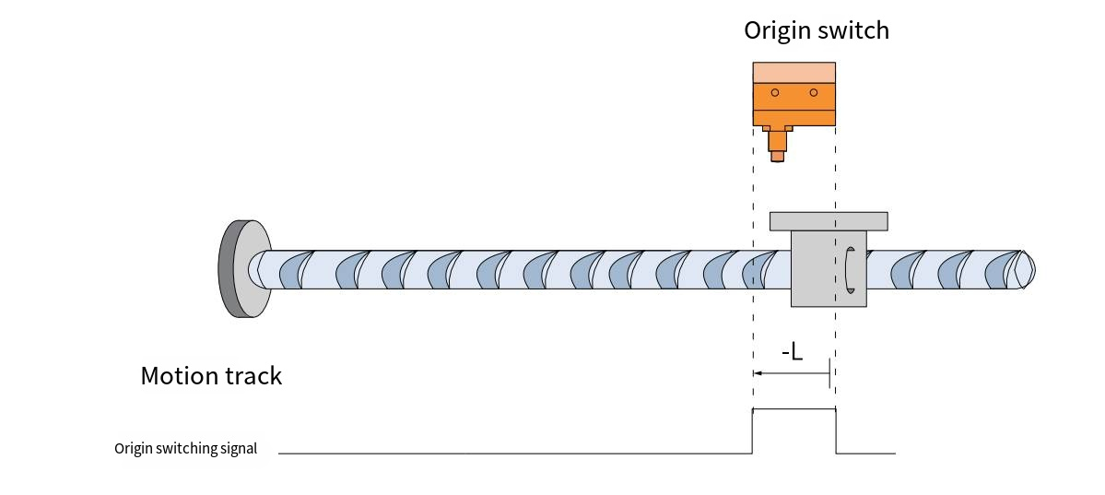
When HOME=ON, the machine homing at a low speed in the reverse direction and stops when it encounters the falling edge of HOME.

Method 20 (6098=20)
Origin: Origin switch signal (HOME)
Deceleration point: Origin switch signal (HOME)
- The origin signal switch is invalid when starting homing
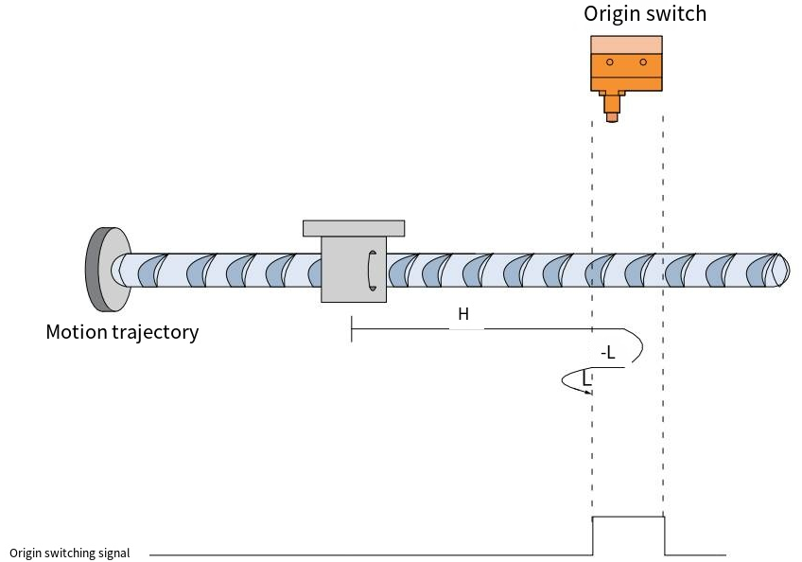
When HOME=OFF, it starts homing at a high forward speed. After encountering the rising edge of HOME, it decelerates and reverses, and runs at a low speed in the reverse direction. After encountering the falling edge of HOME, it decelerates and reverses, and runs at a low forward speed. It stops after encountering the rising edge of HOME again.
- The origin signal switch is valid when starting homing
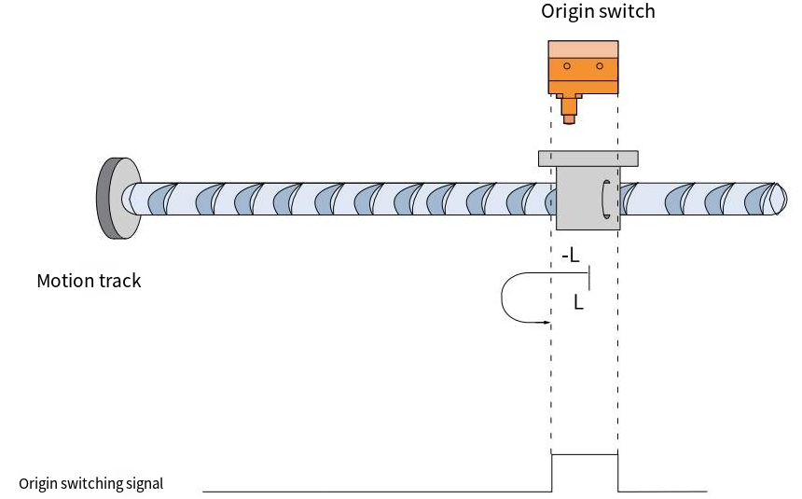
When HOME=ON, it starts homing at a low speed in the reverse direction. After encountering the falling edge of NOT, it decelerates and reverses, runs at a low speed in the forward direction, and stops after encountering the rising edge of HOME.

Method 21 (6098=21)
Origin: Origin switch signal (HOME)
Deceleration point: Origin switch signal (HOME)
- The origin signal switch is invalid when starting homing
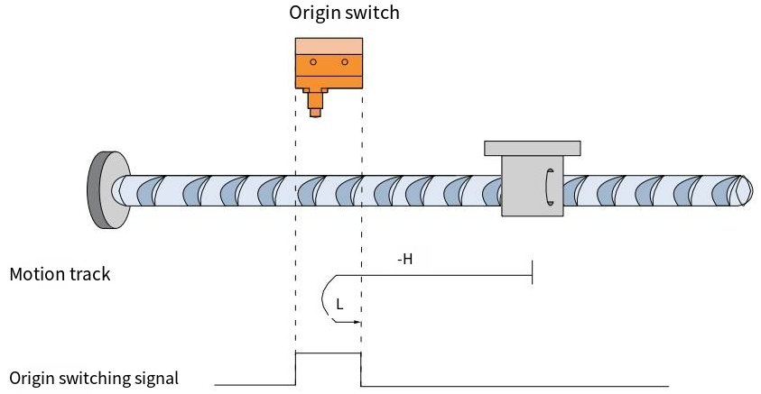
When HOME=OFF, it starts homing at a high speed in the reverse direction. After encountering the rising edge of HOME, it decelerates and reverses, runs at a low speed in the forward direction, and stops after encountering the falling edge of HOME.
- The origin switch signal is valid when starting homing
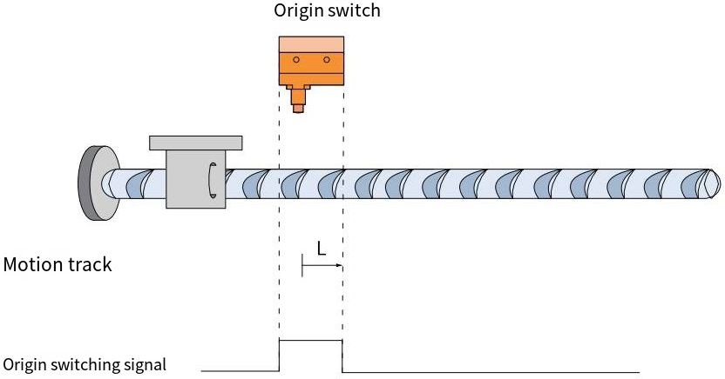
When HOME=ON, it starts homing at a low speed in the forward direction and stops when it encounters the falling edge of HOME.

Method 22 (6098=22)
Origin: Origin switch signal (HOME)
Deceleration point: Origin switch signal (HOME)
- The origin switch signal is invalid when starting homing
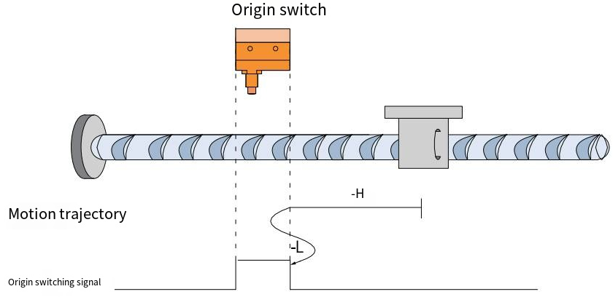
When HOME=OFF, it starts homing at a high speed in the reverse direction. After encountering the rising edge of HOME, it decelerates and reverses, and runs at a low speed in the forward direction. After encountering the falling edge of HOME, it decelerates and reverses, and runs at a low speed in the reverse direction. It stops after encountering the rising edge of HOME again.
- The origin switch signal is valid when starting homing
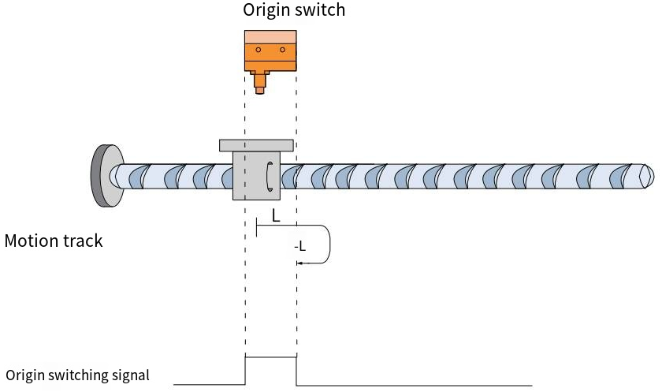
When HOME=ON, it starts homing at a low speed in the forward direction. After encountering the falling edge of HOME, it decelerates and reverses, runs at a low speed in the reverse direction, and stops after encountering the rising edge of HOME.

Method 23 (6098=23)
Origin: Origin switch signal (HOME)
Deceleration point: Origin switch signal (HOME)
- The origin switch signal is invalid when starting homing, and the positive limit switch is not encountered.
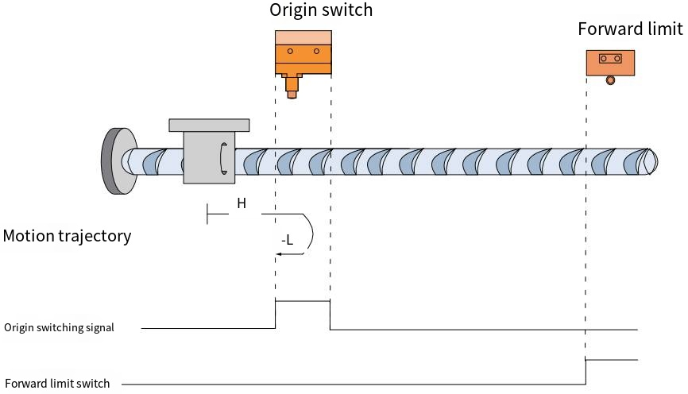
When HOME=OFF, POT=OFF, it starts homing at high speed in the forward direction. After encountering the rising edge of HOME, it decelerates and reverses, runs at low speed in the reverse direction, and stops when encountering the falling edge of HOME.
- When homing, the origin switch signal is invalid and encounters a positive limit switch.
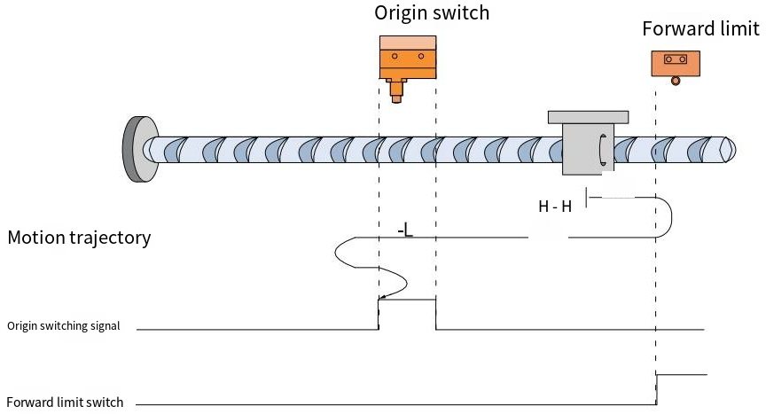

When HOME=OFF, POT=OFF, it starts homing at high speed in the forward direction. After encountering the rising edge of POT, it immediately runs in the reverse direction at high speed. After encountering the rising edge of HOME, it runs in the reverse direction at low speed. After encountering the falling edge of HOME, it decelerates and reverses, and runs in the forward direction at low speed. After encountering the rising edge of HOME, it decelerates and reverses, and runs in the reverse direction at low speed. It stops after encountering the falling edge of HOME again.
- The origin switch signal is valid when starting homing.
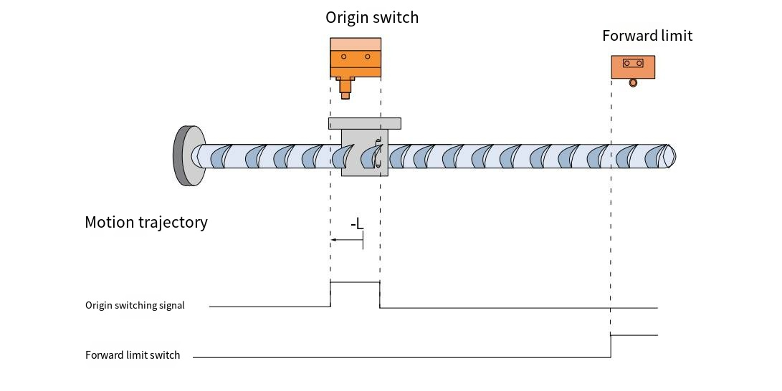
When HOME=ON and POT=OFF, the machine starts homing at a low speed in the reverse direction and stops when it encounters the falling edge of HOME.

Method 24 (6098=24)
Origin: Origin switch signal (HOME)
Deceleration point: Origin switch signal (HOME)
- The origin switch signal is invalid when starting homing, and the positive limit switch is not encountered.
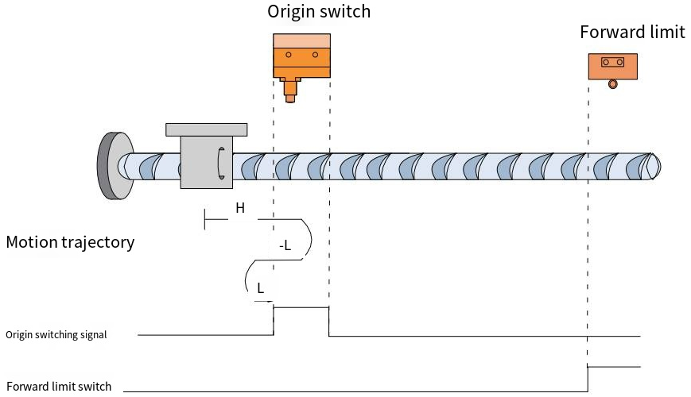
When HOME=OFF, POT=OFF, it starts homing at high speed in the forward direction. After encountering the rising edge of HOME, it decelerates and reverses, and runs at low speed in the reverse direction. After encountering the falling edge of HOME, it decelerates and reverses, and runs at low speed in the forward direction. It stops after encountering the rising edge of HOME again.
- When homing, the origin switch signal is invalid and encounters a positive limit switch.
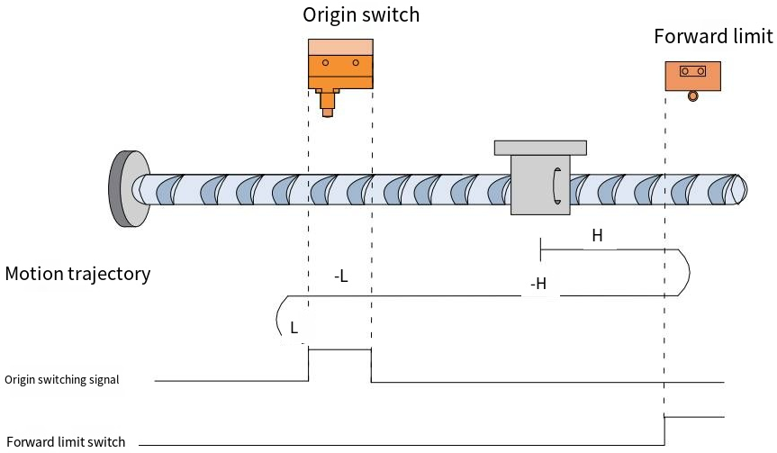

When HOME=OFF, POT=OFF, it starts homing at high speed in the forward direction. When it encounters the rising edge of POT, it automatically runs in the reverse direction at high speed. When it encounters the rising edge of HOME, it runs in the reverse direction at low speed. When it encounters the falling edge of HOME, it decelerates and reverses, runs in the forward direction at low speed, and stops when it encounters the rising edge of HOME.
- The origin switch signal is valid when starting homing.
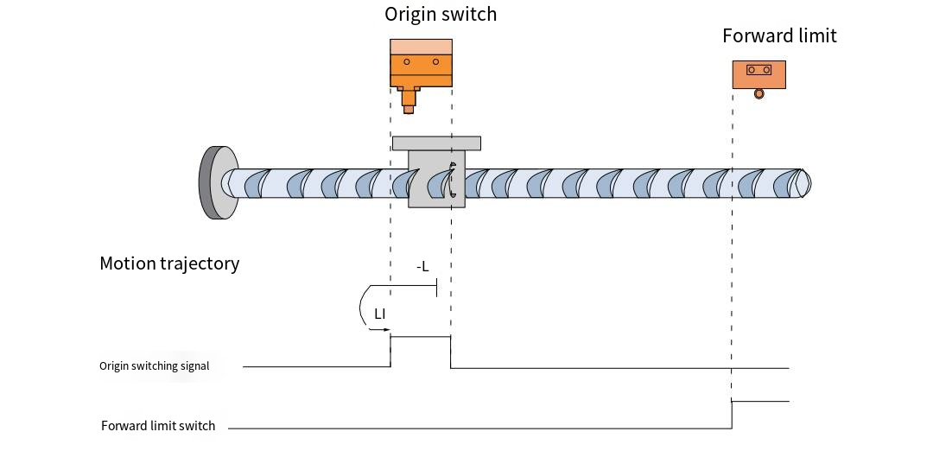
When HOME=ON and POT=OFF, it starts homing at a low speed in the reverse direction. After encountering the falling edge of HOME, it decelerates and reverses, runs at a low speed in the forward direction, and stops after encountering the rising edge of HOME.

Method 25 (6098=25)
Origin: Origin switch signal (HOME)
Deceleration point: Origin switch signal (HOME)
- The origin switch signal is invalid when starting homing, and the positive limit switch is not encountered.

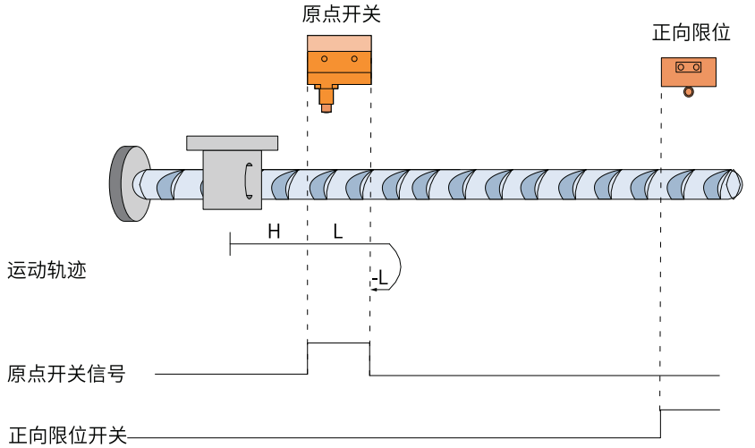
When HOME=OFF, POT=OFF, it starts homing at high speed in the forward direction. After encountering the rising edge of HOME, it runs at low speed in the forward direction. After encountering the falling edge of HOME, it decelerates and reverses, runs at low speed in the reverse direction, and stops after encountering the rising edge of HOME.
- When homing, the origin switch signal is invalid and encounters a positive limit switch.
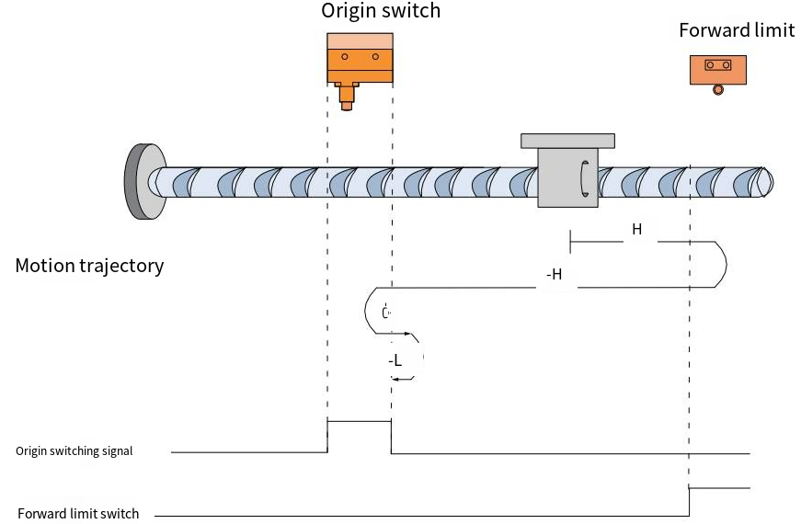
When HOME=OFF, POT=OFF, it starts homing at high speed in the forward direction. After encountering the rising edge of POT, it automatically runs in the reverse direction at high speed. After encountering the rising edge of HOME, it decelerates and reverses, and runs in the forward direction at low speed. After encountering the falling edge of HOME, it decelerates and reverses, and runs in the reverse direction at low speed. It stops after encountering the rising edge of HOME again.

- The origin switch signal is valid when starting homing.
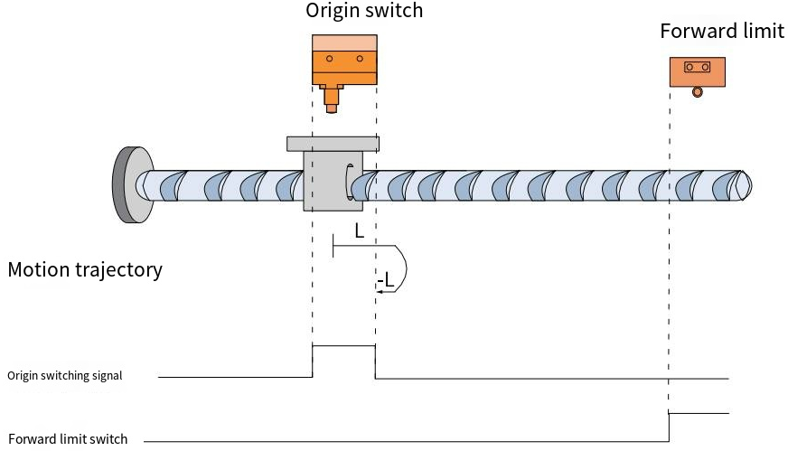
When HOME=ON and POT=OFF, the machine starts homing at a low speed in the forward direction. After encountering the falling edge of HOME, it decelerates and reverses, runs at a low speed in the reverse direction, and stops after encountering the rising edge of HOME.

Method 26 (6098=26)
Origin: Origin switch signal (HOME)
Deceleration point: Origin switch signal (HOME)
- The origin switch signal is invalid when starting homing, and no positive limit switch is encountered.
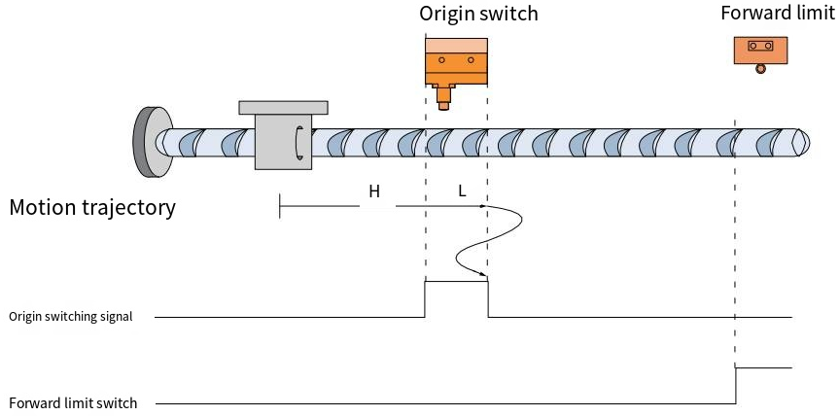

When HOME=OFF, POT=OFF, it starts homing at high speed in the forward direction. After encountering the rising edge of HOME, it runs at low speed in the forward direction. After encountering the falling edge of HOME, it decelerates and reverses, and runs at low speed in the reverse direction. After encountering the rising edge of HOME, it decelerates and reverses, and runs at low speed in the forward direction. It stops after encountering the falling edge of HOME again.
- When homing, the origin switch signal is invalid and encounters a positive limit switch.
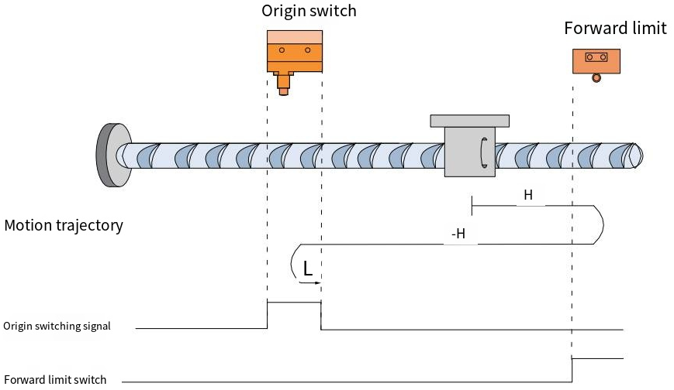
When HOME=OFF, POT=OFF, it starts homing at high speed in the forward direction. After encountering the rising edge of POT, it automatically runs in the reverse direction at high speed. After encountering the rising edge of HOME, it decelerates and reverses, runs in the forward direction at low speed, and stops after encountering the falling edge of HOME.
- The origin switch signal is valid when starting homing.
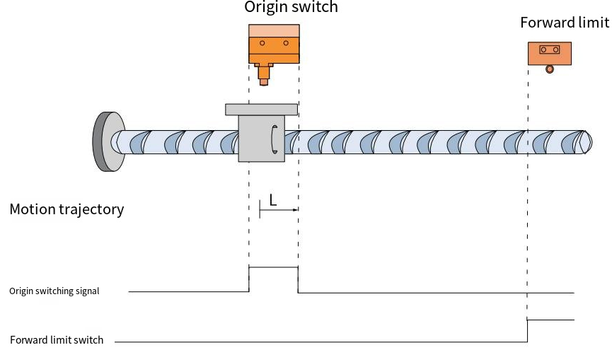

When HOME=ON and POT=OFF, the system starts homing at a low forward speed and stops when it encounters the falling edge of HOME.

Method 27 (6098=27)
Origin: Origin switch signal (HOME)
Deceleration point: Origin switch signal (HOME)
- The origin switch signal is invalid when starting homing, and no negative limit switch is encountered.
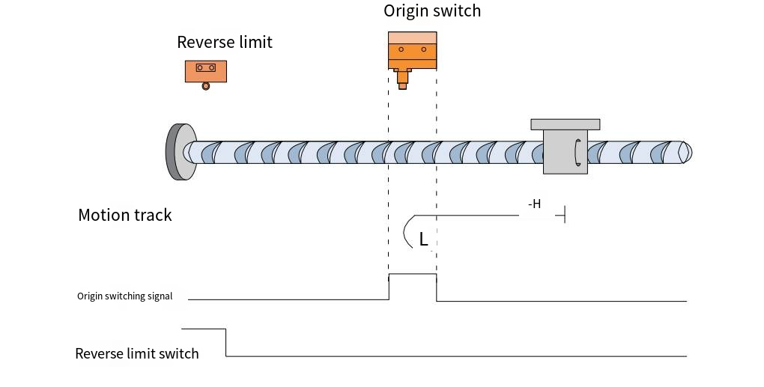
When HOME=OFF, NOT=OFF, it starts homing at high speed in the reverse direction. After encountering the rising edge of HOME, it decelerates and reverses, runs at low speed in the forward direction, and stops when encountering the falling edge of HOME.

- When starting homing, the origin switch signal is invalid and encounters a reverse limit switch.
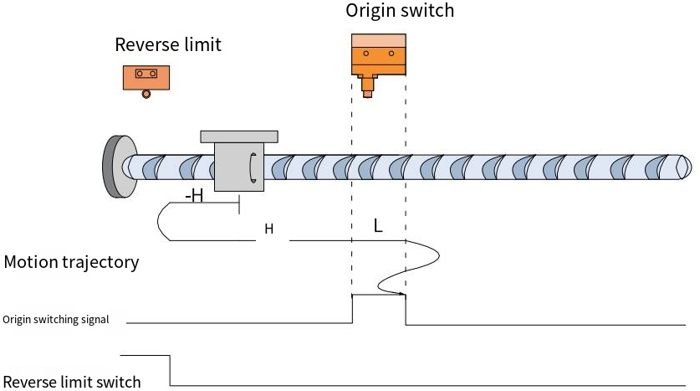
When HOME=OFF, NOT=OFF, it starts homing at high speed in the reverse direction. After encountering the rising edge of NOT, it automatically runs in the forward direction at high speed. After encountering the rising edge of HOME, it runs in the forward direction at low speed. After encountering the falling edge of HOME, it decelerates and reverses, and runs in the reverse direction at low speed. After encountering the rising edge of HOME, it decelerates and reverses, and runs in the forward direction at low speed. It stops after encountering the falling edge of HOME again.
- The origin switch signal is valid when starting homing.
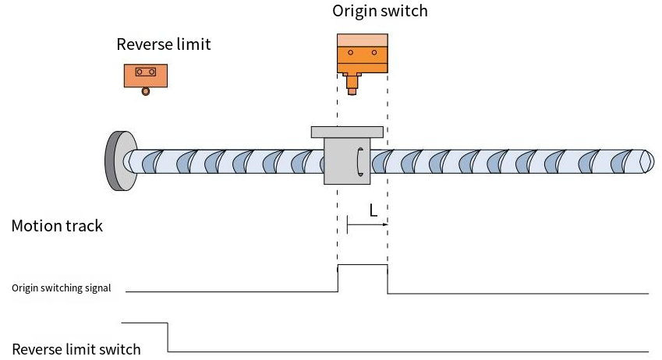
When HOME=ON, NOT=OFF, the system starts homing at a low forward speed and stops when it encounters the falling edge of HOME.

Method 28 (6098=28)
Origin: Origin switch signal (HOME)
Deceleration point: Origin switch signal (HOME)
- The origin switch signal is invalid when starting homing, and no negative limit switch is encountered.
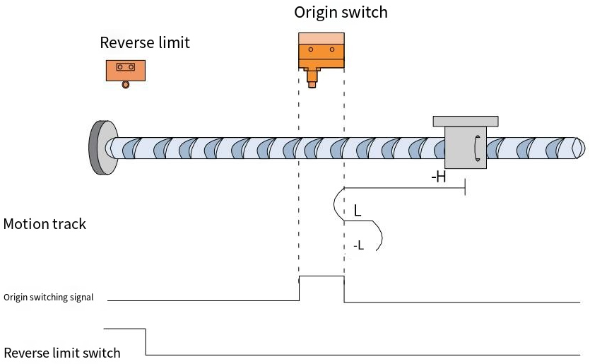
When HOME=OFF, NOT=OFF, it starts homing at high speed in the reverse direction. After encountering the rising edge of HOME, it decelerates and reverses, and runs at low speed in the forward direction. After encountering the falling edge of HOME, it decelerates and reverses, and runs at low speed in the reverse direction. It stops after encountering the rising edge of HOME again.

- The origin switch signal is invalid when starting homing, and a negative limit switch is encountered.
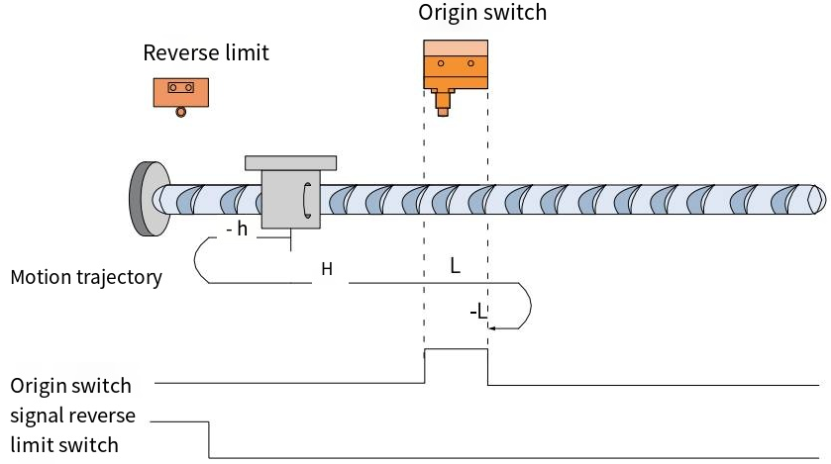
When HOME=OFF, NOT=OFF, it starts homing at high speed in the reverse direction. After encountering the rising edge of NOT, it automatically runs in the forward direction at high speed. After encountering the rising edge of HOME, it runs in the forward direction at low speed. After encountering the falling edge of HOME, it decelerates and reverses, runs in the reverse direction at low speed, and stops after encountering the rising edge of HOME.
- The origin switch signal is valid when starting homing.
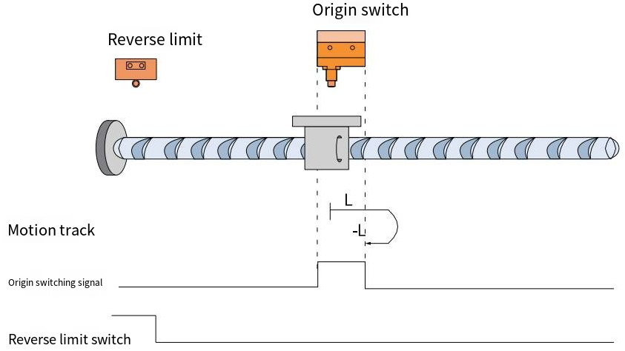
When HOME=ON, NOT=OFF, it starts homing at a low speed in the forward direction. After encountering the falling edge of HOME, it decelerates and reverses, runs at a low speed in the reverse direction, and stops after encountering the rising edge of HOME.

Method 29 (6098=29)
Origin: Origin switch signal (HOME)
Deceleration point: Origin switch signal (HOME)
- The origin switch signal is invalid when starting homing, and no negative limit switch is encountered.
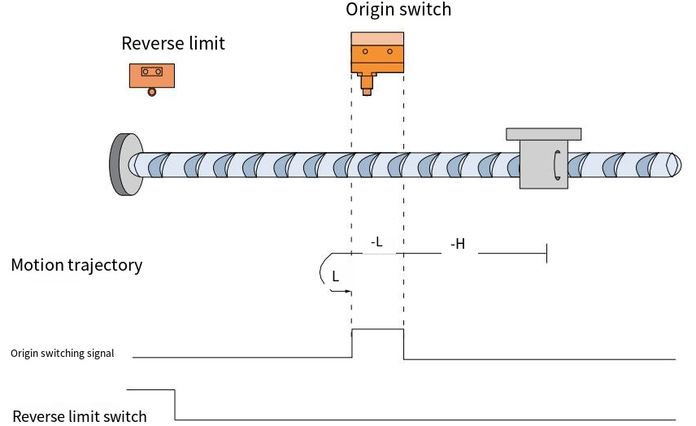
When HOME=OFF, NOT=OFF, it starts homing at high speed in the reverse direction. After encountering the rising edge of HOME, it runs in the reverse direction at low speed. After encountering the falling edge of HOME, it decelerates and reverses, runs in the forward direction at low speed, and stops after encountering the rising edge of HOME.
- The origin switch signal is invalid when starting homing, and the negative limit switch is encountered.
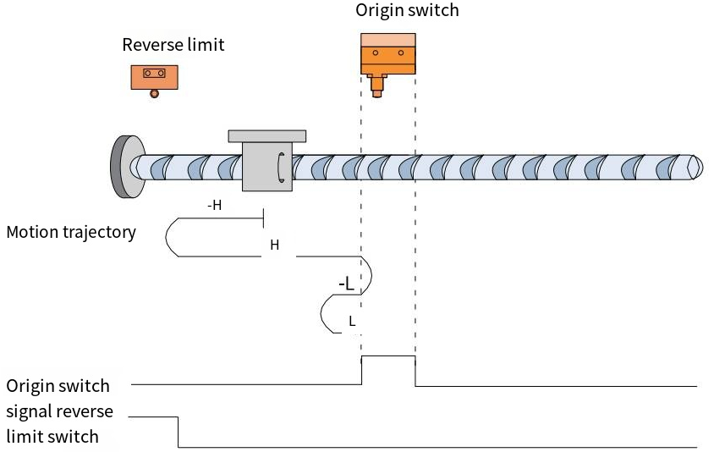

When HOME=OFF, NOT=OFF, it starts homing at high speed in the reverse direction. After encountering the rising edge of NOT, it automatically runs in the forward direction at high speed. After encountering the rising edge of HOME, it decelerates and reverses, and runs in the reverse direction at low speed. After encountering the falling edge of HOME, it decelerates and reverses, and runs in the forward direction at low speed. It stops after encountering the rising edge of HOME again.
- The origin switch signal is valid when starting homing.
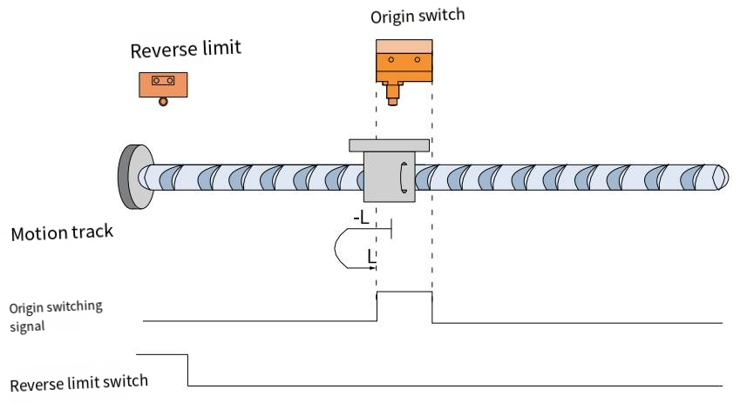
When HOME=ON, NOT=OFF, it starts homing at a low speed in the forward direction. After encountering the falling edge of HOME, it decelerates and reverses, running at a low speed in the forward direction, and stops after encountering the rising edge of HOME.

Method 30 (6098=30)
Origin: Origin switch signal (HOME)
Deceleration point: Origin switch signal (HOME)
- The origin switch signal is invalid when starting homing, and no negative limit switch is encountered.
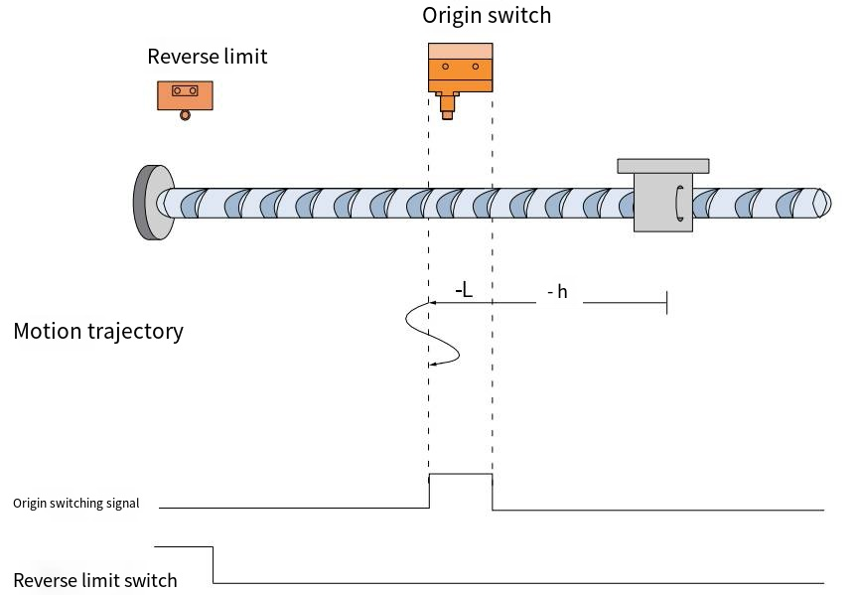
When HOME=OFF, NOT=OFF, it starts homing at high speed in the reverse direction. After encountering the rising edge of HOME, it runs in the reverse direction at low speed. After encountering the falling edge of HOME, it decelerates and reverses, runs in the forward direction at low speed, and stops after encountering the rising edge of HOME.
- When starting homing, the origin switch signal is invalid and encounters a negative limit switch.
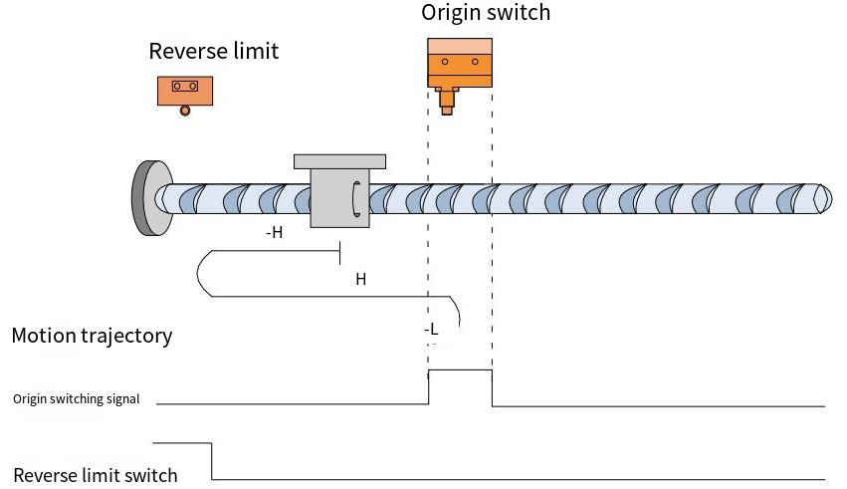

When HOME=OFF, NOT=OFF, it starts homing at high speed in the reverse direction. After encountering the rising edge of NOT, it automatically runs in the forward direction at high speed. After encountering the rising edge of HOME, it decelerates and reverses, and runs in the reverse direction at low speed. After encountering the falling edge of HOME, it decelerates and reverses, and runs in the forward direction at low speed. It stops after encountering the rising edge of HOME again.
- The origin switch signal is valid when starting homing.
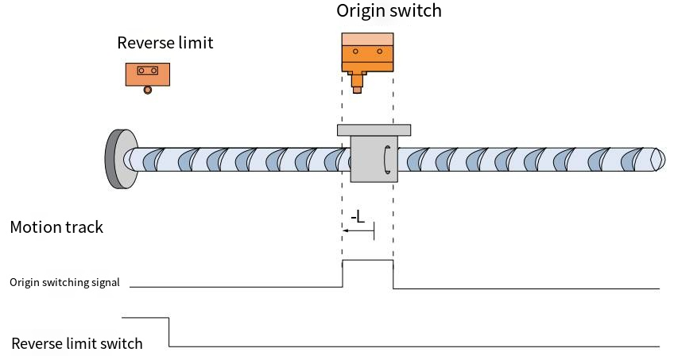
When HOME=ON, NOT=OFF, it starts homing at a low speed in the reverse direction. And stops after encountering the rising edge of HOME.

Method 33/34 (6098=33/34)
Origin: Z signal
Slowdown point: None
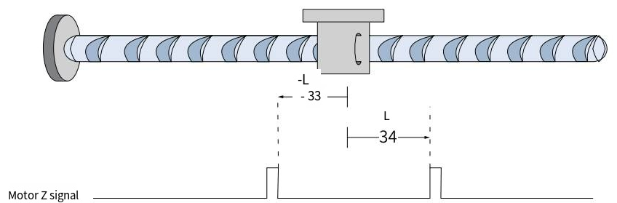
Homing method 33: Run in reverse at low speed and stop at the first Z signal.
Homing method 34: Run in forward at low speed and stop at the first Z signal.

Method 35 (6098=35)
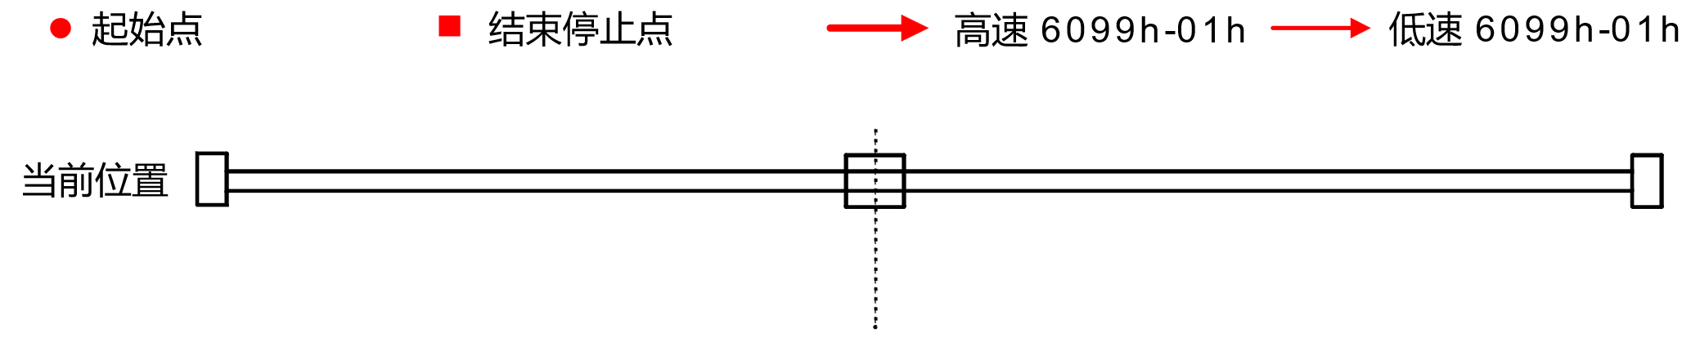
Homing method 35, using the current position as the mechanical origin.



